  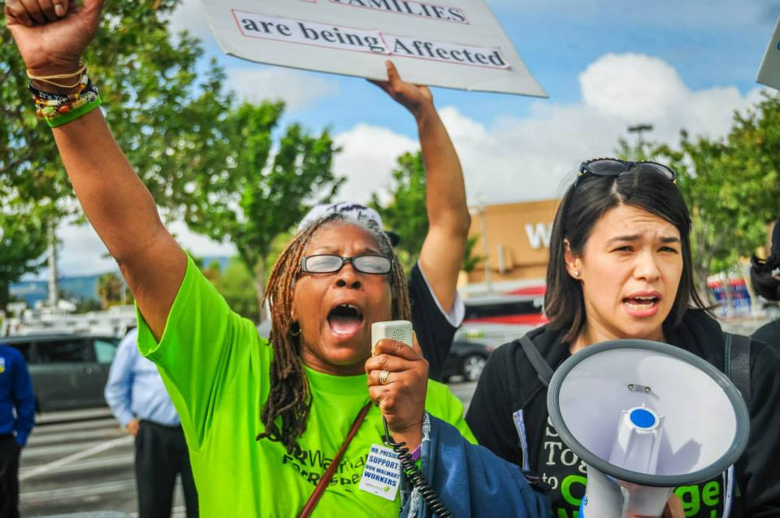
    - september-october
  Low-Wage Economy exposed
  Inequality in the USA
  Messaging
  [Where?]
  [When?]
  [what will this event look like?]
  d
  [list of speakers?]
  [highlights]
  [facts? Contact info? Etc]
  [sponsors]

