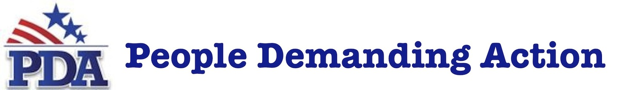

To: The Honorable [Congressperson’s Full Name] February [delivery date], 2016
From: Constituents of [Congressional District]

Dear ______________,

You’ve been hearing from your constituents for many months now regarding issues and legislation that concern us. Often, we urge you to co-sponsor one bill or vote no on another.

This letter is different as it addresses a single issue that could determine the future direction of this nation—and have devastating implications for the voters in your district and the communities in which we live, for generations to come.

You’ve taken a solemn oath to represent your district, so we ask you to carefully consider the information here and if necessary, reach out to us or to any number of informed organizations for answers, clarifications or supporting data before making a decision on the Trans-Pacific Partnership, or TPP.

This could well be the most significant vote of your congressional career. And it’s one we’ll be watching very closely.

Now that President Obama and 11 other TPP partner nations have signed the agreement in New Zealand, the next step will be to present TPP to you for an up or down vote.

There is no shame in telling voters you need to learn more—but please, take time to fully review the details and understand the lasting impact of your decision—and then say NO to the Trans-Pacific Partnership when it comes up for a vote.

Organizations opposing the TPP run the full range of the political spectrum, and you’ve no doubt heard from all of them. So we won’t get into the weeds about nearly half a million potential lost jobs, about shrinking wages, human rights issues with partner nations, environmental impacts, digital privacy v. copyright protection, access to affordable medicines, food safety, or any other issues you already know about.

We’re here today to talk about TPP’s specific impact on the district you were elected to represent. Few people take the time to connect the dots between globalization and communities in crisis because of crumbling infrastructure.

We have taken the time, and what we’ve learned is disturbing to say the least.

We know that when jobs are lost to outsourcing, when unfair foreign competition drives down wages, and when corporations can sue the United States, a state or our community for their lost potential profits and collect from us—the taxpayers—that there is less money available in local tax reserves to support the very resources so critical to keeping communities healthy and thriving.

We know that when shrinking tax bases starve our communities of financial resources, our public works become vulnerable to privatization—often by the same foreign corporations threatening to sue us. A community cannot survive and grow stronger when it exists only as a revenue stream for soulless corporations with no motivation to put anything back.

As the trusted representative of the people in your district, how could you—in good conscience—vote for this deal? To do so would be a betrayal of the public trust you’ve taken an oath to protect.

This is a no-brainer: TPP puts communities at risk and undermines our American way of life at its most basic level.

We urge you: say yes to supporting a thriving and robust district, and vote NO on TPP and any other foreign trade deal that puts the profits of corporations ahead of the health and well-being of your community.

Respectfully,

[ORGANIZER NAME(S)]
[CONTACT INFO: EMAIL AND PHONE NUMBER]
[ORGANIZATION/CHAPTER NAME]

