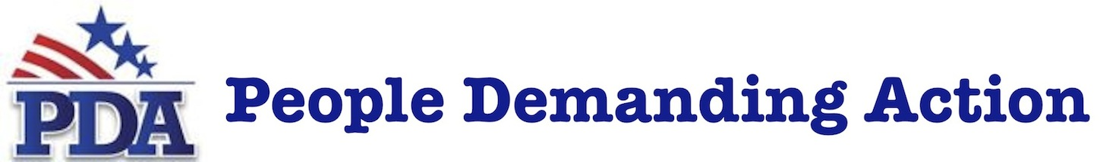

March [delivery date], 2016
To: The Honorable [Congressperson’s Full Name]
From: Constituents of [Congressional District]
Budgets are moral documents; every progressive issue and value is impacted by the Federal budget. Each year, the Congressional Progressive Caucus (CPC) offers an alternative budget resolution to the “austerity” budgets supported by the House Majority and Speaker Ryan. The People's Budget offers a solid blueprint to:
- Invest more than $1 trillion in housing, education, transportation, clean energy and safe water to create millions of jobs
- Prevent cuts, restore social spending and reduce poverty by half in 10 years
- Increase educational opportunities, provide Pre-K and debt-free college for all
- Increase, not cut, Social Security and health care
- Close corporate tax loopholes, tax Wall Street speculation and raise taxes on the top 2%
- Redirect wasteful Pentagon spending and direct to peoples needs, ending Pentagon pork and the overseas contingency "slush fund"
The People's Budget is backed by hard numbers and research by the Economic Policy Institute. You can read the FY2017 People's Budget here: http://cpc-grijalva.house.gov/the-peoples-budget-prosperity-not-austerity-invest-in-america/
The People's Budget has been endorsed by national networks from community, labor, Faith, human services, environment and the peace movement. Endorsing organizations include: American Federation of Teachers, Campaign for America’s Future, American Friends Service Committee, Bend the Arc, Coalition on Human Needs, Daily Kos, Friends of the Earth, MoveOn.org, National Alliance of HUD Tenants, National Priorities Project, NETWORK Lobby, Peace Action, PICO, Progressive Congress, Progressive Democrats of America, Social Security Works, Social Solutions, US Labor Against the War and Win Without War
Vote “Yes” on The People’s Budget and support local communities.
Sincerely,

[Your name]
[Chapter/Organization]

