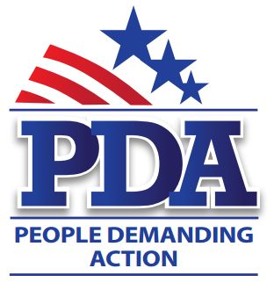

July xx, 2015

The Honorable [Senator First and Last Name]
Address

Dear Senator [Senator Last Name],

You’ve been hearing from your voters for many months now regarding our strong opposition to the Trans Pacific Partnership. This is not a trade deal; this is an assault on our local community. The TPP has the power to overturn our laws, it threatens our jobs and our livelihood, threatens the environment and raises the cost of prescription drugs. This July we declare our independence from the corporations and we say “NO” to the TPP and other bad trade deals. We also say, “No Lame Duck TPP vote!”

America needs a raise. We need to share in the prosperity enjoyed by Wall Street at the expense of Main Street. The Inclusive Prosperity Act (S 1371– Sanders) uses a small tax on Wall Street to improve our infrastructure, strengthen our financial security, expand opportunity and reduce market volatility. HR 1464 will raise more than $300 billion per year. Mothers pay tax when they buy diapers; shouldn’t Wall Street pay a tax when they buy/sell stocks and bonds? Prior to 1968 Wall Street did pay a financial transaction tax and it is time that they do so again.

We also ask that you cosponsor the End Polluter Welfare Act (S 1041 – Sanders). This bill eliminates certain subsidies for fossil fuel production. It repeals the corporation income tax exemption for publicly traded partnerships from activities relating to fossil fuels and eliminates accelerated depreciation for property that is receiving a subsidy for fossil fuel production. We are in a climate emergency and it is well past time to transition to clean, safe, renewable energy. We have the technology; we need the political leadership.

And finally, we must get money out of politics by overturning Citizens United with a Constitutional amendment. SJ Res 5 (Udall). This amendment authorizes Congress and the states to set reasonable limits on the raising and spending of money by candidates and others to influence elections, grants Congress and the states the power to implement and enforce this amendment by appropriate legislation and allows them to distinguish between natural persons and corporations or other artificial entities created by law, including prohibiting such entities from spending money to influence elections.

Respectfully,

[NAME]
[STATE/CHAPTER]

