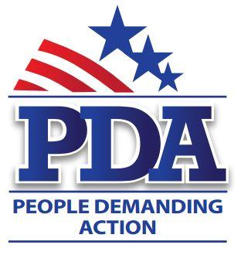

September 14, 2016

The Honorable [Rep First Name] [Rep Last Name]
Address

Dear Representative [Rep Last Name],

As you probably know, President Obama wants the Trans-Pacific Partnership (TPP) to be his legacy, but he will only ask for a vote if he thinks he can win. That’s why I’m asking you, as your constituent and as an economic stakeholder in this district, to make sure TPP does NOT come up for a House vote before he leaves office in January—or if it does, to vote no and urge your colleagues to do the same.

Of all the decisions you’ll make in office, this could well be the most important because the TPP will determine not only the future of America’s economy, but also our ability to self-govern now and forever.

The president’s claims about TPP opening new markets for U.S. exports are greatly exaggerated. Those who’ve studied TPP have noted that the limited profits arising from U.S. exports will be more than offset by the costly special privileges granted to foreign trading partners at the expense of U.S. companies.

“Made in USA” manufacturers already have a declining market share because of previous bad trade deals. They could be growing with the U.S. economy, but their market share is eroding due to other governments’ subsidized imports. American business can compete with foreign companies, but not with foreign governments that subsidize their own industries to ship predatory-priced goods to the U.S. New rights for them will only exacerbate the problem.

From currency manipulation to value added tax rebates and state subsidies, foreign countries game trade deals so that their domestic companies take market share from U.S. business and prevent our companies from selling there, despite tariff reductions. As we’ve learned from NAFTA, TPP won’t boost the U.S. economy because it isn’t a trade deal.

The TPP will impact the U.S. economy in negative ways that the White House, Commerce Secretary Pritzker, and the National Chamber of Commerce are not being straight about when they talk to small businesses and other stakeholders. We don’t need TPP. Business owners here could hire more workers and grow their state and local economies without economically-toxic additives that rob the U.S. of our sovereignty.

TPP gives unique rights to foreign entities that U.S. businesses don’t enjoy, specifically: the right to SUE the U.S. government before a special panel of “profit protecting” corporate lawyers who alternately serve as both attorneys for foreign corporations and as the judges who rule on their claims. This provision in TPP gives foreign corporations an unfair advantage.

The TPP jeopardizes America’s claim to our natural resources (including energy reserves) and all but erases “buy local” and “buy American” protections by subjecting them to foreign lawsuits that U.S. taxpayers can’t afford to defend.

Loss of tax revenue will threaten the economic health of every single state, and make more U.S. land, utilities, and public infrastructure vulnerable to foreign takeover. With trading partners that include communist countries, how can you in good conscience put America in such a vulnerable position?

TPP is not just bad for the U.S. economically. It’s bad for our national security. While this is one vote; it is perhaps the most important one you will ever cast. And it’s a vote that I and other business people in your district will remember. Please make the right decision for your district and all your constituents.

Vote No on TPP.

Sincerely,

[Your Name]
[Your Congressional District]

