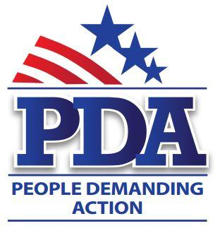

September xx, 2016

The Honorable [Rep First Name] [Rep Last Name]
Address

Dear Representative [Rep Last Name],
As concerned, informed voters in [STATE]-[DISTRICT], we call upon you to cosponsor legislation that protects American businesses, “Made in the USA”, makes voting a Constitutional right and ensures that our votes will be fairly counted by modern, non-hackable equipment.
The president’s claims about TPP opening new markets for U.S. exports are greatly exaggerated. Those who’ve studied TPP have noted that the limited profits arising from U.S. exports will be more than offset by the costly special privileges granted to foreign trading partners at the expense of U.S. companies.
“Made in USA” manufacturers already have a declining market share because of previous bad trade deals. They could be growing with the U.S. economy, but their market share is eroding due to other governments’ subsidized imports. American business can compete with foreign companies, but not with foreign governments that subsidize their own industries to ship predatory-priced goods to the U.S. New rights for them will only exacerbate the problem
Constitutional Right to Vote (HJ Res 25 - Pocan) Because voting in America is a privilege that has been expanded through Constitutional amendment, this bill seeks to make voting a Constitutional right for all Americans which would establish strict judicial standards for other Federal laws relating to voting rights and procedures.
No doubt you have read many stories stating our current voting technology can be easily hacked changing the outcome of our elections. Rep. Hank Johnson is introducing two new bills on September 21st that address the issue of lax security in our voting system as well as voter purges. The Election Infrastructure and Security Promotion Act of 2016 calls on the Department of Homeland Security to designate our election equipment as critical infrastructure including it in the Critical Infrastructure Protection Act. Currently only a few vendors engage in voting machine development; this bill will also require future developments be open source. The Election Integrity Act of 2016 requires any new voting systems purchased must provide durable voter-verified paper ballots, establishes guidelines for the publication of voter purge lists and a process by which individuals can challenge their placement on a purge list. The Election Integrity Act also requires a mandatory response by the Attorney General for allegations of voter suppression and intimidation.
We ask that you cosponsor the legislation listed above.
Respectfully,

[Your Name]
[Your Congressional District]

