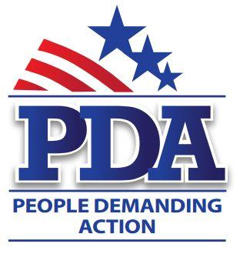

October xx, 2016

The Honorable [Rep First Name] [Rep Last Name]
Address

Dear Representative [Rep Last Name],

As we go into the 2016 Presidential elections, it seems that we are fighting the same battles that we have been fighting since 2004; it is time to move forward on the basic principles of Healthcare NOT Warfare. We ask you to cosponsor the following legislation:

As Dr. Martin Luther King, Jr. remarked, “Of all the forms of inequality, injustice in health care is the most shocking and inhumane”. Six years after the ACA people are still experiencing medical bankruptcy and the working poor are dying because insurance is not healthcare. We urge you to cosponsor HR 676 – Expanded and Improved Medicare for All (Conyers) to provide lifelong healthcare for everyone.

Our misadventures in the Middle East have made us far less safe than ever before. Regime change has not produced the results we want so at this time we need to change direction. HR 4108 (Gabbard) prohibits use of funds for regime change in Syria. A nation that continues year after year to spend more money on military defense than on programs of social uplift is approaching spiritual doom ~ Dr. Martin Luther King, Jr.

When Congress returns from recess after the election, they will again be working on a budget. The Inclusive Prosperity Act (HR 1464 – Ellison) is a tiny tax on Wall Street transactions (50 cents on a $100 sale) that generates more than $300 billion in revenue each year that is used to fund discretionary social programs.

According to the Census, 50.8% of the US population is female; 68.1% of seniors living in poverty are female. The simple reason for this statistic is that over their working lives women still consistently earn less than their male counterparts. It is way past time to ratify the Equal Rights Amendment. HJ Res 51 (Speier) seeks to add three (3) new states to the original 35 ratified states to complete the Constitutional amendment process.

We are in a climate emergency and the clock is ticking on humanity. It is time to transition from fossil fuels to clean, safe, renewable energy by ending fossil fuel extraction leases. HR 4535 – Keep It In the Ground (Huffman) seeks to do exactly that and end our dependence on fossil fuel.

Please consider becoming a cosponsor on the above-mentioned legislation.

Respectfully,

Your Name
Your Chapter

