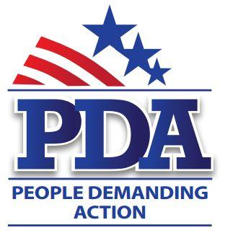

October xx, 2016

The Honorable [Senator First Name] [Senator Last Name]
Address

Dear Sentator [Senator Last Name],

As we go into the 2016 Presidential elections, we see that the Federal government still needs a plan to raise revenue, our college students are emerging as the most indebted generation in history before they even enter the workforce, 30 years after the Equal Rights amendment passed women’s earnings have risen from .77 to .78 of a man’s earnings and now hourly workers struggle to vote on election day because of long lines. It is way past time to begin our transition from fossil fuels to clean, safe, renewable energy. We ask you to cosponsor the following legislation:

Millennials are drowning in student debt. The College for All Act (S 1373 – Sanders) directs the Department of Education (ED) to award grants to states to eliminate tuition and required fees at public institutions of higher education. This bill also allows student loan borrowers to modify interest rates on outstanding federal student loans to current rates; reauthorize the Federal Work Study program for FY2016-FY2020; eliminate existing base guarantees of Federal Work Study funds to Institutions of Higher Education and requires funds to be allocated based solely on the aggregate need of the institution’s students.

77.2 million American workers are hourly workers with 1.3 million earning only the minimum wage of $7.25/hour. Civic engagement should not compete with a worker’s ability to pay for food and rent. S 1969 – The Democracy Day Act – Sanders would make election day a Federal holiday.

When Congress returns from recess after the election, they will again be working on a budget. The Inclusive Prosperity Act (S 1371 – Sanders) is a tiny tax on Wall Street transactions (50 cents on a $100 sale) that generates more than $300 billion in revenue each year that is used to fund discretionary social programs.

According to the Census, 50.8% of the US population is female; 68.1% of seniors living in poverty are female. The simple reason for this statistic is that over their working lives women still consistently earn less than their male counterparts. It is way past time to ratify the Equal Rights Amendment. SJ Res 15 (Cardin) seeks to add three (3) new states to the original 35 ratified states to complete the Constitutional amendment process.

We are in a climate emergency and the clock is ticking on humanity. It is time to transition from fossil fuels to clean, safe, renewable energy by ending fossil fuel extraction leases. S 2238 – Keep It In the Ground (Merkley) seeks to do exactly that and end our dependence on fossil fuel.

Please consider becoming a cosponsor on the above-mentioned legislation.

Respectfully,

Your Name
Your Chapter

