PA Voting Requirements/Highlights – Quick Guide
Who can vote in PA? Registrants must be:
- U.S. citizens for at least one month prior to election.
- PA residents living in that voting district for at least 30 days before the next election.
- 18 years or older on the day of the election.

PA Voter Registration Form used for:
- Registering to vote for the first time.
- Change of name; Change of address or other info.
- Change of party affiliation
- Federal or state employees registering to retain prior voting residency.

College Students:
PA residents can register to vote in the PA voting district where they are attending school.

ID Requirements:
Only people who are voting in that district for the first time or the first time after a name change must show ID.
- Acceptable Photo ID  - PA driver’s license or PA ID card  - ID issued by any PA Commonwealth agency  - ID issued by U.S. government  - U.S. Passport  - U.S. Armed Forces ID  - Student ID  - Employee ID | - Acceptable NonPhoto ID  - Non-photo ID issued by Commonwealth of PA (PA Voter ID card applies)  - Non-photo ID issued by U.S. government  - Firearm permit  - Current utility bill  - Current bank statement  - Current paycheck  - Government paycheck
Absentee Ballots:
Voters must provide a valid excuse to request an absentee ballot.
- Away from municipality during the time that the polls are open.  - Vacation.  - College student away at school.  - Leave of absence/sabbatical.  - Illness or disability. | - Observance of religious holiday.  - Hospitalized veteran.  - Election duties.  - Military service.

In prison or convicted of a felony:
Only people in prison serving felony sentences are prevented from voting in PA. However, neither prisons nor halfway house addresses can be used on the registration form. An applicant must use their home address (prior to incarceration) to register and/or request an absentee ballot.

Voter Registration – New Format
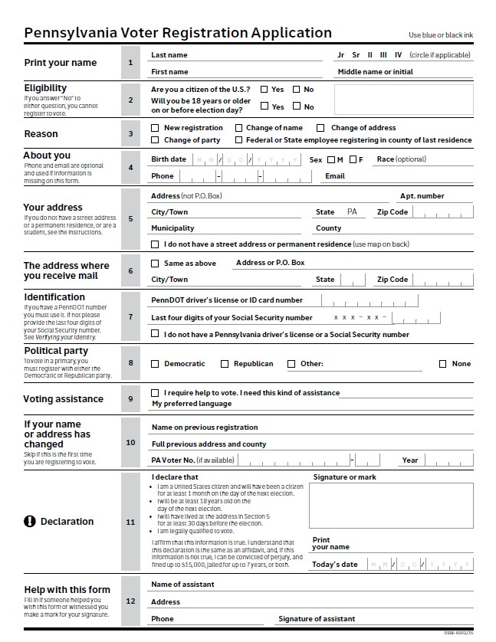
All sections
must be
completed

#5 If voter is unsure of “municipality” leave blank.
#6 Check box if address is the same as in #5 or add P.O. Box info.
#7 Encourage voter to use their PA driver’s license or PA ID numbers. #8 Explain PA’s closed primary process to voter before they complete this section.
#9 Complete this section if the voter will need help at the poll on Election Day.
#10 This section is for name changes and address changes.
#11 Voter must print and sign their name as well as including the date.

Voter Registration – Old Format
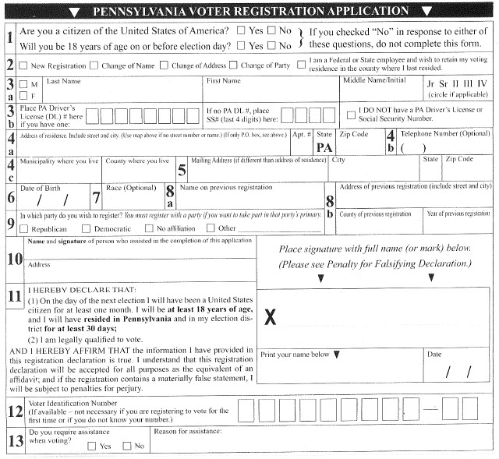
All sections must be completed
#3b Encourage voter to use their PA driver’s license or PA ID numbers.
#4c Voter can leave blank if unsure.
#8a This section is for name changes.
#8b This section is for address changes.
#9 Explain PA’s “closed” primary process to voter before they complete this section.
#12 This is not necessary.
#13 Complete this section if the voter will need help at the poll on Election Day.
Signature Section:
Voter must print and sign their name as well as including the date.

