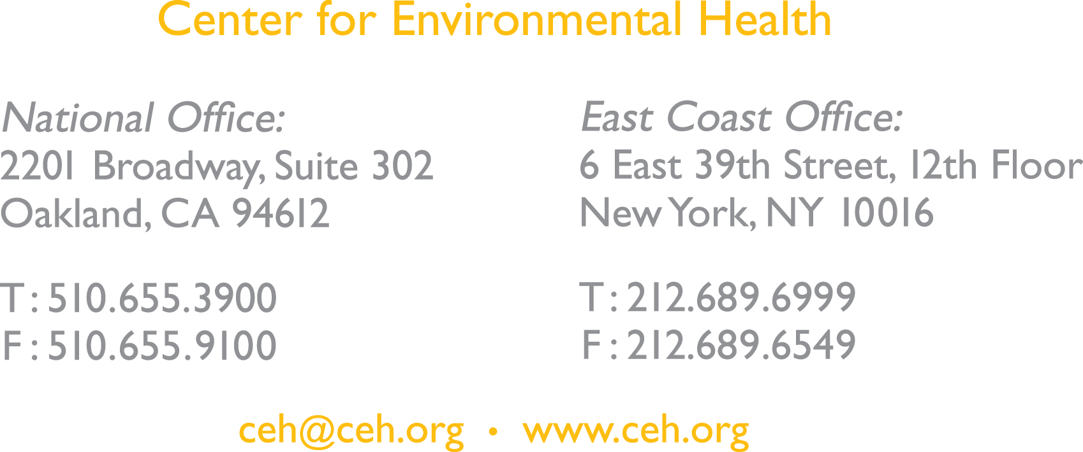

August 9, 2017

Dear fellow Defenders of Democracy:

Once again, the Trump Administration is attempting to ram a corporate shill into a position of federal authority. You’ve heard the story a few times now. But wait until you hear about this guy. For the first time in a long while, our political friends are telling us that this nomination process could be denied. If people mobilize.

Here’s the context: The Trump Administration just appointed the tobacco and chemical industry’s gun-for-hire to be the top official overseeing toxic chemical regulations. The nominee, Michael Dourson, was hired by the tobacco industry to downplay the effects of secondhand smoke, by the chemical industry to bless Teflon, and by the Koch brothers to dismiss the health concerns related to petroleum coke. Dourson is the latest gift to the industry after Trump appointed asbestos-friendly Scott Pruitt to head the EPA, and the chemical industry’s lobbyist Nancy Beck to lead the Office of Pollution Prevention and Toxics. You can read more about Dourson here: www.ceh.org/trumpgift/.

This is the third corporate lackey to come into the EPA, spelling doom for the health of our communities. These folks are supposed to regulate lead, asbestos, BPA, and other chemicals that have been clearly connected to cancer, delayed mental and physical development, lowered IQ, and caused major reproductive harm. And they are already trying to gut critical programs that were put in place to address environmental injustices across this country. If this man comes into power, our most vulnerable communities, and especially children in them, will feel it first.

Will you help us dump Dourson? We need our allies in the Democracy Initiative in this offensive. The American public has already lost faith in our government and if Dourson goes through without a fight, it will be the final nail in the coffin. Pruitt, Beck, and Dourson, the Three Horsemen of the Apocalypse, will run the EPA’s toxic program into the ground, unleashing countless poisonous chemicals onto the market and in our bodies.

This is a nomination where we can actually hold the line, but only if we have a show of support and public outcry. CEH and our partners are ready to fight tooth and nail against it. We look forward to talking with you about what we’re planning and how we can partner to dump Dourson.

Best,
Ansje Miller and Christine Sangobowale
Center for Environmental Health
While everyone had a few names to offer, the common theme that emerged was that TERA (i.e. Mike Dourson) was the leading choice.” TERA had “a very good reputation among the folks that are still in the business of blessing criteria,” Bingman explained, going on to describe the company’s ability to “assemble a package and then sell this to EPA, or whomever we desired.
-Excerpt from an email from a DuPont employee looking for an “expert” to help push approval of the Teflon chemical PFOA. From Sharon Lerner’s, Trump’s EPA Chemical Safety Nominee Was in the “Business of Blessing” Pollution, The Intercept, July 21, 2017.

