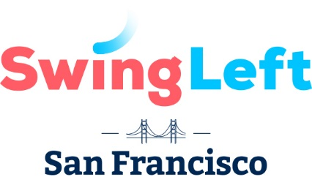
Upcoming Events

Phone Banks

Saturday Aug. 18, from 1 - 5pm. RSVP
Saturday Aug. 25, from 1 - 5pm. RSVP
Saturday Sept. 1, from 1 - 5pm. RSVP
Saturday Sept. 8, from 1 - 5pm. RSVP
Saturday Sept. 15, from 1 - 5pm. RSVP
Saturday Sept. 22, from 1 - 5pm. RSVP
Saturday Sept. 29, from 1- 5pm. RSVP
Saturday Oct. 27, from 1-5pm. RSVP

Canvasses
Turlock: Aug. 18, from 10am - 2pm. RSVP
Firebaugh: Aug. 25, from 9am – 1pm. RSVP
Ripon: Sept. 1, from 10am - 2pm. RSVP
Waterford: Sept. 8, from 10am - 2pm. RSVP
Turlock: Sept. 15, from 10am - 2pm. RSVP
Modesto: Sept. 22, from 10am - 2pm. RSVP
Mendota: Sept. 29, from 9am – 1pm. RSVP
Ripon: Oct. 6, from 10am - 2pm. RSVP
Modesto: Oct. 13, from 10am – 2pm. RSVP
Turlock: Oct. 20, from 10am - 2pm. RSVP
Firebaugh: Oct. 27, from 9am – 1pm. RSVP
Modesto: Nov. 3, from 10am – 2pm. RSVP
Modesto: Nov. 4, from 10am – 6pm. RSVP
Modesto: Nov. 5, from 10am – 6pm. RSVP
Modesto Nov. 6, from 9am – 8pm. RSVP

Other Events

Swing Left Happy Hour
Tuesday, Aug. 28th, 6pm – 8pm
Standard Deviant Brewing, 280 14th St. SF. RSVP

New Citizen Voter Registration
Paramount Theatre, 2025 Broadway in Oakland, September 6th
Morning Session: 10am - Noon. RSVP OR Afternoon session: 2pm - 4pm. RSVP

How to Make an Impact in the Midterms
Sept. 5, 6pm – 7pm, 95 Brady St, SF.
Panel discussion with United Dems. More info here.

September General Meeting
Wednesday, Sept. 12, from 6:30 to 8pm, Chinatown Library, 1135 Powell St, San Francisco. RSVP

Spanish for Activists
Saturday, Sept. 15, from 10:30am – 12:30pm
Presidio Library, 3150 Sacramento St. ST
RSVP

