Second Chances Florida – Sample Social Media

Twitter

- FL is 1 of only 4 states where ppl w/ past felony convictions are permanently barred from voting, but that can change in Nov. Join a @YesTo2ndChances phone bank in person or at home during #EarlyVoting Sat 10/27 to call FL voters & ask them to VOTE #YesOn4 tinyurl.com/ycrganzy

- People across the country are making calls during #EarlyVoting Sat 10/27 to support Second Chances and make sure that FL votes #YESon4 to restore the eligibility to vote to 1.4 million people. Join a @YesTo2ndChances call party or make calls from home tinyurl.com/ycrganzy

- Did you know 1 in 10 Floridians can’t vote? We're phone banking during #EarlyVoting on Sat to turn out the vote for Amendment 4 and fix this broken system keeping 1.4M people from the polls. Join us: tinyurl.com/ycrganzy #YesOn4

- Join us during #EarlyVoting Sat 10/27 for a @YesTo2ndChances Day of Action, where we'll make calls to encourage FL voters to vote #YesOn4, retire the state's lifetime ban on voting, and restore the vote to 1.4 million Floridians w/ past felony convictions tinyurl.com/ycrganzy

Facebook

- Florida is 1 of only 4 states where people with a past conviction are permanently barred from voting. Amendment 4 fixes this broken system by providing Second Chances to more than 1.4 million returning citizens. Join a @SecondChancesFlorida phone bank in person or make calls from home during Early Voting on Saturday 10/27 to call voters and ask them to VOTE #YesOn4: tinyurl.com/ycrganzy

- People across the country are making calls during Early Voting on Saturday 10/27, to support Second Chances and make sure that Florida votes #Yeson4 to restore the eligibility to vote to 1.4 million people. Join a @SecondChancesFlorida call party in person or make calls from home: tinyurl.com/ycrganzy

Share the campaign’s posts about Saturday’s Day of Action on Twitter and Facebook.

Sample - Partner Graphics

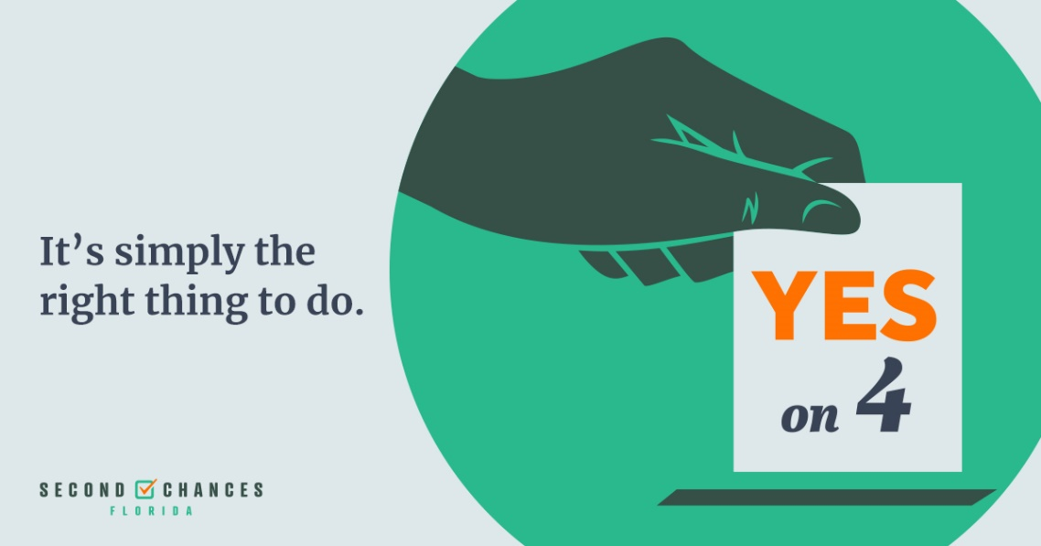
Download this graphic HERE

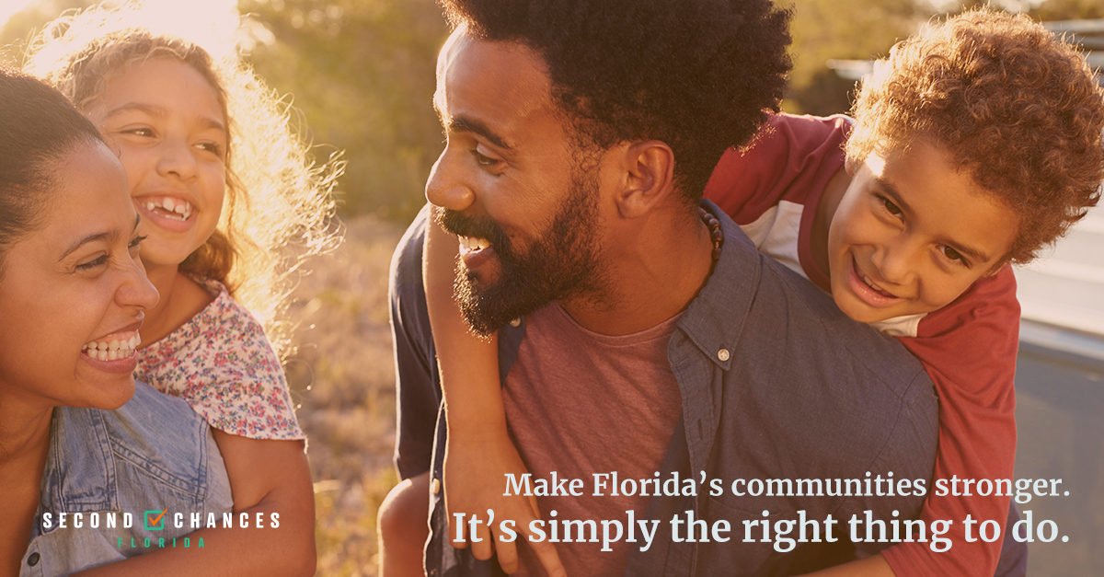
Download this image HERE

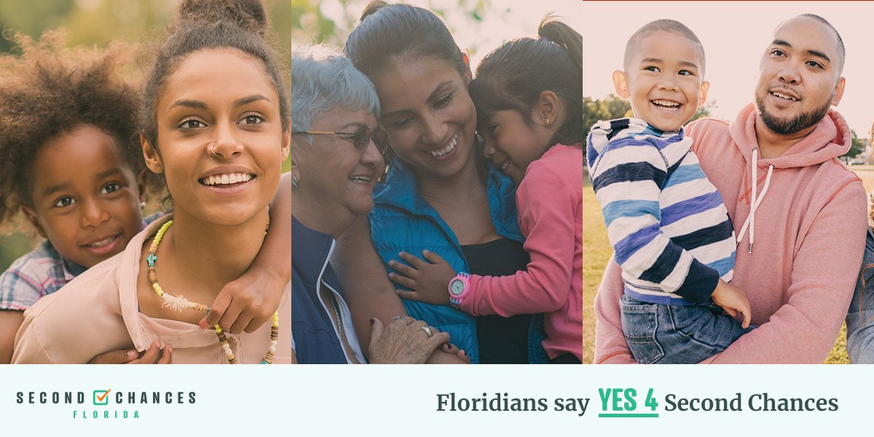
Download this image HERE

