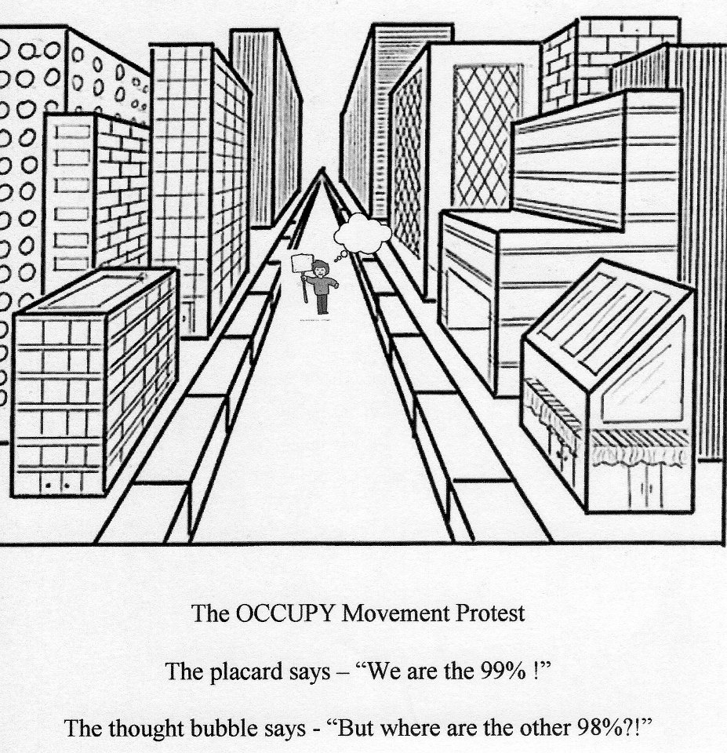

Ninety-Nine
99% of the 99% Awakening

We are the ninety, nine percent
We are normal
The rest are bent

We make a difference
We make a dent

We vote for governments
Who kill and steal
They break the law
But we can’t feel

We buy the goods
To starve poor nations
But we are deaf
To such revelations

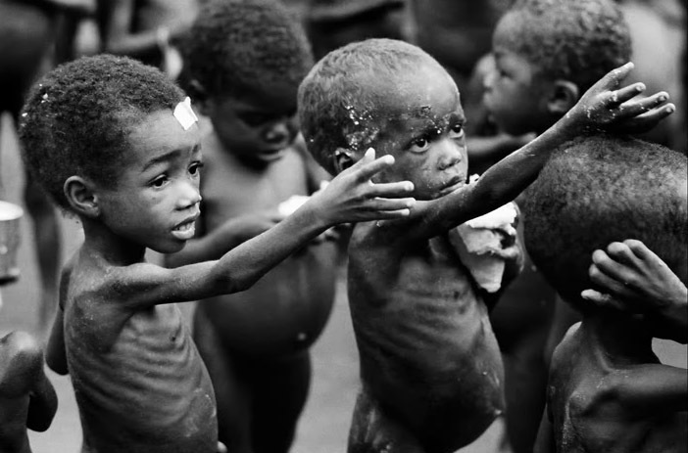

We are the ninety, nine percent
We are normal
The rest are bent

We go to work
To make the weapons
Campaign for peace
But government threatens

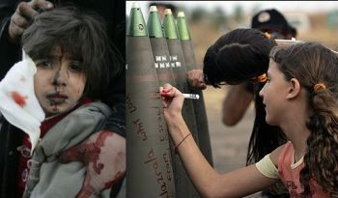

Israeli children send gifts of love to Arab kids
They write messages of national unity, and then the bombs are used to attack Gazans, like this little girl on the left.
The 'missiles' Israel claims it is attacked by, have killed 28 people in all time. Israel kills thousands.

We are the silent
Majority
Who kills the Earth
As ‘We’re not free’

We choose to kill
We have free will
And there are those
Who love the thrill

We are the ninety, nine percent
We are normal
The rest are bent

We eat the meat
Resources deplete

Ignore the warning
On global warming

Our kids are hypnotised
We send them to school
We’re so robotic
We obey every rule

We want the freedom
But act the fool

Love’s the only
Golden Rule

At school the government
Sharpens its tool...

The next generation
Of gullible slaves
So our protests
Do not make waves

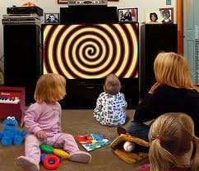

We send them to school
They watch TV
I still blame you
Instead of me

We go to church
Repent, confess
We’re responsible
For this world’s mess

Mass starvation
Flooding and drought
We just moan
But do not shout

Not just numb
But selfish and dumb

Aspartame, fluoride
Pills and jabs
Tortured animals
Vivisection labs



All life suffers
Through man’s greed
SELFISHNESS
Replacing need

Science and wisdom
Is so abundant
Scientists, philosophers
Are almost redundant

Every problem
We’ve ever caused
Can be fixed
If not ignored

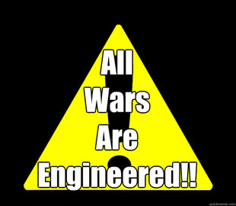

Go vegan
Don’t vote
Just think and feel
Controlled by remote?
Is LOVE in your meal?

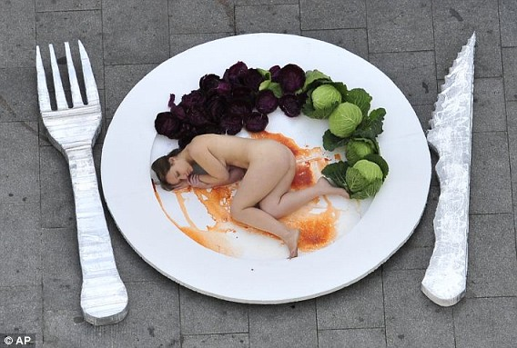

Face your fears
Open your mind
Don’t be selfish
The key is
Be kind

We are the ninety, nine percent
We are normal
The rest are bent

Guilt and fear
Selfishness and hate
Corpse and two veg
Upon your plate

These all cause war
Destruction of life
Retrain your taste buds
YOU wield the knife

Self-pity and blame
Excuses are lame
WE are responsible
WE feel the shame

We are the ninety, nine percent
We are normal
The rest are bent

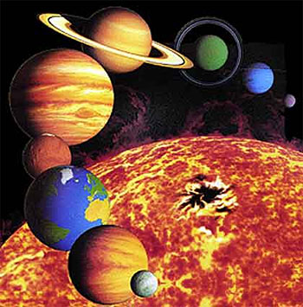

2012
A time of change
Ready or not
It will feel strange
Some awaken
Some derange

Make your choice
Unite as one voice

Calendar’s end
Peace in our time
For once, take action
Instead of, just whine

We are the ninety, nine percent
We are normal
The rest are bent

Love in Action!
Creates a Reaction!

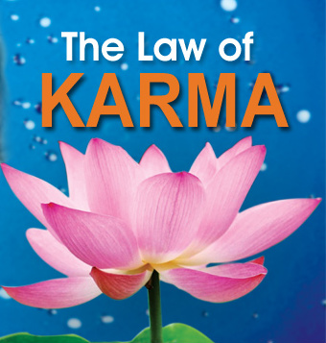

https://www.youtube.com/watch?v=fVgWbLUkgY4

