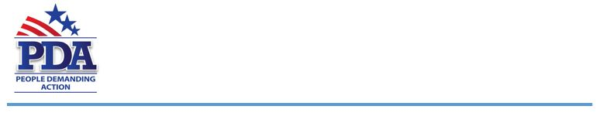
April xx, 2019

The Honorable Representative [Representative Name]
[Address]
[City, State Zip]

Dear Representative [Representative Last Name],
As a voter in your district, I am asking you to join the 160 other bi-partisan co-sponsors of HR1595 (SAFE Banking Act – Perlmutter CO-7). Cannabis legislation has the support of baby boomers, the nation’s largest and most consistent voting bloc.
This legislation would solve a key logistical and public safety problem in states that have legalized medicinal or recreational cannabis.
When businesses are forced to operate on a cash-only basis, public safety threats rise. It makes marijuana and marijuana-related businesses vulnerable to robbery, assault and organized crime; their vendors, employees and customers are vulnerable as well. Today, thousands of licensed and regulated businesses do not have access to the banking system and are unable to accept credit or debit cards, deposit receipts, or write checks to meet payroll or pay taxes.
The SAFE Banking Act, would increase public safety by ensuring access to financial services to legitimate cannabis-related businesses and service providers thereby reducing the amount of cash at such businesses.
Voters in 25 states have voted to allow some form of marijuana decriminalization in their state. Currently medical Marijuana is legal in – Alaska, Arizona, California, Colorado, Connecticut, Delaware, Hawaii, Illinois, Maine, Maryland, Massachusetts, Michigan, Minnesota, Montana, Nevada, New Hampshire, New Jersey, New Mexico, New York, Ohio, Pennsylvania, Rhode Island, Vermont, Washington and the District of Columbia.
There are 10 states (Alaska, Arizona, California, Colorado, Maine, Massachusetts, Michigan, Nevada, Oregon, Vermont, Washington and the District of Columbia) that legalized recreational use.
With the increase of Americans supporting the use of cannabis, we believe Congress should support the SAFE Banking Act.
Respectfully,
[Your name]
[Your chapter]

