Monday, January 13, 2020 @ 1:30 PM

https://www.tinyurl.com/PolkTakeOnTally
Tentative Rally Schedule
7:00 A.M.
- Polk busses leave from RP Funding Center, 701 W Lime St., Lakeland, FL 33815
*RP Funding Center Parking Map
12:00 P.M. (Civic Center open at 9 A.M.)
- Arrive in Tallahassee at the Leon County Civic Center, 505 W. Pensacola St.
Pre-Rally music/speeches; concession stands open before and after the Rally with
restrooms open during the entire event.
- Parking for cars/vans will be at Kleman Plaza, 306 S. Duval St.
**Bus/Car Tallahassee Parking Map
1:30 P.M.
- Line up for march to the Old Capitol, 400 S. Monroe St (facing Apalachee Parkway)
2:00 P.M.-4:00 P.M.
- Rally on the front steps of the Old Capitol
4:00 P.M.- 5:00 P.M.
- Boxed dinner pick-up from Civic Center
5:00 P.M.- 10:00 P.M.
- Busses depart for Lakeland; arrive home
10:30 A.M.- 4:30 P.M. Trolleys will shuttle between the civic center and the Capitol for those needing assistance.
*RP Funding Center Parking Map
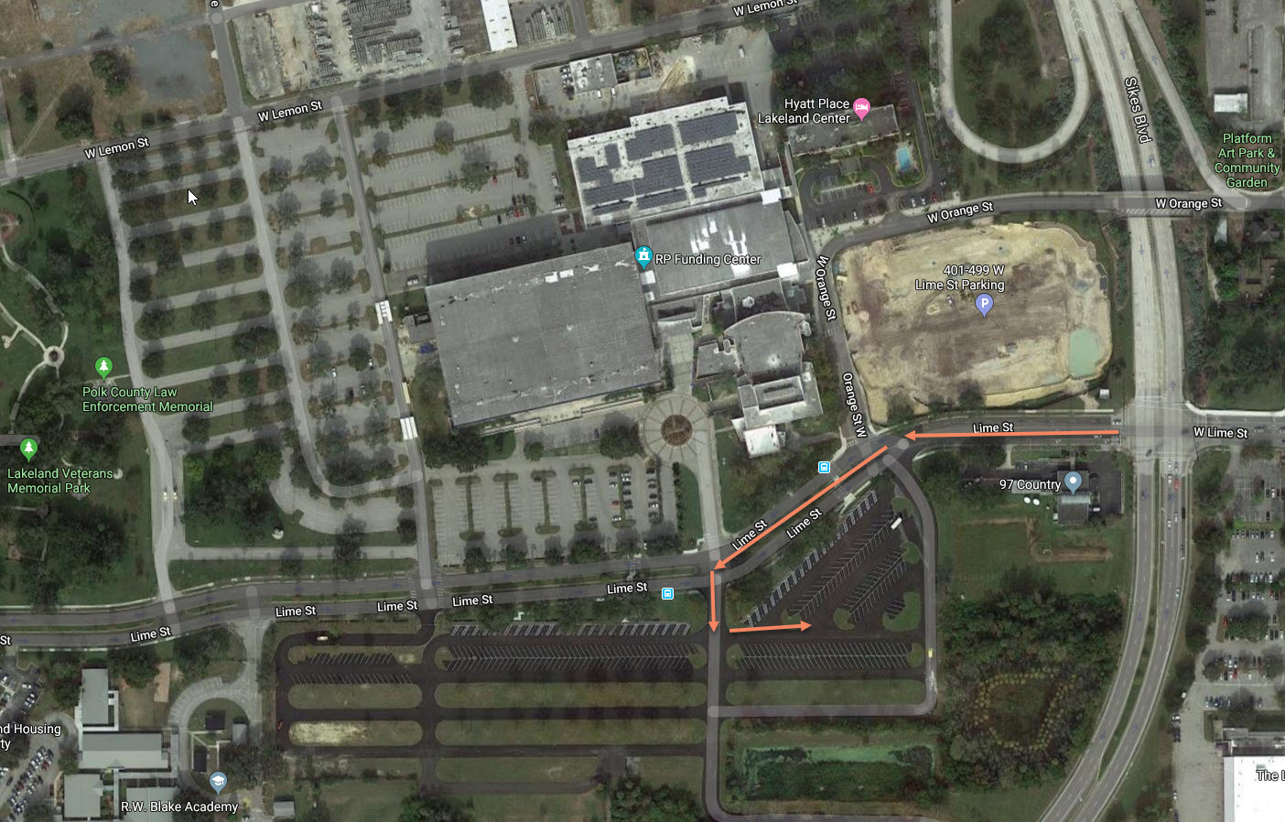

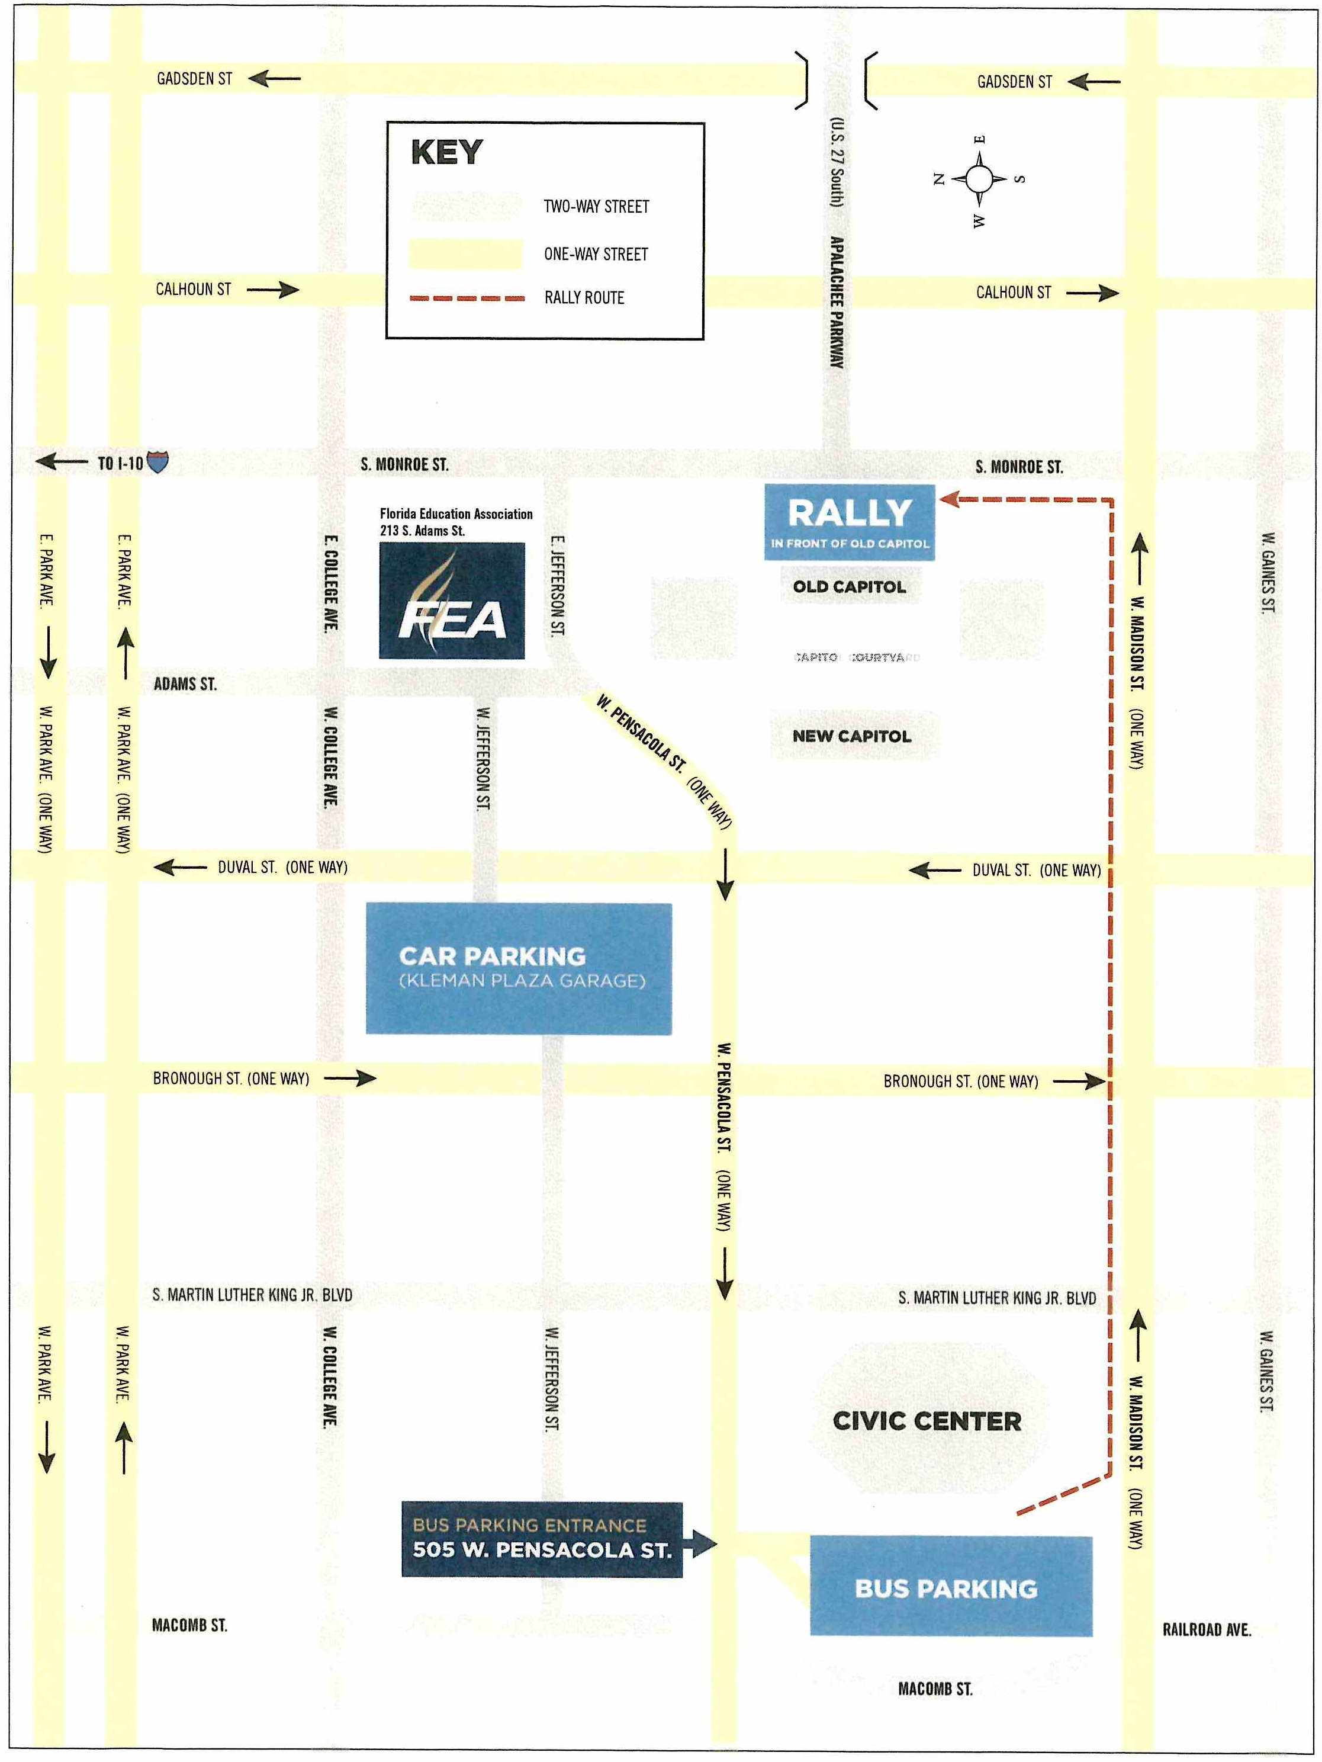

**Bus/Car Tallahassee Parking Map

