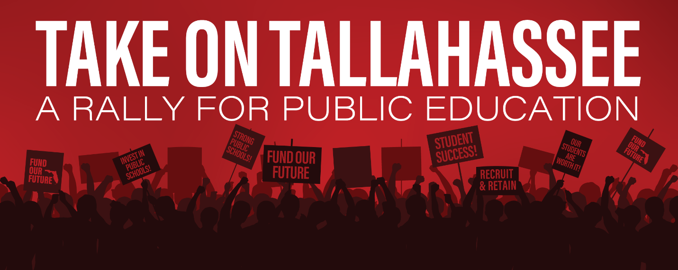

Monday, January 13, 2020 @ 1:30 PM

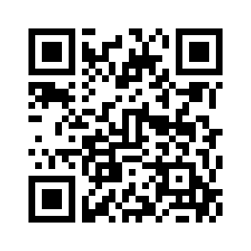
To register for the Polk busses, go to:
https://www.tinyurl.com/PolkTakeOnTally

What do Florida’s kids deserve?
- Experienced, qualified teachers in every classroom.
- Class sizes small enough for one-on-one attention.
- Support, tools and time to learn.
- Safe schools and inviting classrooms.
- Well-rounded curriculum that includes art, music and PE.

That’s how taxpayer funds should be spent. But…
- Across our state there is a growing teacher shortage and it is hurting Florida’s students.
- Thousands of children do not have a qualified teacher in front of their classroom.
- Our schools are not getting the funding they need for repairs.
- Florida’s class sizes are growing.
- Students are spending too much time taking high-stakes tests.
- And parents are worried about their children’s safety.

Florida’s students and families deserve better.
Together we can build a better future for Florida’s children.

