

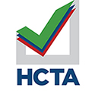**Call the HCTA office @ 813.238.7902 to join us for January 13th!**