TRANSLATOR

Translating government-speak to the language of the sane

The mass media is the lie machine of the government

Governments and corporations are one

Governments which appear to be separate or opposed to each other, are one

The evil invisible global government pulls the strings of the corrupt puppet politicians

“Just look at us. Everything is backwards; everything is upside down. Doctors destroy health, lawyers destroy justice, social workers destroy families, universities destroy knowledge, governments destroy freedom, the major media destroys information, and religions destroy spirituality”
Michael Ellner

This whole pandemic scenario is an illusion which can only exist while the masses continue to lie to themselves and avoid reality. This is unfair on those who bravely face the truth and fight for the rights and freedoms of the selfish sleepers.

“People do not like to think. If one thinks, one must reach conclusions.
Conclusions are not always pleasant”
Helen Keller

CV = Corona Virus XR = Extinction Rebellion

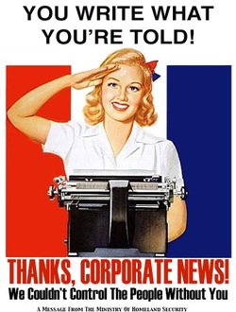
………………………………………………………………………………………………………………………

“A newspaper is a device for making the ignorant more ignorant and the crazy crazier”
Henry Louis Mencken

John Swinton (1829 - 1901) was a Scottish-American journalist, newspaper publisher, and orator.
“There is no such a thing in America as an independent press, unless it is out in country towns. You are all slaves. You know it, and I know it. There is not one of you who dares to express an honest opinion. If you expressed it, you would know beforehand that it would never appear in print. I am paid $150 for keeping honest opinions out of the paper I am connected with. Others of you are paid similar salaries for doing similar things. If I should allow honest opinions to be printed in one issue of my paper, I would be like Othello before 24 hours passed: my occupation would be gone. The man who would be so foolish as to write honest opinions would be out on the street hunting for another job. The business of a journalist is to distort the truth, to lie outright, to pervert, to vilify, to fawn at the feet of Mammon, and to sell his country and his race for his daily bread, or for what is about the same - his salary. You know this, and I know it; and what foolery to be toasting an ‘Independent Press’! We are the tools and vassals of rich men behind the scenes. We are jumping-jacks. They pull the string and we dance. Our time, our talents, our lives, our possibilities, are all the property of other men. We are intellectual prostitutes”

………………………………………………………………………………………………………………………

https://www.youtube.com/watch?v=WfGMYdalClU
Man - Steve Cutts

………………………………………………………………………………………………………………………

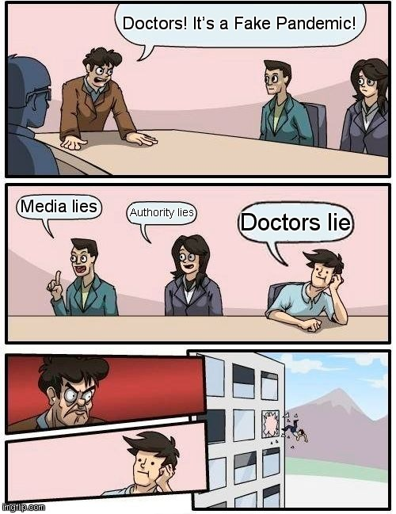

………………………………………………………………………………………………………………………

Quotes from the Government / Mass Media

………………………………………………………………………………………………………………………

“Allotments interfere with the food chain, so they will be banned”
Translation:
They want to squeeze you, pressurise you, and starve you, into submission. This is part of their CV agenda. Also, governments profit from the food, oil, drugs, vaccines, water, energy, industries, so they don’t want you producing your own food, natural plant medicines, water, and energy. From profit, and your silent obedience, comes power. Take it back! People in US have been taken to court in the past for growing food and collecting rain water in their own gardens. People in some countries are fighting over water which is controlled by the governments/corporations combined. Food, energy, water, and all resources, will be plentiful when the masses awaken, when they prefer liberty to oppression, when they start to think for themselves, and think of others first, and take compassionate action for Sacred Nature and all sentient beings.

Dictatorships do already exist on this planet; so, being soul-less psychopaths, they would obviously love to extend their power and control to the whole world. Therefore, this fake pandemic should be of no surprise to anyone.
………………………………………………………………………………………………………………………
“Scientists urge caution after NHS warning of coronavirus-related syndrome emerging in children”
“Some children have died from a new disease linked to COVID-19, says health secretary”
Translation:
Anything labelled ‘syndrome’ is often suspicious and fake! For example, ‘Shaken Baby Syndrome’ is vaccine damage. ‘Shaken Baby Syndrome’ is a term invented by big pharma to avoid being sued and losing sales.

Keep your child away from doctors and hospitals! Use natural medicines. Get plenty of beneficial sunshine, fresh air, exercise, and lots of organically grown raw plant foods like oranges, strawberries, bananas, and green foods. You can also make juices and smoothies from these. Athletes use these to create abundant health, strength, and energy. Nature knows best. https://gamechangersmovie.com/

Germs are part of life, and the immune system learns and adapts. Junk food, nutritional deficiencies, and lack of sunshine and exercise, make us prone to disease, whether its flu or cancer.

Your life is in your hands and your lifestyle choices. Spend more time in Nature.

Toxic vaccines damage the immune and nervous systems and cause and spread disease. They do not protect at all! Consuming processed sugar will immediately deplete the immune system. Swap sweets for fruit and freshly-made natural chemical-free juices and smoothies. Artificial sweeteners are highly toxic. US Pilots are banned from eating chewing gum because it contains aspartame, sucralose, saccharin, and other sweeteners, which have caused brain seizures and death mid-flight. People who eat processed sugar just before a vaccine are much more likely to be damaged. Vaccines do not protect because they contain so many poisons.

Believe government and big pharma lies at your peril!
………………………………………………………………………………………………………………………

“Ventilators are saving lives”
Translation:
Ventilators are profitable for the rich and powerful medical industry, but they are damaging and killing people, and are thereby falsifying the CV statistics. The safe and effective alternatives of vitamin C and iron lungs are being suppressed by big pharma. These treatments save lives and money.

………………………………………………………………………………………………………………………



………………………………………………………………………………………………………………………

“Sewers are being blocked due to the panic buying of toilet rolls”
Translation:
Does having more toilet rolls mean having more poos? No! Though more 5G may mean more diarrhoea. Fear mongering. Adding to the overall confusion and lies. A smoke screen for the truth.

………………………………………………………………………………………………………………………

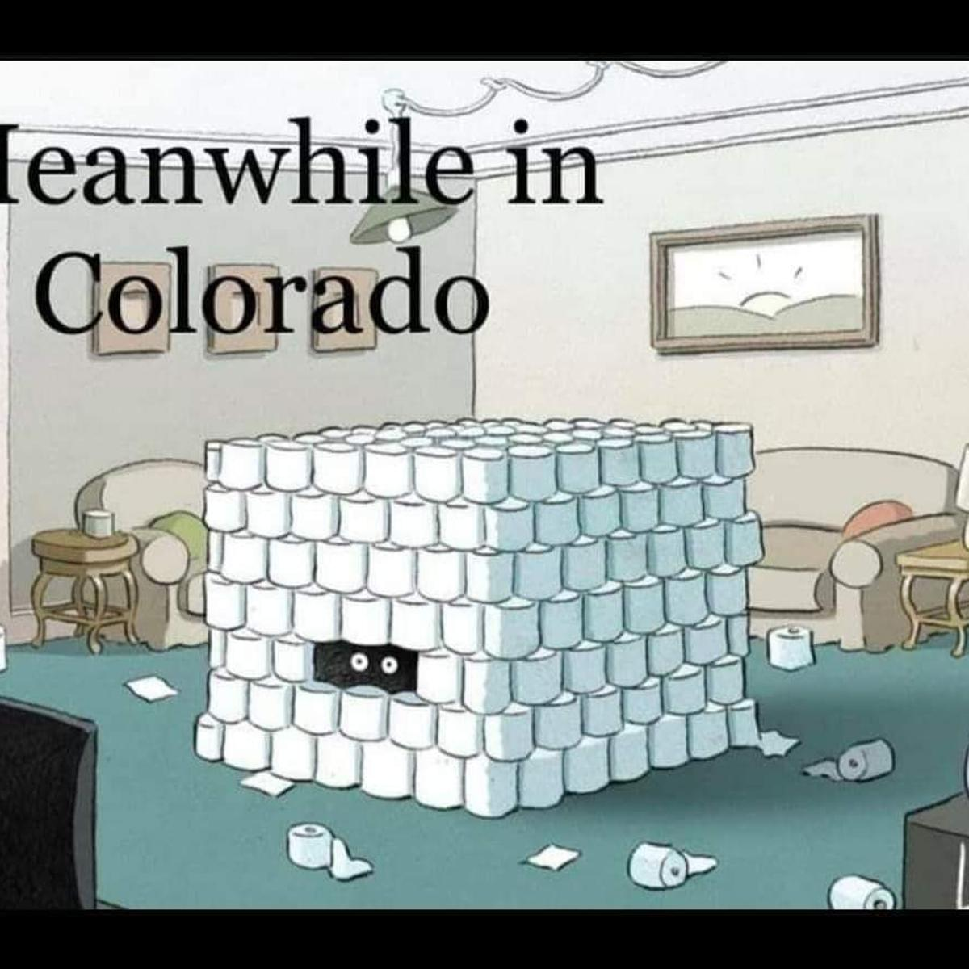

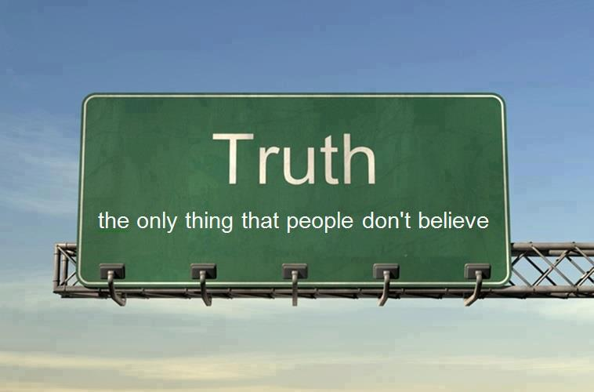

………………………………………………………………………………………………………………………

“All murder investigations have been stopped due to CV”
Translation:
Suicides and murders are being classified as CV deaths.

………………………………………………………………………………………………………………………

“Don’t listen to fake news”
Translation:
Governments desperately want to stop you from hearing the truth! Weak people will use the above line as an excuse to disregard the real facts. Obviously, it’s only the government/corporations/mass media that prints fake news.

According to sociologists and psychologists, there are two types of people:

1 - Those who question everything.

2 - Those who blindly believe in authority, and obey. When in a position of authority, they will obey those above them, while expecting obedience from those below them.

“When people have power over a human or animal, they often misuse it and abuse them”
James Green, Sociologist

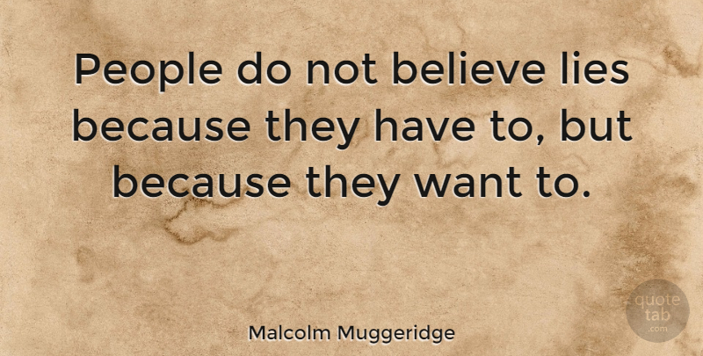

………………………………………………………………………………………………………………………

“Smoking kills the corona virus”
Translation:
Some weak people will start smoking again using the above as an excuse. Smoking depletes the immune system, so they want you to smoke more to help them to falsify the CV statistics and increase the numbers of so-called CV cases and so-called CV deaths. 5G reduces the oxygen in the air and body, which can cause flu-like symptoms, just to create the illusion of a pandemic. Smoking worsens the problem. Reduced oxygen allows microbes and cancer cells etc to flourish. One cigarette destroys a whole day’s supply of vitamin C. This vitamin is essential for detoxification, healing, and the immune system.

“With terminal cancer patients, “CV” is written on their death certificates, blatantly falsifying data”.

“Suicides and murders are being classified as CV deaths”.

The media said that all murder investigations have been stopped “due to CV”. Now we know why.

People dying from heart disease, old age, and any other disease, are now being recorded as CV deaths.

Falsified CV deaths are up, so ‘deaths’ from cancer and other diseases are down.

All this is fear-mongering to confuse and control the masses while they bring in new legislation that will take away our rights and freedoms and increase the level of dictatorship globally, in every country which does not awaken to the shocking truth of the fake pandemic and take action.

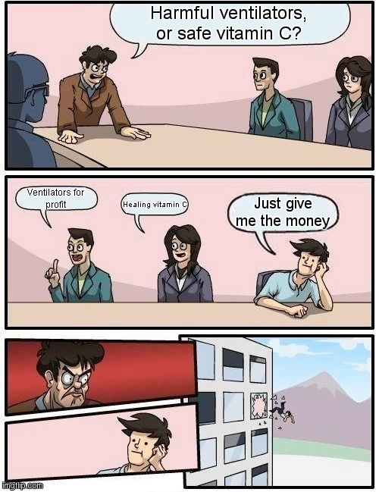

………………………………………………………………………………………………………………………

“Alcohol eliminates viruses”
Translation:
Pure alcohol is pure poison. Diluted alcohol, as sold in shops, is diluted poison, which destroys brain cells, damages the liver, and depletes the immune system, thereby increasing the numbers of so-called CV cases and so-called CV deaths. Your choice. Through gullibility and fear, people are suddenly paranoid about germs, illness, and dying, yet the real, but avoidable, problems of pollution which is causing 300 species to go extinct daily, carcinogenic nuclear pollution, carcinogenic meat and junk food, poisonous ineffective vaccines, excessive alcohol, tobacco and illegal drugs (being your choice), and spit and dog poo on pavements and dirty public toilets (not your choice), never bothered anyone in the past.

Regardless of your lifestyle choice, and your desire, or lack of desire, for health, quality of life, and longevity, the difference between all the above and the engineered pandemic, is that we lose our rights and freedoms when we believe the corona virus lies. What is the point of living a lie, and suffering for it?! Let’s drink to Bravery, Truth, and Compassion and Freedom for all lifestreams.

“Since when did governments tell the truth, or care about you, your health, or the Planet?!”
John White PhD

“The health of humans and the Planet are linked”
Dr. Adam Harvey MD

………………………………………………………………………………………………………………………

“Vaccines are the saviour of mankind”
Translation:
Vaccines are unsafe and ineffective. Every ingredient is highly toxic. The whole vaccine theory is flawed, and we have been lied to for over 200 years just for big pharma’s profit. Vaccines are useful for dumbing down, depopulation, and creating pandemics (see the 1918 Spanish flu article). Vaccines make huge profits for governments and for the second richest industry in the world, the drugs industry. Vaccines + micro-chips + chemtrails + 5G = Welcome to their New World Order dictatorship. Free-reign party time for big pharma, military, electronics cartels, information-gathering mass surveillance media machines, energy companies, frackers, forest destroyers, polluters.

Highly recommended:-

http://www.whale.to/vaccine/rattigan2.html
Excellent free online booklet - “Vaccination - Assault on the Species”

http://www.vacinfo.org/uploads/7/9/8/5/79856028/dispelling_vaccination_myths.pdf
Excellent free online booklet - “Dispelling Vaccine Myths

https://www.youtube.com/watch?v=f6Zqpf0FELM
Ex-ET

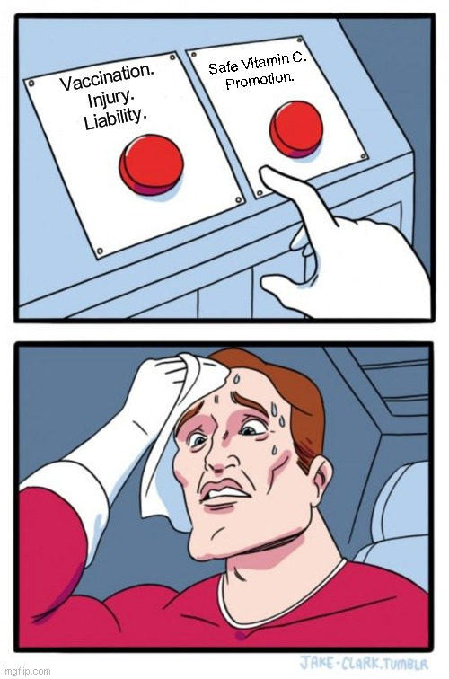

………………………………………………………………………………………………………………………

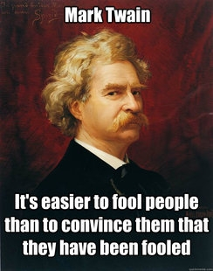

………………………………………………………………………………………………………………………

“Pollution from nuclear power plants and nuclear bombs does not cause cancer”
Translation:
The public and university students are told this, and students believe it. Pollution from nuclear power plants and nuclear bombs does cause cancer. Blocked by greed and ego, and devoid of common sense, feelings, spirituality, and morality, universities vivisect animals in horrific experiments. Vivisection gives dangerously misleading results, thereby harming humans, and delaying medical progress. The results of barbaric, cruel, painful, animal tests are routinely falsified just to suit profits. The more we test on animals, the less we know about human health. We now have 20,000 new diseases, and rising. Safe, effective, natural, treatments for diseases are suppressed by universities, big pharma, and all medical research ‘charities’ which all fund or conduct vivisection for profit. Universities are big businesses, with financial links to the rich, corrupt, polluting, destructive, fracking, nuclear, and oil industries, big pharma, and the military, etc. All wars are engineered, for land, profit, and power.

………………………………………………………………………………………………………………………

“Mercury and fluoride are good for you”
Translation:
The public and university students are told this, and students believe it. Mercury and fluoride are highly toxic, but are good for industry profit and for dumbing down the masses. Fluoride is rat poison and is harmful to the brain and body. It does not benefit teeth and bones, but makes them brittle. Fluoride also damages the pineal gland in the brain. It is illegal to put mercury into the environment. But it’s OK to inject large quantities into babies?
………………………………………………………………………………………………………………………

“Lock down will last for four more weeks”
Translation:
Lock down/dictatorship will be forever. Or until the masses awaken. Look how long they strung out Brexit, for example, through daily creative lying, after the public voted.

………………………………………………………………………………………………………………………
“You must maintain social distancing and stay at home”
Translation:
A ban on all protests, including XR. No more rights and freedoms! They don’t want you communicating and realising that the pandemic is fake, protesting, and losing faith in the government. The illusion of a ‘sane government’ will be broken, and their power will be gone forever.
………………………………………………………………………………………………………………………
“Germs will kill you”
Translation:
Germs will not kill you; ignorance will. We are all filled with and surrounded by trillions of microbes, and have been for millions of years. The body and immune system, controlled by the subconscious, always learns, adapts and survives. Childhood diseases are mild when treated naturally and they are necessary to improve and update the immune system and to also clear out old diseases in the family. Poverty, lack of hygiene, junk food, pollution, and especially vaccines because they are so toxic and are injected directly into the bloodstream thereby bypassing the body’s protective mechanisms, are the main factors in all diseases, but governments and big pharma suppress this knowledge. Vaccines contain highly toxic mercury; formaldehyde (embalming fluid); aluminium (causes Alzheimer); latex; lead; cadmium; paraffin; pesticides; human and animal diseased blood and excrement, aspartame (a sweetener which has caused brain seizures and death) and they also contain dead, attenuated, and LIVE genetically engineered microbes, and many other poisons. Vaccines cause and spread disease. With chemical drugs on top, the toxins in the body increase faster than it can eliminate them, leading to everything from a cold to cancer. Toxins destroy nutrients. Toxins and nutrient deficiency causes diseases. Vaccines damage the nervous and immune systems, which is no surprise considering their toxicity. Global governments want to force vaccines onto everyone on the planet! Throw away your face mask, gloves, fear, and paranoia, and open your eyes to the global political manipulation that is happening right under your nose.

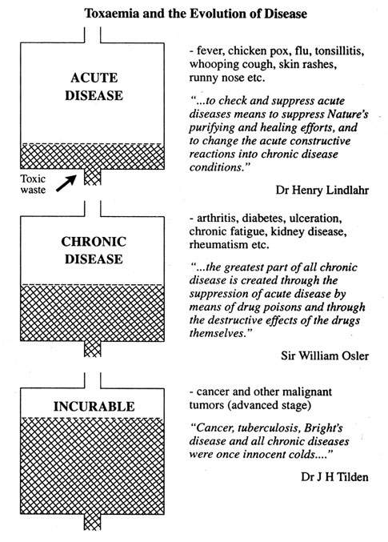

………………………………………………………………………………………………………………………

“Clap for the NHS workers”
Translation:
The hospitals are empty because it’s a fake pandemic so there are no heroes working day and night, risking their lives, and mopping the sweat from the fevered brows of the ‘millions’ of sick and dying. Egotistic nonsense! So what are they clapping for? This engineered egotism blocks people’s perception of reality. Like wearing a face mask and gloves, it’s another Psy Op (military psychological operation) trick, just to make you convince yourself that there is a real emergency - when there isn’t. Instead, how about clapping for Greta Thunberg who, at only 15 years old, protested alone in the street, and for XR, and for people who choose veganism in order to protect the Planet, stop mass extinction, prevent mass human suffering and starvation, and help animals who have suffered for millennia at the hands of unthinking unfeeling man.

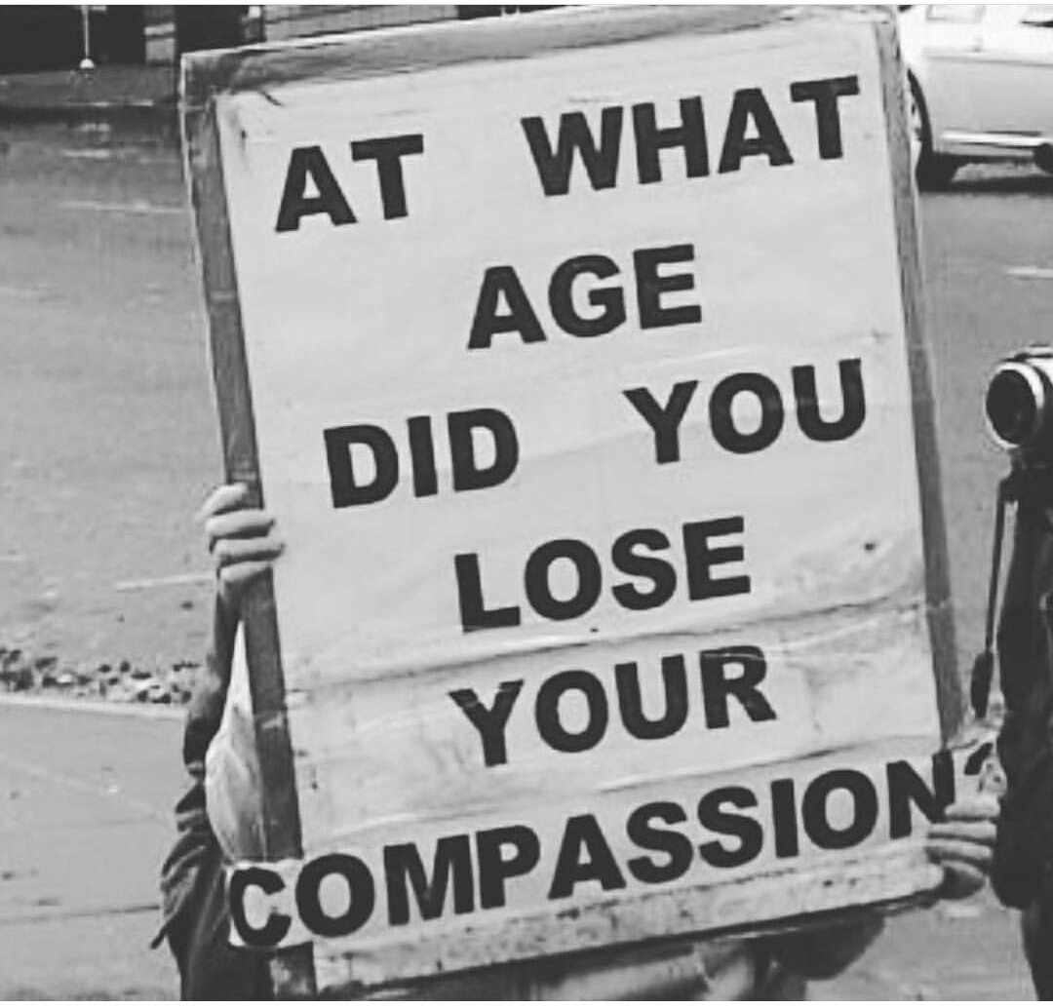

………………………………………………………………………………………………………………………

“5G (Fifth Generation) radiation is harmless. The conspiracy theory is nonsense”
Translation:
“It’s harmless” means it’s harmful. “The conspiracy theory is nonsense” means just the opposite. Yes, governments do conspire against their ‘enemy’, the public. https://www.5gspaceappeal.org/the-appeal

Hundreds of researchers have given us well-documented evidence of the harmful effects of the radiation emanating from smart meters, mobile phone masts, routers, 5G lamp posts, etc, and they have warned the public and governments for many years. Some schools have banned sources of radiation.

There are safer frequencies we can use, and there are safe alternative systems using fibre optics etc, which are also cheaper and more efficient. There was never any logical reason to change from 3G to 4G to 5G. We are constantly lied to. Some UK cities and countries have banned 5G on health grounds.

Systems which monitor our every move and thought and constantly assess our psychological profile, are now in place ready to bring about global dictatorship. These systems also emit harmful radiation to intentionally damage our mental, emotional, and physical health, in order to weaken us to make the manipulation of the masses easier. https://www.fiercewireless.com/5g/brussels-halts-5g-plans-over-radiation-rules

“The more complete the despotism, the more smoothly all things move on the surface”
Elizabeth Cady Stanton

“Democracy passes into despotism”
Plato

“Timid men prefer the calm of despotism to the tempestuous sea of liberty”
Thomas Jefferson

………………………………………………………………………………………………………………………

“Will the CV mean an end to cash?”
Translation:
Governments have wanted to create a cashless society for many years. Now they are using this fake pandemic, yet again, to fulfil their agenda in order to control and monitor the masses.
https://www.youtube.com/watch?v=bfcQRlt22aI - A Cashless Society
………………………………………………………………………………………………………………………
“German medical lawyer Beate Bahner has been committed to a psychiatric institution and severely abused for publicly disagreeing with lockdown”
Translation:
Now we see why the clauses altering detention under the Mental Health Act were added to the UK Coronavirus Act. Failure to obey is now considered a sign of insanity. https://twitter.com/FreeWales/status/1250130572539834374

………………………………………………………………………………………………………………………

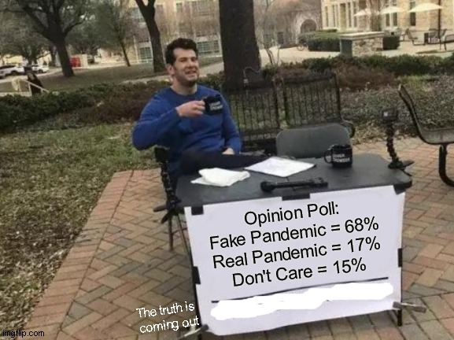

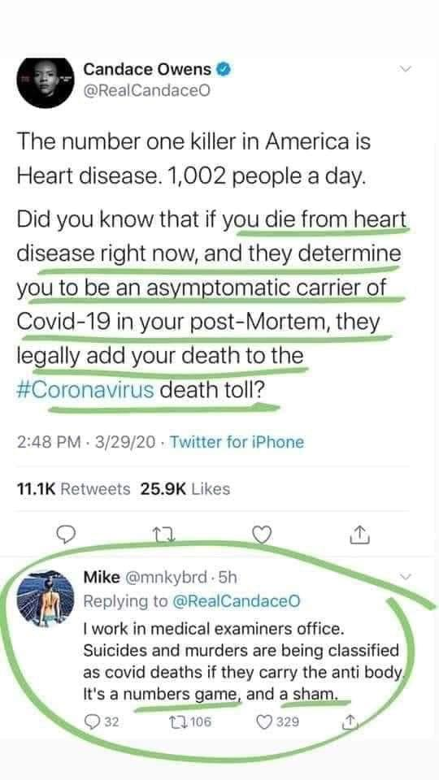

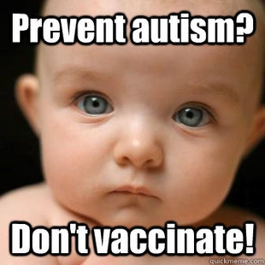

https://www.imdb.com/title/tt1442008/ - Autism: Made in the USA - Film

Our mistake is to delude ourselves into thinking that dictatorships only exist in distant places, or in the distant past, or in movies, and that such evil people cannot exist, when they clearly do.

It’s our Home, our life, our body, our health, our rights, and our freedoms, which are at stake.

Awaken the heart and mind, change, and take action like never before, or cause mass suffering and destruction.

We can have a beautiful planet once more, or hellish conditions. Educate, Communicate, Meditate and ask for inspiration, guidance, and help.

Choose.

Time is so very short!

“We are terrible at listening to warnings about disasters - whether it’s about mass extinction, toxic vaccines, political manipulation, our health, nuclear pollution, or earthquakes and pollution caused by fracking”
Dr. Mike West MD

https://www.youtube.com/watch?v=qJr8jiriqs4&feature=emb_logo
Beyonce - Rise Up - ‘Epic’ movie

https://www.ddees.com/
Amazing Art

………………………………………………………………………………………………………………………
Please share with all your contacts, asking them to do the same
………………………………………………………………………………………………………………………

