VACCINATION LIES

Poisons for profit
Lies for cash
Truth rejected
Karma’s whiplash



Parents feel guilt
So much shame
Poison their child
Our loss
Their gain

Mercury’s healthy
Poison is sweet
Formaldehyde
Nutrients deplete

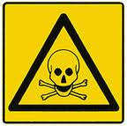

Toxins
Deficiencies
Cause disease
We speak the truth
They do as they please

Truth is lies
Lies are truth
Open your heart
Don’t demand proof

200 years
Of lies and gain
Poison is evil
It is so plain

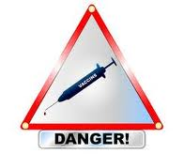

Vaccine truth
Vaccine lies
Vaccines don’t work
What a surprise!

Your comfort zone
Of self-denial
Harms your baby!
Your Soul’s on trial!

Ego and guilt
Ignorance and greed
They poison us
Their banks we feed



Earth’s not flat
Vaccines don’t work
The magic bullet
To kill and hurt

They like money
Killing is funny

Lay down and die!
Don’t ask why!

Be different
Be wise
Question!
Their lies

No fear
No guilt
Truth is
Inbuilt

A normal child
Gets his jab
Becomes autistic
“My mom is mad!”

Robots rebel
Rejecting the hell
Just keep fit
Just keep well



We have a choice
We have the right
Protect your child
Stand up, and fight



Billionaires
Sell their wares
Enforced “medication”
Boosts their shares

My child is dead!
I was misled

Following rules
Is just
For fools

Shaken baby?
Murder trial!
Profits reign
Total denial!



Imprisoned and innocent?
What’s their crime?
Obeyed doctor’s orders
Every time



A parent is love
A parent is brave
To rich industry
We won’t be slave

Dumbing you down
Depopulate
Reject the vaccine
Change your fate

Protect the child
Open your mind
Awaken hearts
Don’t be blind



Conform with evil?
Reject the jab!
Tested in
An evil lab



Tested on humans
Ensures it “works”
Damage and profits
We’re the berks!

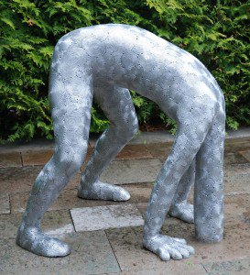

“There’s none so blind
As they who will not see”
Later you will
I guarantee! …

… A little too late
Created your fate
Swallowed their bait
Check mate!

Detox your child
Detox your guilt
Live in the now
Health CAN be rebuilt



Just say “NO!”
Don’t give in!
Study hard!
Reverse the sin!

Good health is the only immunity!

WORLD ANTI-VACCINATION DAY!



11/11



We are all
ONE

See below

Please support
WORLD ANTI-VACCINATION DAY
WAVD is November 11 annually

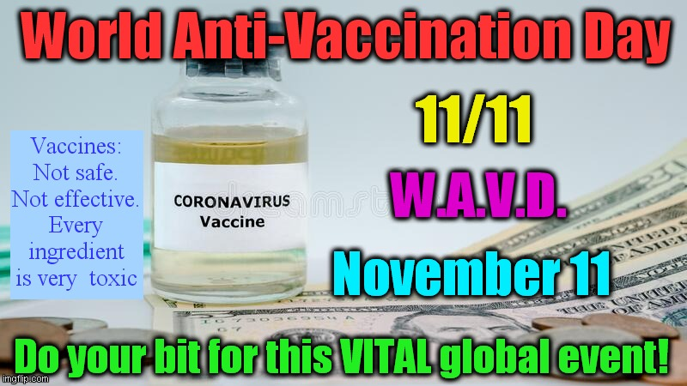

Please share this poem with all your contacts, asking them to do the same

NOTES

Be different
Be wise
Question!
Their lies

No fear
No guilt
Truth is
Inbuilt

Truth is lies
Lies are truth
Open your heart
Don’t demand proof

Do not demand proof from genuine researchers who care and who do not profit from vaccines, if you accept the lies of the rich drugs industry and corrupt authority, without question.

All vaccines are unsafe and ineffective.

Animals are tortured in vivisection laboratories, and we don’t bat an eyelid because we don’t witness and feel their excruciating pain, and we selfishly think that we will gain, when we know it is morally wrong to cause suffering to any Created sentient being. Animals have feelings, and they continuously give us so much love, and they feel pain just like us, so if you would not like to be tortured for profit yourself, why allow others to inflict such horrendous pain on other sentient beings?

We also know that animals are physically different to us, i.e., there are species-differences, and that therefore, vivisection gives grossly misleading results which actually harm humans. The more we test on animals, the less we know about human health. Animal test results are routinely falsified, just for profit. Vivisection is the worst form of selfishness. Would YOU like to be vivisected? Vivisection is as barbaric as it is unscientific. It harms both humans and animals. There are 20,000 new diseases, and rising.

The mega-rich drugs/vivisection/vaccination industry also suppresses the safe and effective natural disease prevention methods and natural cures for diseases because they don’t like any competition for their profits. Profit always comes before animals and humans.

“Of all the black crimes that humanity is committing against the great Creation, vivisection is the blackest”
Gandhi

“Many great Masters have spoken out against cruelty to animals, and today, many millions of people follow in their footsteps and are giving up meat, fur, vivisection, and all cruelty. This is a huge step forward in our spiritual evolution”

“Until he extends his circle of compassion to include all living things, man himself will not find peace”
Albert Schweitzer - Theologian, Organist, Writer, Humanitarian, Philosopher, Physician

“The greatness of a nation and its moral progress can be judged by the way its animals are treated”
Mahatma Gandhi - 1869 - 1948 - Spiritual Leader, lawyer, a political ethicist using non-violent resistance to achieve India’s independence from British Rule, inspiring civil rights & freedoms movements globally, vegetarian

Vaccines: People usually automatically and blindly accept whatever governments, doctors, and big pharma say, without question, when they have ulterior motives like profit, dumbing down, and depopulation, yet when genuine researchers speak the accurate truth, they are questioned and disbelieved.

Truth is within. Open your heart and mind. Be humble.

In the end, it is mainly yourself that you have to question. Use your own judgement and logic, be unbiased, be willing to unlearn, seek the truth, and discriminate so that you know the difference between truth and lies, fact and fiction, good and bad people, and correct motive and incorrect motive of self and others.

How determined are you to find the truth? Question yourself really deeply on this.

If you really want the truth and the facts, you will have to do much reading; not of ‘official’ orthodox literature which is incorrect, profit-motivated, and purposely misleading, but of information from genuine researchers who do NOT profit from vaccines and the drugs industry.

Are you brave enough to seek and accept the truth?

Can you open your heart and mind to the truth and act upon the facts?

For your own sake? For others? For animals? For children?

Highly recommended booklets:-

http://www.whale.to/vaccine/rattigan2.html
Excellent free online booklet - “Vaccination - Assault on the Species”

http://www.vacinfo.org/uploads/7/9/8/5/79856028/dispelling_vaccination_myths.pdf
Excellent free online booklet - “Dispelling Vaccine Myths

