

SCIENTISTS

‘Scientists’ believe
The Earth is flat
Their gigantic brain
Lies under their hat

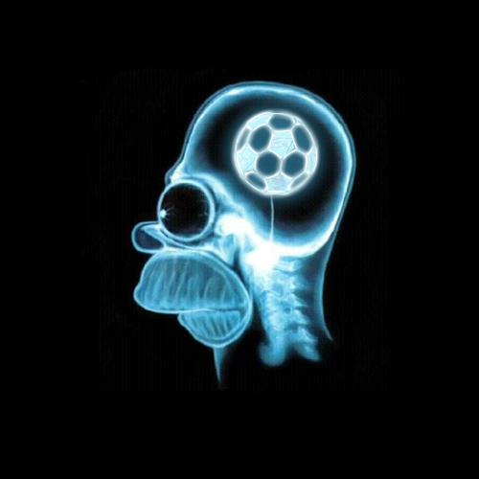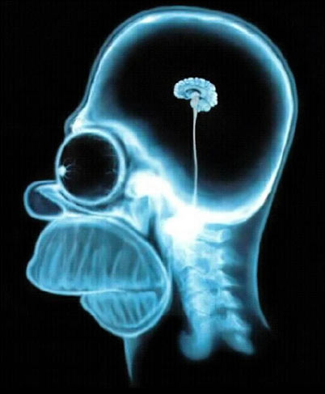
Football fanatic Typical materialistic scientist

Round-earth theory?
There is no proof!
Full of ego
And so aloof

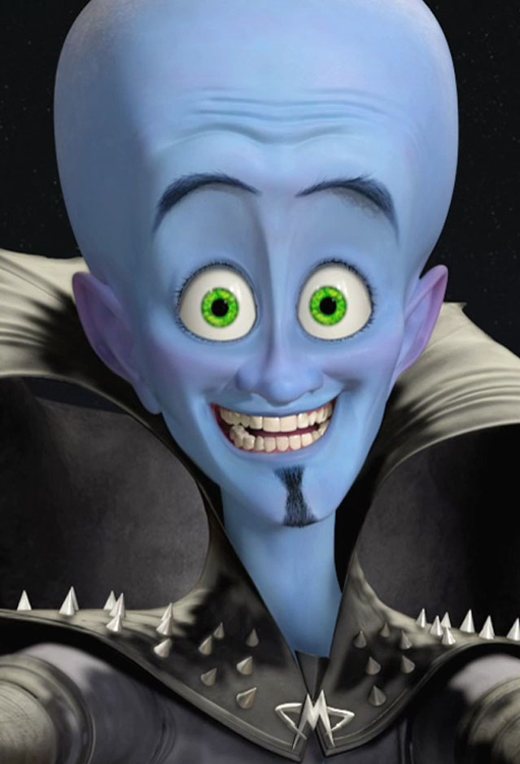
Scientists’ delusional perception of self

‘Scientists’ invent
The nuclear bomb
Demonstrate intelligence
Then we’re all gone…

Atlantis, Lemuria,
Maldek too
All destroyed
Because of you…



Believing in ‘scientists’
Instead of God;
Denying the Self
Is stupid and odd

https://www.youtube.com/watch?v=WfGMYdalClU – Man – Steve Cutts

‘Scientists’ torture animals
In vivisection lab
And they, still think
That they, are fab

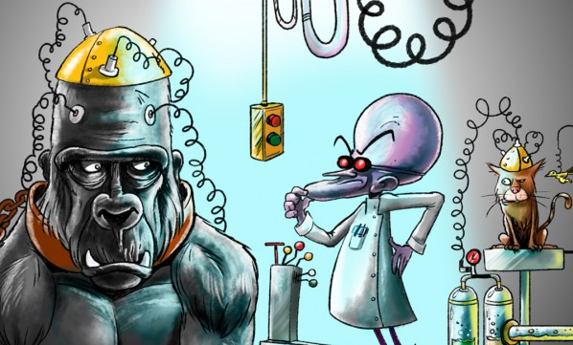

Heart and mind dead
Their hands are red
Still believe the nonsense?
That we’re all fed?



They lie
And they falsify
‘Scientific’ results
“We have the proof
So no more insults!”

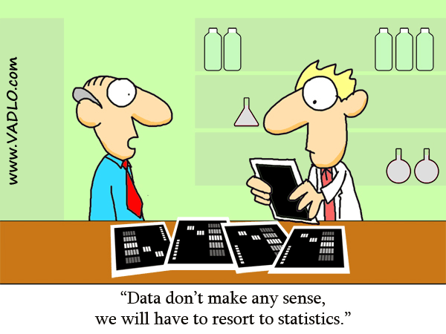

We’re caring and brainy
With high IQ
Would we ever
Lie to you?!

“I am a scientist!”
And
“I demand proof!”
Favourite phrases
But still shun Truth

Don’t need their approval
Just their removal

To say Cancer’s curable
Is a sin
Because Cancer ‘charities’
Bring billions in

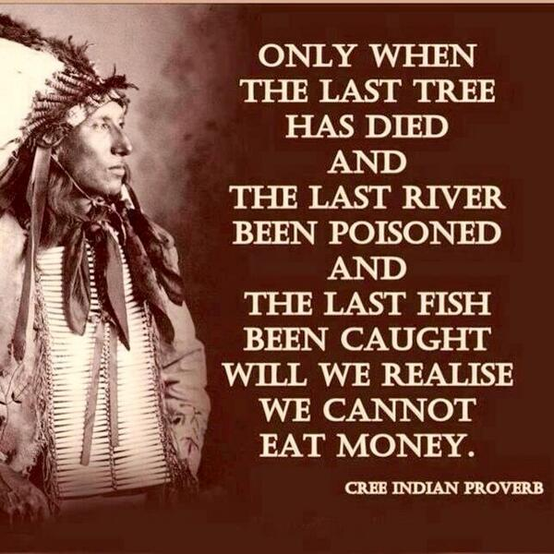

Chemtrails are killing
All the trees
We’ll still deny it
When we’re on our knees



With one tree left
We’ll protect our clan
Ego will be
The death of man

https://www.youtube.com/watch?v=IWm03wYBTbM - Five Years - David Bowie


This is NOT autumn, but spring! There are over 100 million dead trees in this forest in California in US due to chemtrails, and it is rapidly worsening. (It is not due to drought, fungi, beetles, etc. These factors and chemtrails will obviously exacerbate the effects of each other, confusing the picture). Tests on trees, water, air and soil show that chemtrails are the cause of mass tree deaths. This is an urgent global problem! It’s too serious for denial! Stop chemtrails NOW!
https://www.youtube.com/watch?v=aQ53_yJ7tKw - Mamas & Papas - California Dreamin'

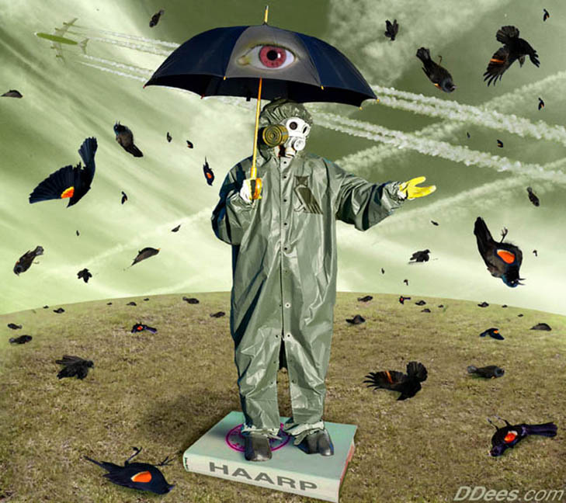
“When the trees or bees die, we die” – Time is short!
https://www.youtube.com/watch?v=fIMy5Q0BXEE
Amazing UFO Destroys Chemtrail, Alien Technology? UFOs protecting Earth?


https://www.youtube.com/watch?v=PlMi0nq3fCs - David Bowie - Starman

Millions of sightings
Of UFOs
“But there’s no proof!”
Their story goes

https://www.youtube.com/watch?v=teBV0EoJJY8
Carpenters - Calling Occupants of Interplanetary Craft


Believe in us!
We’re the latest religion!
Close your mind
Stop your derision!

Water powered cars
Can’t possibly work!
There is no proof
If I’ve no perk

https://www.youtube.com/watch?v=RqLpqR0SPnQ
QUANT e-Sportlimousine with nanoFLOWCELL® drive



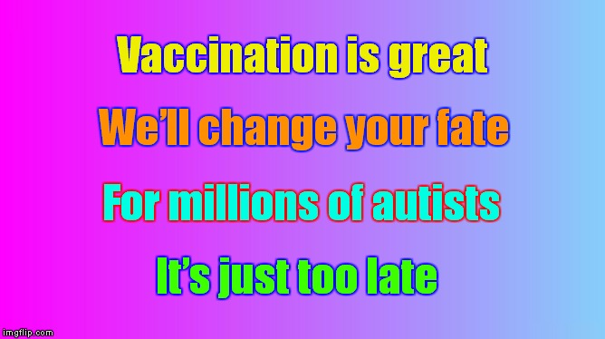

‘Scientific’ poisons
Are good for you
It’s good for my wage
And ego too

Millions of injuries
And deaths by the score
There’s your proof
You don’t need more

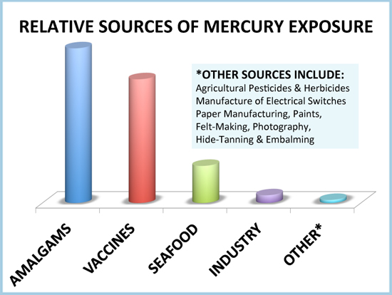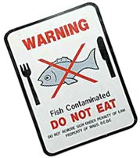



Fluoride and mercury
Are poisons we’re told
Illegal to dump it
Unless you are cold…

Enough to inject it
Into babes
To ideas and governments
We are all slaves

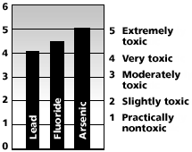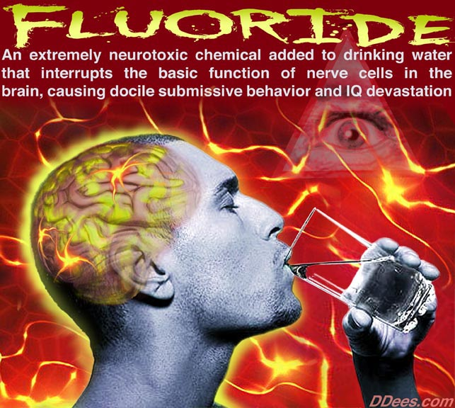

http://articles.mercola.com/sites/articles/archive/2010/11/13/cdc-and-ada-now-advise-to-avoid-using-fluoride.aspx

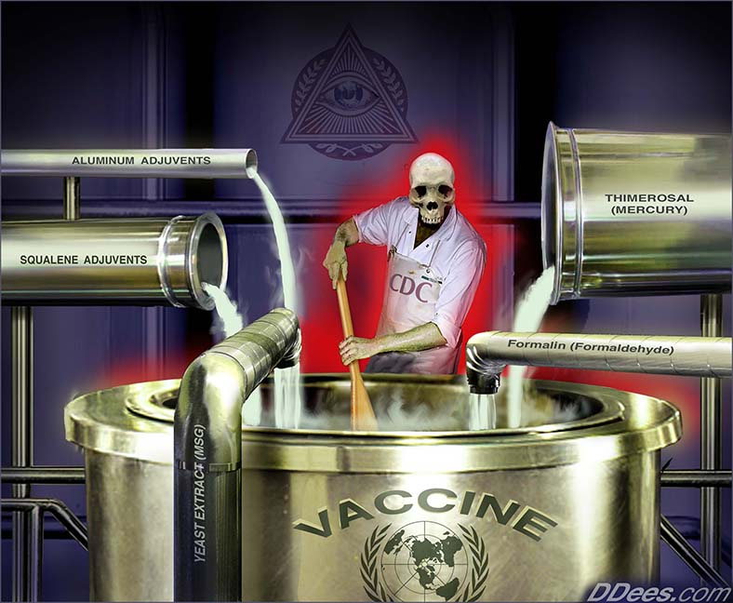

If you’re against fracking,
Vivisection and meat
You’re labelled a ‘terrorist’
As lies you defeat



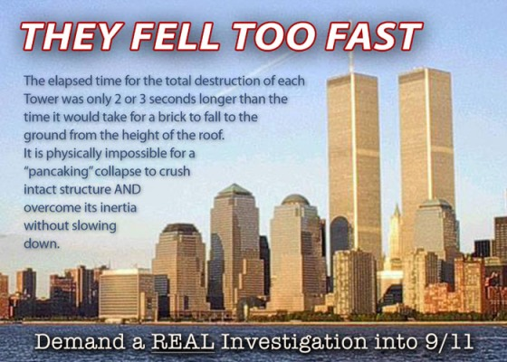

With 9/11 truth
They always
Want proof

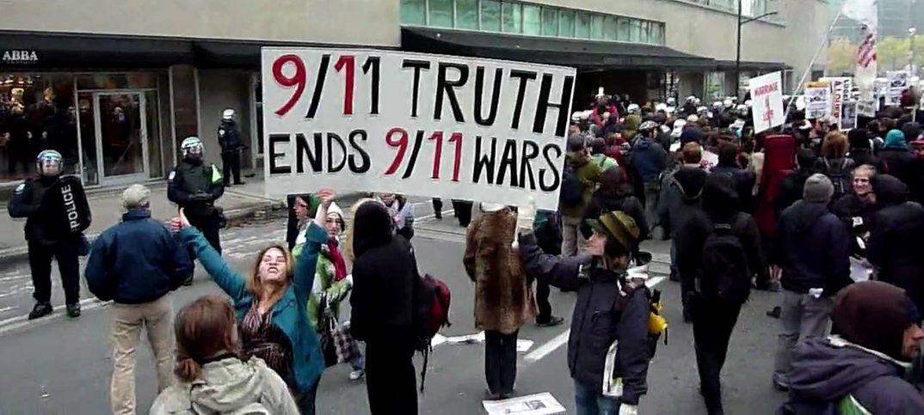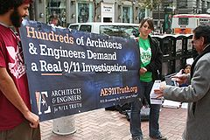

They say that they do
Though it’s too hard to face
The truth with lies
They always replace

Why fool me?
I can do that myself
I love my delusion
Leave truth on the shelf

https://www.youtube.com/watch?v=P5Ps6MxMXDg
Talking Heads - Mind lyrics

For oil
They will kill
It gives them
A thrill

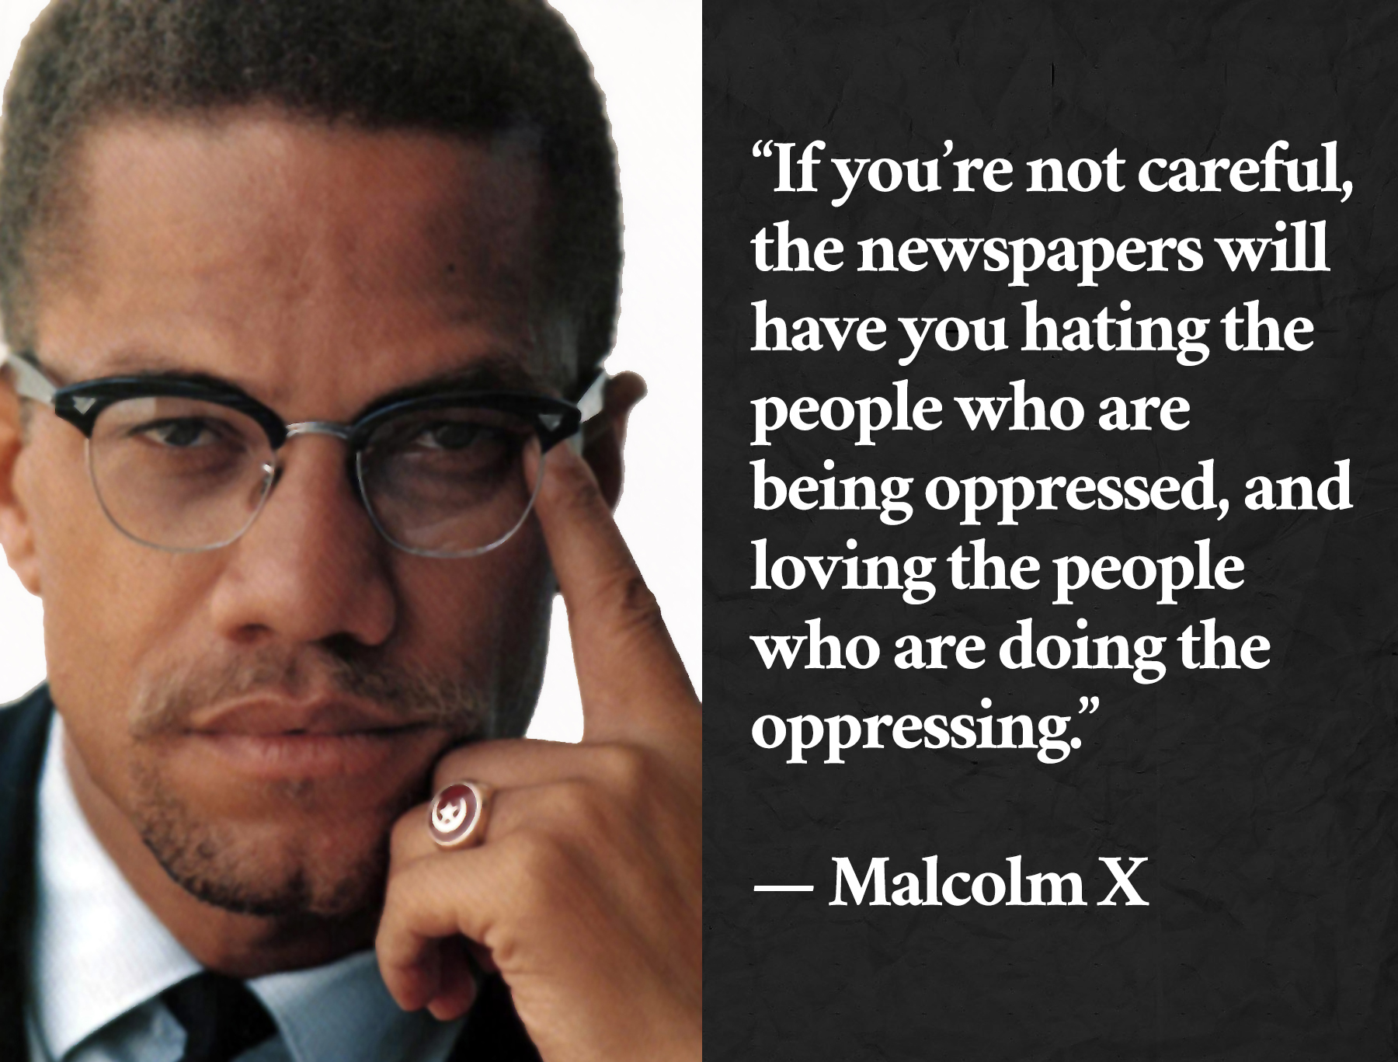

Engineered wars
The end will come
Famine and earthquake
Lies are spun…

Sign of a New Age
Yet to be
We can build it
Create harmony
(Matthew - chapter 24, verses 6, 7, 8)

It’s thé 11th hour!
Take back your power!

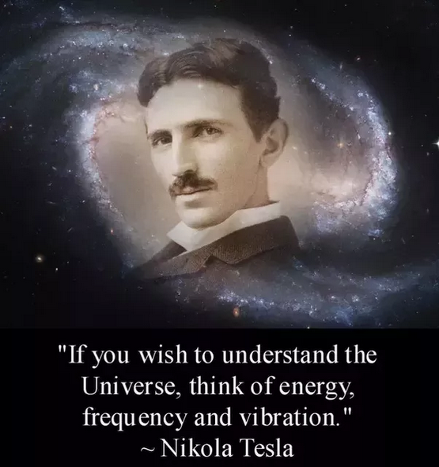

Homoeopathy cannot work!
Its sugar!
You berk!

Energy doesn’t heal
Energy’s not real

It was on the radio
That’s how we know

Transceiver
Deceiver

Closed hearts and minds
Can’t invent or conceive
The radio or God
Believe and receive

Tesla was veggie
Believed in Love
And other energies
From Above

Invented radio
AC, and more
Water-powered cars
Inventions galore

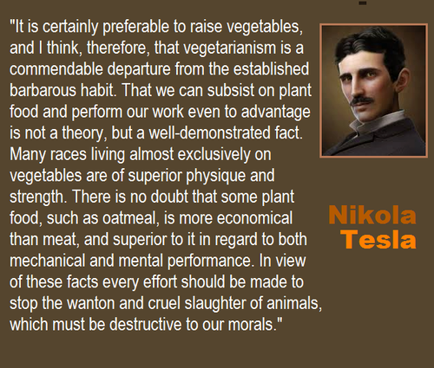

The closed heart and mind
Is no use to man
The ‘scientist’ will die
Along with his clan

The Spirit will live
In thé New Age
When thinking of others
Not fame and wage!

22/4/17 (Earth Day)

P.S.
Homoeopathy is safe and effective.
Water powered cars were first invented in 1806, and later reinvented by Nikola Tesla and others.



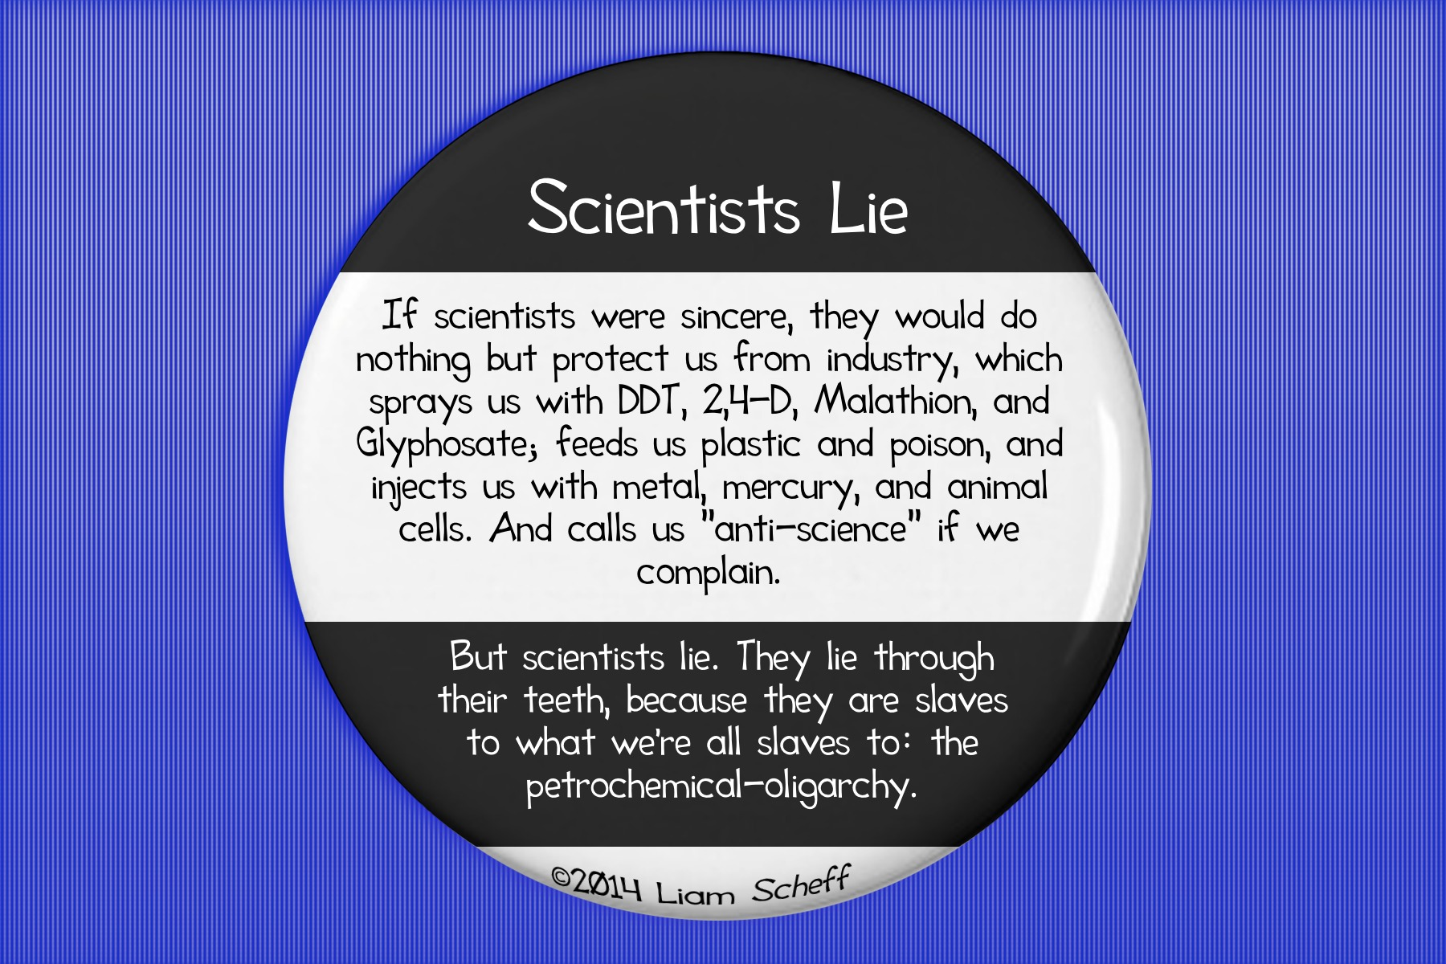

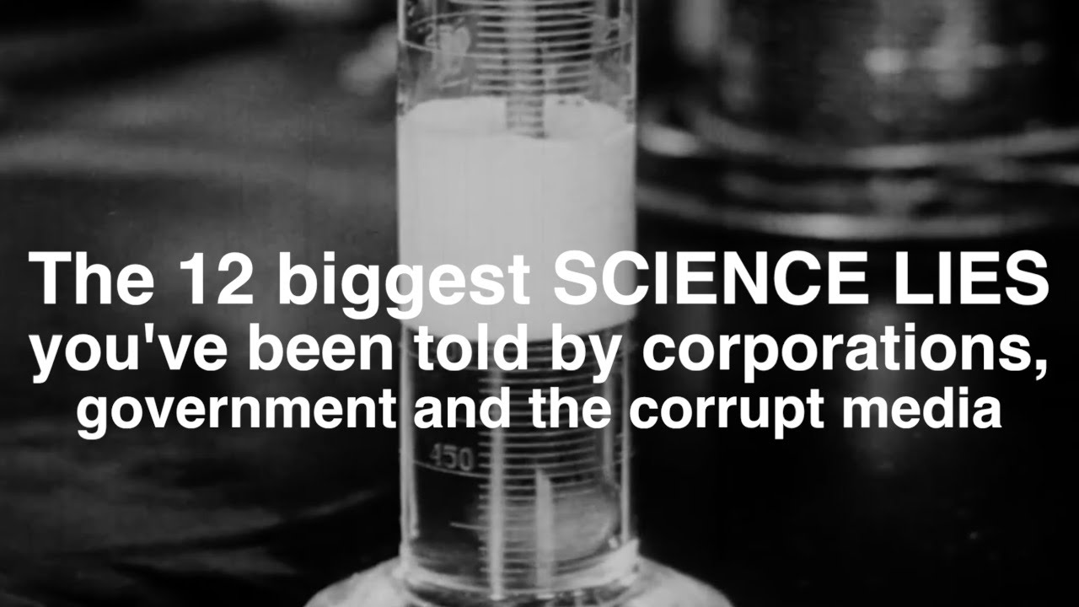
https://www.youtube.com/watch?v=vGyuyJyaxG4

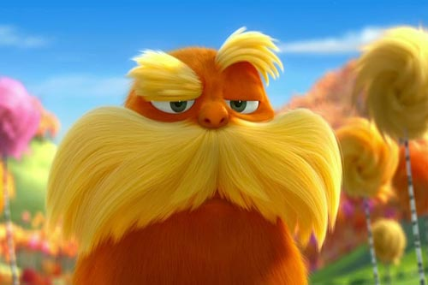
“I am the Lorax, I speak for the trees”
https://www.youtube.com/watch?v=3nNgHSJNbEE - Dr Seuss - The Lorax - Did you chop down this tree?
The Lorax - when all the trees are gone - Dr Seuss

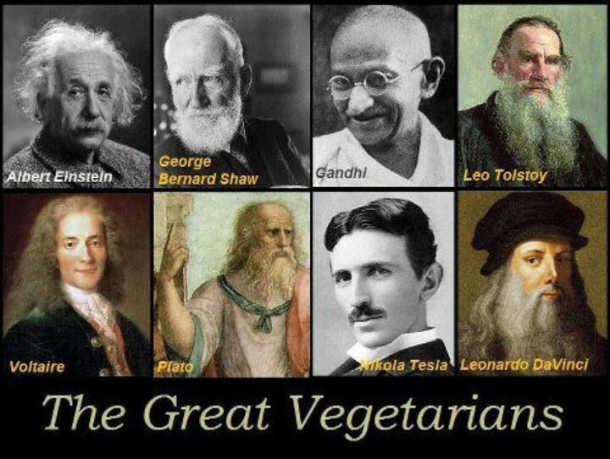
Albert Einstein – George Bernard Shaw – Gandhi – Leo Tolstoy – Voltaire – Plato – Nikola Tesla – Leonardo Da Vinci

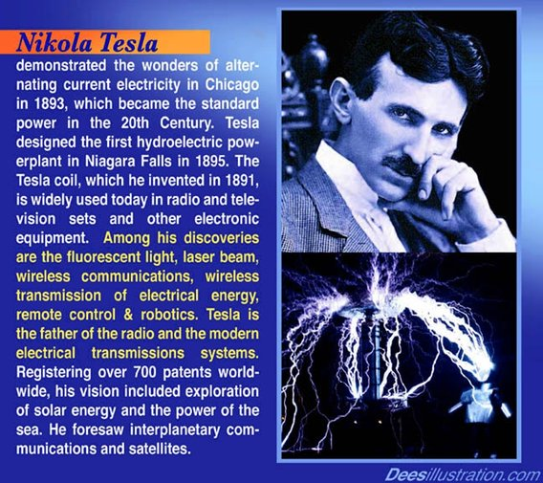

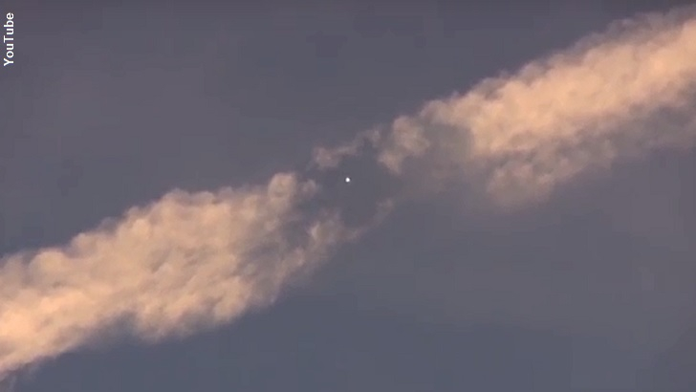
UFO Clearing Chemtrails
https://www.youtube.com/watch?v=fIMy5Q0BXEE

https://www.youtube.com/watch?v=WfGMYdalClU - Man - 3min 36sec

https://www.youtube.com/watch?v=R5d7sCRgIyc - Toxic Rain Is Killing Our Forest – 14min 43sec

https://www.youtube.com/watch?v=QBYmu7t-KTQ - Trees Are Dying Everywhere – 21min 54sec

https://www.youtube.com/watch?v=BaLCOQhRaFY
Chemtrails Exposed By Pilots, Doctors, & Scientists. Soil & Water Tested High In Aluminium & Barium - 15min 13sec

https://www.youtube.com/watch?v=dyjrzgHsASo
Chemtrails / Morgellon’s Kills!!!!!!! Must See!!!!!!! 100% TV Media Proof - 10min 40sec

https://www.youtube.com/watch?v=jHm0XhtDyZA
Geoengineering Whistleblower ~ Ex-Military ~ Kristen Meghan, Hauppauge, NY, January 18th, 2014 – 21min 36sec

https://www.youtube.com/watch?v=j0giCKz9ZsE - A Moment of silence for the sick dying trees - 12min
…………………………………………………………………………………………………………………..

From the book “2012 and Beyond” by Diana Cooper
Trees

Trees offer so much to our planet and we need to value and appreciate them for their wisdom as well as for the use they have to us.

They are ancient wise beings who keep records of local history and form a network around the planet.

Each species of tree has a different quality that it offers to the world. For example, if you wanted qualities of strength and sturdiness, you might intuitively lean against an oak tree. Remember that you can call upon ethereal angels and elementals for help but you can also tune into trees for the assistance that you need and you will receive it in a very grounded way.

Large forests are keepers of ancient wisdom. They anchor it and help to hold the energy of the country in which they grow. They even bring in the light from other planetary systems and store it until we are ready for it.

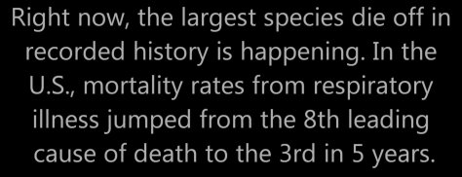
Chemtrails

Know that the weapons of evil are fear and confusion caused by lies.
All lies are a deviation from the Truth, are a deviation from Reality,
therefore are evil things.

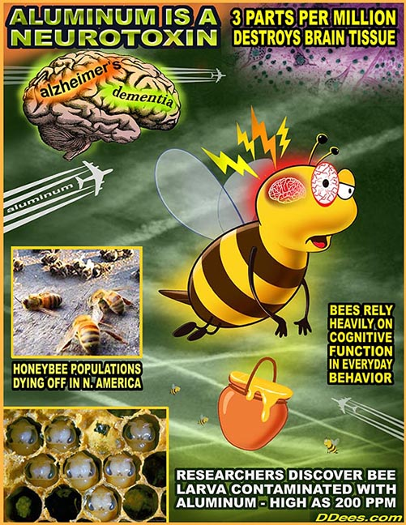
Chemtrails – Nano, Aluminium, etc
“When the trees or bees die, we die” – Time is short!

The health of man and the Planet are linked



https://www.youtube.com/watch?v=xGNvDVKOxCk
Avatar - Destruction of ‘Home Tree’
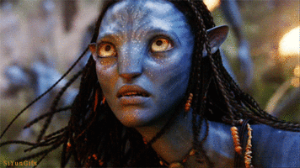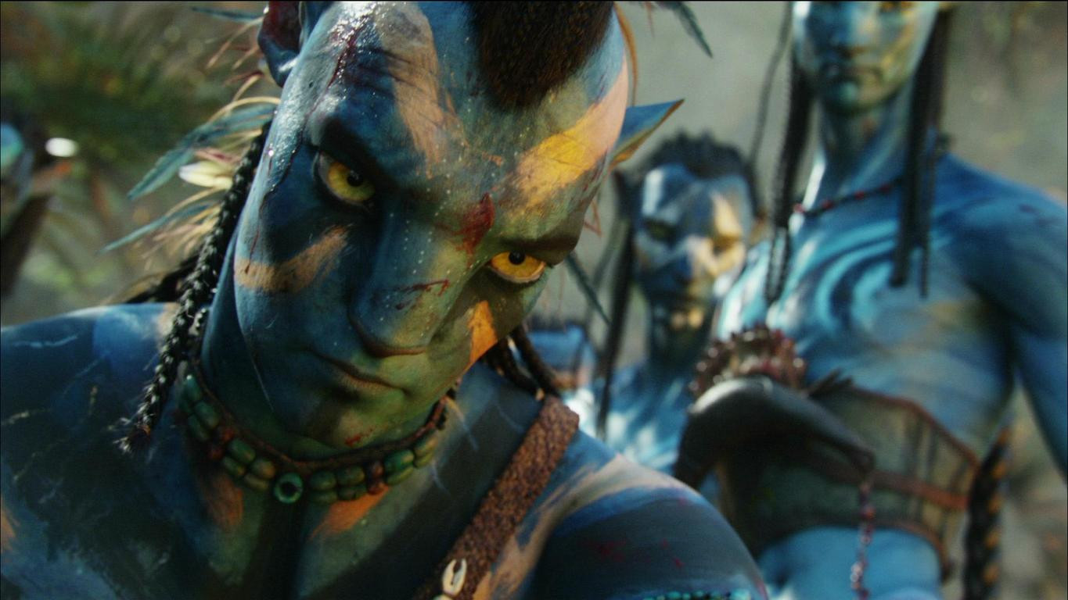

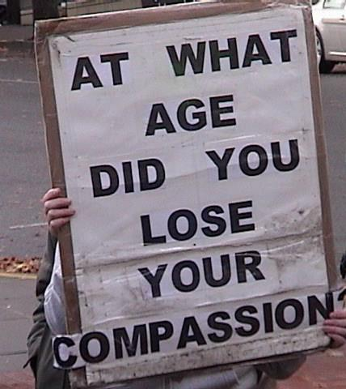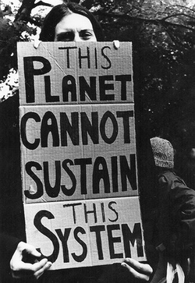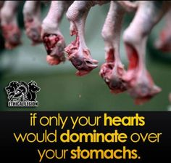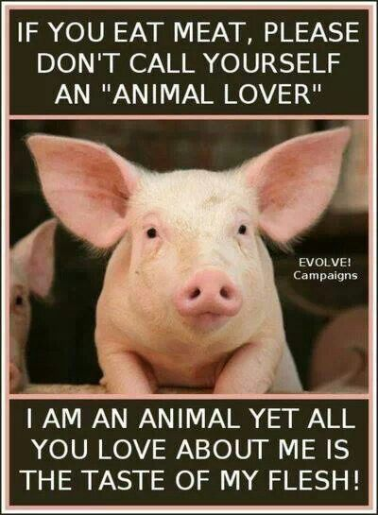

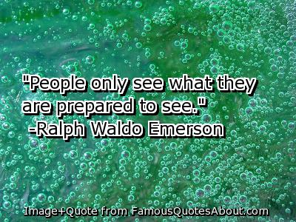

https://www.youtube.com/watch?v=10YeFhYGVJU - John Lennon - Gimme Some Truth

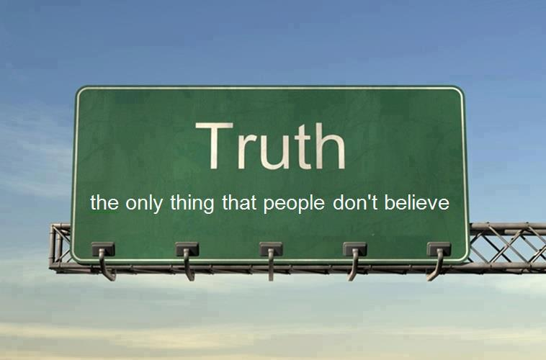

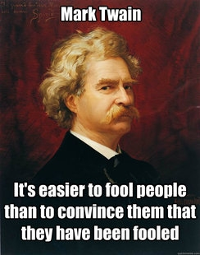

“Truth must be repeated again and again because error is constantly being preached round about”
Johann Wolfgang von Goethe (1749 -1832)

“Right is right, even if everyone is against it; and wrong is wrong, even if everyone is for it”
William Penn

“The hardest thing to explain is the obvious, which everybody has decided not to see”

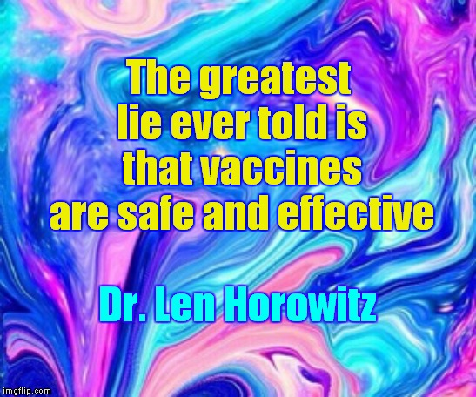

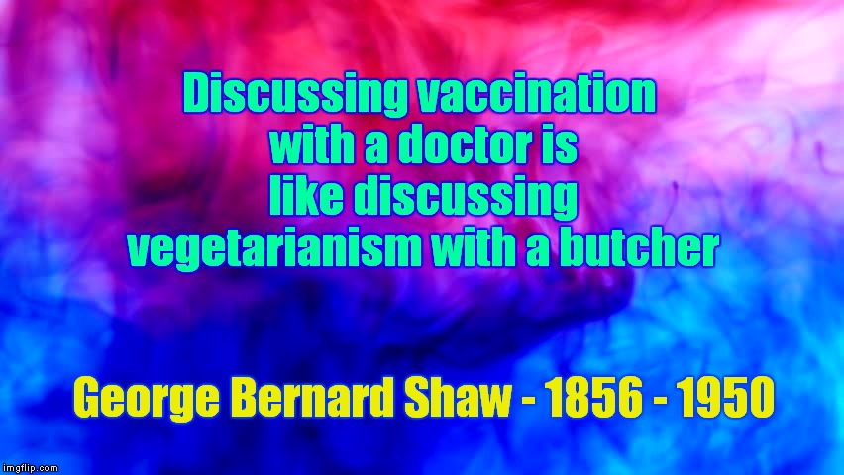

“God heals and the Doctor takes the fee”
Benjamin Franklin (1706-1790)

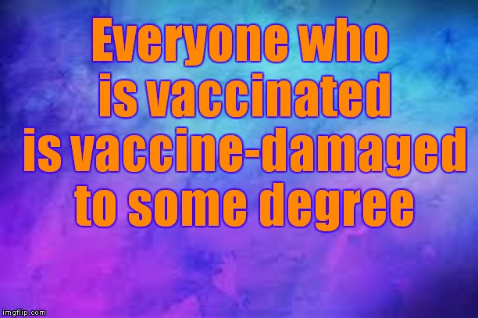

"Your failure to be informed does not make me a wacko"
John Loeffler

"Facts do not cease to exist because they are ignored”
Aldous Huxley (1894 – 1963)

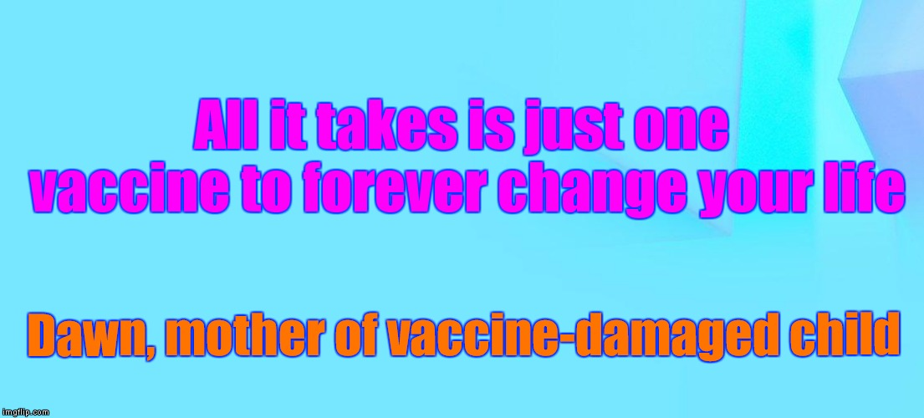

"An error does not become truth by reason of multiplied propagation, nor does truth become error because nobody sees it"
Mohandas Karamchand Gandhi (1869 – 1948)

“I know that most men, including those at ease with the problems of the greatest complexity, can seldom accept even the simplest and most obvious truth if it be such as would oblige them to admit the falsity of conclusions which they have delighted in explaining to colleagues, which they have proudly taught to others, and which they have woven, thread by thread, into the fabric of their lives”
Leo Tolstoy (1828 – 1910)

"Uneducated people believe what they are told...Educated people question what they are told"

"People do not like to think. If one thinks, one must reach conclusions. Conclusions are not always pleasant"
Helen Keller (1880 – 1968)



Our Deepest Fear
Marianne Williamson
From her book “A Return to Love”

Our deepest fear is not that we are inadequate.
Our deepest fear is that we are powerful beyond measure.
It is our light not our darkness that frightens us.
Your playing small does not serve the world.
There is nothing enlightened about shrinking
so that other people won't feel insecure around you.
We are all meant to shine as children do.
It’s not just in some of us, it’s in everyone.
And as we let our own light shine, we unconsciously
give other people permission to do the same.
As we are liberated from our own fear,
Our Presence automatically liberates others.

We ask ourselves –
“Who am I to be brilliant, gorgeous, talented, and fabulous?”
Actually, Who are we NOT to be?



“A truth’s initial commotion is directly proportional to how deeply the lie was believed…When a well-packaged web of lies has been sold gradually to the masses over generations, the truth will seem utterly preposterous and its speaker, a raving lunatic”
Dresden James

“If you think that something is right just because everyone believes it, then you are not thinking"
Vivienne Westwood

“The mind is like a parachute; it only functions when it is open”

"We have not lost faith, but we have transferred it from God to the medical profession"
George Bernard Shaw

“An empire is an immense egotism”
Ralph Waldo Emerson (1803 – 1882)

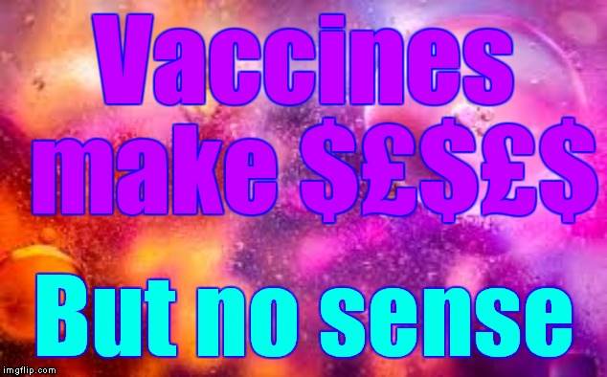

“This guy’s doctor told him he had six months to live. The guy said he couldn’t pay his bill. The doctor gave him another six months”
Henny Youngman (1906 – 1998)

"You never change things by fighting the existing reality. To change something, build a new model that makes the existing model obsolete"
Buckminster Fuller (1895 – 1983)

“Do not believe in anything simply because you have heard it. Do not believe in anything simply because it is spoken and rumoured by many. Do not believe in anything simply because it is found written in your religious books. Do not believe in anything merely on the authority of your teachers and elders. Do not believe in traditions because they have been handed down for many generations. But after observation and analysis, when you find that anything agrees with reason and is conducive to the good and benefit of one and all, then accept it and live up to it”
Buddha

“Everyone thinks of changing the world, but no one thinks of changing himself”

Leo Nikolaevich Tolstoy

“Become the person you want the world to be”
Gandhi

"All truth passes through three stages.
First, it is ridiculed.
Second, it is violently opposed.
Third, it is accepted as being self-evident"
Arthur Schopenhauer (1788 – 1860)

Three Stages of Truth
1. Ridicule
2. Violent opposition
3. Acceptance

"If you are a Christian, then live the Laws as laid down by Jesus. If you are a Buddhist, live the Laws as laid down by Buddha. If you are a Hindu, then be the best Hindu. This procedure is the one true Way for men of Earth to save themselves from their lower aspects"

“To put the world right in order, we must first put the nation in order; to put the nation in order, we must first put the family in order; to put the family in order, we must first cultivate our personal life; we must first set our hearts right"
Confucius (551BC – 479BC)

"First they ignore you, then they laugh at you, then they fight you, then you win"
Mohandas K. Gandhi said it about the importance of persistence in activism

If you want to awaken all of humanity, then awaken all of yourself. If you want to eliminate the suffering in the world, then eliminate all that is dark and negative in yourself. Truly, the greatest gift you have to give is that of your own self-transformation.

Lao Tzu

"All meaningful and lasting change starts in the mind”
Albert Einstein

“Every human being is the author of his own health or disease”
Buddha

"If we don’t do the impossible, we shall be faced with the unthinkable"
Petra Kelly. Founder of the German Green Party (1947 – 1992)

“Problems cannot be solved by the same level of thinking that created them”
Albert Einstein (1879 – 1955)

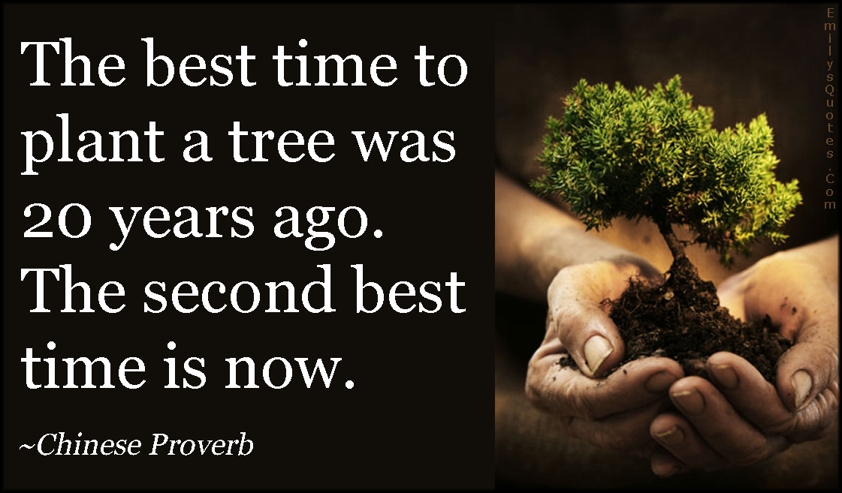

“Blind belief in authority is the greatest enemy of truth”
Albert Einstein

"Nothing will benefit human health and increase the chances for survival of life on earth as much as the evolution to a vegetarian diet"
Albert Einstein

“Our task must be to free ourselves... by widening our circle of compassion to embrace all living creatures and the whole of nature and its beauty”
Albert Einstein - Theoretical Physicist, Philosopher, Nobel Prize Winner

“The world is a dangerous place to live, not because of evil people, but because ordinary people do nothing about it”
Albert Einstein

“95% of the people in the world need to be told what to do, how to think & behave, & have to be given orders”
Arnold Schwarzenegger

“What good fortune for those in power that the people do not think”
Adolf Hitler (1889 – 1945)

"All that is necessary for the triumph of evil is that good men do nothing"
Edmund Burke (1729 – 1797)

"Isn't man an amazing animal? He kills wildlife - birds, kangaroos, deer, all kinds of cats, coyotes, beavers, groundhogs, mice, foxes and dingoes - by the million in order to protect his domestic animals and their feed. Then he kills domestic animals by the billion and eats them. This in turn kills man by the millions, because eating all those animals leads to degenerative - and fatal - health conditions like heart disease, kidney disease, and cancer. So then man tortures and kills millions more animals to look for cures for these diseases. Elsewhere, millions of other human beings are being killed by hunger and malnutrition because food they could eat is being used to fatten domestic animals. Meanwhile, some people are dying of sad laughter at the absurdity of man, who kills so easily and so violently, and once a year, sends out cards praying for Peace on Earth"

David Coat

“The fate of animals is of greater importance to me than the fear of appearing ridiculous; it is indissolubly connected with the fate of men”
Emile Zola (1840 – 1902)

“We do not have to visit a madhouse to find disordered minds; our planet is the mental institution of the Universe”
Johann Wolfgang von Goethe

"Earth is an insane asylum, to which the other planets deport their lunatics"
Voltaire (1694 – 1778)

“Vivisection is the blackest of all the black crimes that man is at present committing against God and his fair creation. It ill becomes us to invoke in our daily prayers the blessings of God, the Compassionate, if we in turn will not practise elementary compassion towards our fellow creatures”
Mohandas Gandhi

"The spirit of inquiry, the search for greater truth beyond religion and science, the profound seriousness of doing real thinking, philosophy and ontology – these are almost totally lacking in humanity. Humanity is therefore subhuman from lack of genuine intelligence....they automatically reject any emergent facts or realities that do not fit their brain-dead cognitive pattern of belief and disbelief.
They watch too much television"
Gabriel Chiron, "Truth is Greater Than Man"

“In a time of universal deceit, telling the truth is a revolutionary act”
George Orwell (1903 – 1950)

“The soul is the same in all living creatures, although the body of each is different”
Hippocrates (460BC – 370BC)
“Cruelty to animals is not only a stupid act, but an insult to God”
Sir Isaac Newton (1643 – 1727)

“Your past does not determine your future, your present thoughts do!”
Dr. Joseph Mercola

"Flesh eating is simply immoral, as it involves the performance of an act which is contrary to moral feeling: killing. By killing, man suppresses in himself, unnecessarily, the highest spiritual capacity, that of sympathy and pity towards living creatures like himself and by violating his own feelings becomes cruel"
Leo Tolstoy (1828 – 1910)

"Just look at us. Everything is backwards; everything is upside down. Doctors destroy health, lawyers destroy justice, universities destroy knowledge, governments destroy freedom, the major media destroy information and religions destroy spirituality"
Michael Ellner

“If you judge people, you have no time to love them”
Mother Teresa (1910 – 1997)

“Always forgive your enemies; nothing annoys them so much”
Oscar Wilde (1854 - 1900)

"Rise like Lions after slumber; In unvanquishable number; Shake your chains to earth like dew; Which in sleep had fallen on you; Ye are many; They are few"
“The Mask of Anarchy” Percy Bysshe Shelley (1792 – 1822)

"Few will have the greatness to bend history itself; but each of us can work to change a small portion of events, and in the total of all those acts will be written the history of this generation"
Robert Francis Kennedy (1925 - 1968)

"Opportunities multiply as they are seized"

Sun Tzu (544BC – 496BC)

"It does not require a majority to prevail, but rather an irate, tireless minority keen to set brush fires in people's minds"
Samuel Adams
"There is far more to this world than taught in our schools, shown in the media, or proclaimed by the church and state. Most of mankind lives in a hypnotic trance, taking to be reality what is instead a twisted simulacrum of reality, a collective dream in which values are inverted, lies are taken as truth, and tyranny is accepted as security. They enjoy their ignorance and cling tightly to the misery that gives them identity" Thomas Cox

The liberation of animal life can only be achieved through the radical transformation of human consciousness and the overthrow of the existing power structure
Transpecies Unlimited

"Those who can make you believe absurdities can make you commit atrocities”
Voltaire (1694 – 1778)

“Every man is guilty of all the good he didn’t do”
Voltaire (1694 – 1778)

"We have enslaved the rest of the animal creation, and have treated our distant cousins in fur and feathers so badly that beyond doubt, if they were able to formulate a religion, they would depict the Devil in human form"
William Ralph Inge (1860 – 1954)

“Clear thinking requires courage rather than intelligence”
Thomas Szasz (1920 – 2012)

“I am the only person in the whole universe who can create my negative Karma and my positive Karma”

“When you're one step ahead of the crowd you're a genius.
When you're two steps ahead, you're a crackpot”

"If you are a Christian, then live the Laws as laid down by Jesus. If you are a Buddhist, live the Laws as laid down by Buddha. If you are a Hindu, then be the best Hindu. This procedure is the one true Way for men of Earth to save themselves from their lower aspects"



In the past, doctors and dentists promoted cigarettes.

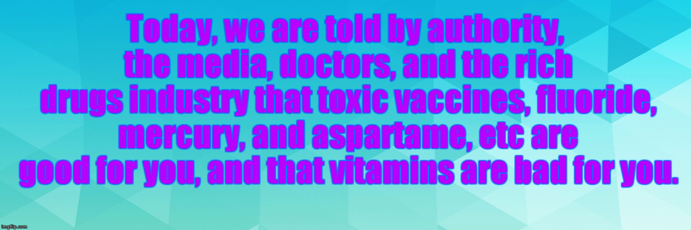

Even though the conscious mind may be in self-denial (through bias, greed, guilt, fear, ego, selfishness, cowardice, jealousy, and other failings and weaknesses), the body and subconscious mind, which does not like lies, makes the correct choice over natural and poisonous substances, eliminating toxic drugs and inoculations, while absorbing nutrients. This is fact. We cannot argue with the body’s wisdom, which is the ONLY thing that keeps us alive.

If a doctor, or his family or child was seriously ill, would he refuse to use life-saving alternative medicines because he was totally brainwashed by medical schools, and instead give drugs, knowing that they had lethal side-effects? Through bias, he probably would!

Medical schools and hospitals are virtually owned and controlled by the drugs/vivisection/inoculation industry.

Knowing that vivisection is unscientific because of species-differences, they test inoculations on humans, including babies and children, to check that the level of poison is not too weak or strong - so that we don't link the inoculation to the resulting bad effect. Inoculations are delayed-reaction poisons.

We have to overcome 200 years of indoctrination and conditioning that tells us that mercury etc is good for you. The earth is not flat. Inoculations are totally ineffective. Inoculations destroy the immune and nervous systems. Inoculation is a trick to create profit, to lower the intelligence, and to depopulate. Expect lies.

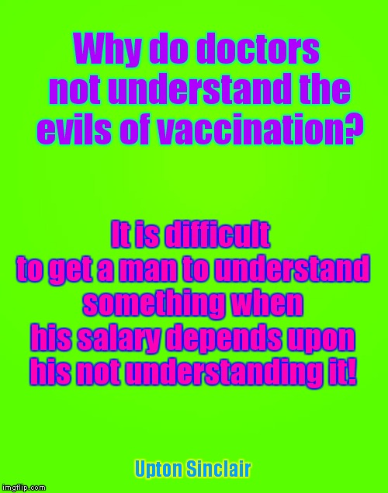

INOCULATIONS and GUILT
Poisoned your child with toxic, ineffective inoculations?
Parents & doctors, etc:- How has guilt affected you?
“You are free to choose, but you are not free from the consequence of your choice”.
We have choice, but children & animals do not. Educated people do not inoculate. Doctors use guilt & fear to get you to inoculate (and increase their income). Then the parent feels guilt for having poisoned their child. The doctor feels guilt too. The heart and mind is blocked by guilt, selfishness, self-pity, ego, fear, greed, etc. Then, instead of stopping inoculating, they continue, even after damage has been done, rather than face their guilt. Compassion for your child should overrule any guilt, selfishness, self-pity, ego, greed, fear, etc. A good parent will not only study the facts without BIAS, but will also bravely face their failings and weaknesses, and change accordingly. We can always remove our guilt by saying that the rich drugs/vivisection/inoculation industry, doctors, media & govt tricked us. Or can we? It is better to stop inoculating, admit to having faults & having poisoned our child through wilful ignorance, and then detox the child in order to detox our guilt. We can then also start to create positive Karma, instead of negative Karma. Then tell everyone to STOP inoculating. We have natural, moral & legal rights & choice!

MAN’S GUILT
Humans have such immense guilt which has accumulated for millennia, due to committing multiple genocide (all wars are engineered), poisoning their children with inoculations, killing billions of animals, harming & destroying the Planet & all lifestreams with fracking, killing billions of trees etc with chemtrails, and many other selfish acts. It must all STOP immediately. We may as well create positive Karma instead of negative Karma with the short life allotted to us, and reap what we have sown. Love, protect & respect all life, then we will receive the same.

https://www.youtube.com/watch?v=uVXR2LYeFBI - John Lennon - Watching the Wheels



