“Become the person you want the world to be”
Gandhi

Human laws, our consciousness, and our life, are meant to be a reflection of the Laws of the Universe.

Be the Law

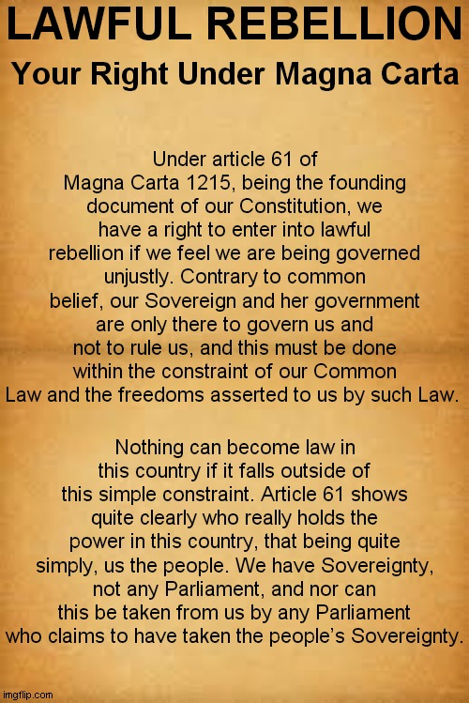

“Magna Carta Libertatum” is Medieval Latin for “Great Charter of Freedoms”, and is a Charter of Rights agreed to by King John of England at Runnymede, near Windsor, on 15 June 1215.

LAW

The Global Court
Is in the street
We all now vote
With our feet

Governments are illegal
Take them down
They destroy our world
We act like a clown

Its time to change
At 11th hour
And to take
Back our power

Our silence is wrong
We must be strong
Or death of our planet
Won’t be long

Change is easy
The preferable choice
We think it’s hard
We can use our voice

If we don’t
We’ll all regret
On our life
We can bet

In unity, it’s simple
One mind, heart and voice
Open them up
So all can rejoice

The end of all terror
Silence is our error

Our greatest opportunity
To end it all here
Unite and Love
End all fear

If we can go
To the moon
We can end
Their reign soon

We can avoid
Certain doom
They must dance
To our tune

Love in Action
Unity and Hope
The words in all hearts
No need for a Pope

Dictatorships, fracking
They must be sent packing

Vaccines, nuclear
Poisoning the Earth
Fight, and know
Creation’s worth

It’s now or never
Be the change
Now and forever
Mind rearrange

The Mental Revolution
Is within our reach
Through Loving Action
We all can teach

28/5/20
……………….

St Francis, the Patron Saint of Animals, who lived to about 250 years, and spoke to animals, instructed his disciples (disciplined ones) to “Go out and teach. Use words if necessary”.

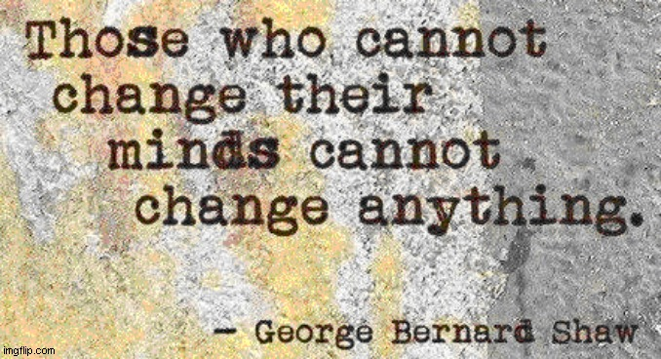
https://www.youtube.com/watch?v=P5Ps6MxMXDg
Talking Heads - Mind

The Fake Pandemic

Governments lie!

Mass media lies!

Big pharma lies!

Corporations and governments are one.

This Fake Pandemic is a political and financial manipulation to create global dictatorship.

They also seek to dumb us down physically, mentally, and spiritually.

A combination of toxins (in vaccines, chemtrails, meat, etc), plus electro-magnetic radiation (5G, smart meters etc), plus engineered fear, are being used to gain power and control over the masses.

Once sufficient people awaken, it’s 'game over' for them.

Most people believe and obey authority. But people are awakening.

Firstly, we must eliminate fear through educating people.

People need to face the truth about the fake pandemic, vaccines, 5G radiation, chemtrails, and other vital issues, including the fact that governments are corrupt and evil.

They need to find the bravery and compassion to face the facts and take action to save the planet, nature, animals, and humans, etc.

We need to fight for our rights and freedoms, including our right of free speech.

It’s a fake pandemic, so the enforcement of vaccines, masks, etc, is unlawful.

MASKS

The WHO, Fauci, the JAMA, BMA and others have all gone on record stating that wearing cloth masks:

1. Does nothing to prevent Covid-19.

2. Is unnecessary, and in fact, is not recommended in healthy individuals.

3. Concentrates moisture which is a breeding ground for germs.

4. Provides poor oxygen flow.

5. Accumulates viruses, bacteria and other microbes both inside and outside the mask, and yet, some dictators will be making the wearing of masks mandatory. (But they don’t do social distancing or wear masks or gloves themselves!).

Because it’s a fake pandemic, taking away our rights and freedoms is unlawful too.

If social distancing was required to stop disease, the human race would have been annihilated a long time ago.

Viruses are not contagious or airborne. They cannot live outside the cell or the body.

There are live viruses in vaccines and meat.

Meat is infested with microbes, fungi, viruses, and parasites, and it causes virtually all food poisoning.

Meat, live exports, factory farming, and vaccinated animals, cause Ebola, bird flu, swine flu, corona viruses, SARS, MERS, Creutzfeldt-Jakob disease (CJD), salmonella, listeria, etc.

Epidemics are wilfully engineered to create fear.

70% of people in UK gave up beef due to mad cow disease (CJD) within one week of the media reporting it.

Many countries refuse to buy UK meat because of all the vaccine toxins and antibiotics in it, which would lead to the public suing them for health damage. Vaccines not only contain harmful dead and attenuated viruses, but also LIVE viruses.

Meat has the vibrations of fear within it, so it affects humans negatively, causing disease and more fear.

LAW

“Americans give the government their consent to force vaccines on us by refusing to fire the whole government. The government continually tells us that they are 100% corrupt, yet Americans sit there like lemmings, refusing to stop the abuse. Refusing to assert their authority to stop the abuse is the same as giving consent to continue the abuse. This is how lawyers determine tacit consent. If you don’t object, then you consent. Objecting to criminals when everything they do is the act of an enemy is not too bright. Yet, Americans continue to do this. Asking the criminals to stop is giving them the authority to say “No”. Do you really want to give them that authority? Why can’t Americans learn that we the people are the authorities? Why can’t we learn that we have to give orders to our disobedient servants? When you give the government the power to abuse you by putting yourself in a subservient position to your servants, you are telling them it’s OK to abuse you”

Important New Website

www.report5Gcrime.com

http://action2crimes.com/

http://report5gcrime.com/letter-for-police/

Please invite everyone you know who is interested in approaching their local council to halt the rollout of 5G or to at least raise awareness with their council.

https://www.bitchute.com/video/7tvtInh63gR5/ - Italy Blows the Lid off Vaccine Scam - Will No Longer Poison Citizens with Globalist Eugenics - 9 min

https://thestaracademy.co.za/u-s-govt-loses-landmark-vaccine-lawsuit/ - U.S. Govt Loses Landmark Vaccine Lawsuit. Forced vaccinations can now be legally stopped - no quality control for 32 years

Case 1:18-cv-03215-JMF - Document 18 Filed 07/09/18

Vaccine injury lawyer Robert F. Kennedy Jr., & Del Bigtree, producer of the suppressed anti-vaccine documentary “Vaxxed” and the Informed Consent Action Network (ICAN), are credited with this victory. They demanded the relevant government documents proving that all federally approved vaccines had been tested for quality over the past 32 years - and there were none.

https://www.crowdjustice.com/case/the-coronavirus-act-2020/?fbclid=IwAR1TMjq-JS6GSkV0EoE6ziIPoitAW0NEFjyChNWwqcmFzNliQPJeVA2VGr8

https://glastonbury.gov.uk/2020/04/29/glastonbury-calls-for-5g-inquiry/?fbclid=IwAR2A9i5xt2wTvCkRacKoypbkQCxmKTtZ924SBlnjilimrvWAfKvhUzNwOfk

https://www.youtube.com/watch?v=5JJ_7WlsLhU&feature=youtu.be
Public Notice of Invocation 1215 Magna Carta Article 61 at Royal Liverpool Hospital Clap 7/5/20 - 26 min

https://questioningcovid.com/ - Excellent website!

“If the machine of government is of such a nature that it requires you to be the agent of injustice to another, then, I say, break the law”
Henry David Thoreau

Harming and killing life is wrong. It’s also illegal, but only because the majority agree that it is.

We need to enact existing laws to stop global dictatorship, and harm to life and suffering of all life, and the destruction of this beautiful living Planet, our only Home.

If something is wrong and is harmful, but it is not already illegal, then the masses need to amend old laws and create new laws.

300 species go extinct every day due to pollution. Such destruction is illegal.

If, for example, fracking corporations can buy and make laws to stop lawful protesters, then we the people must make and enforce laws to protect all life, the Planet, and our precious rights and freedoms.

This engineered fake pandemic and global dictatorship scenario is the biggest threat to the world to date, but it is also our greatest opportunity to stop evil corruption once and for all.

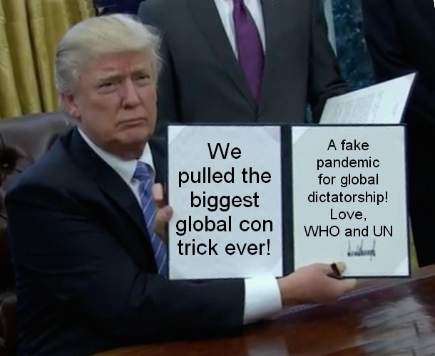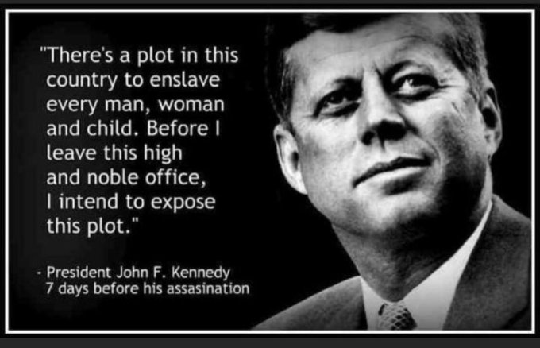

The pandemic is fake. If the pandemic was real, we would all know it, without doubt! We would all personally know many people who had died from CV. See the 1918 Spanish Flu article on https://actionnetwork.org/groups/corona-virus . No one knows ANYONE personally who has genuinely died from CV! CV deaths and are falsified. Deaths from cancer and any disease, old age, suicides, accidents, and murders, are all being classed as CV deaths.

Governments, councils, police, military, and all authority, are all acting illegally.

Enforcing social distancing and mask-wearing is therefore illegal, and both are gags to stop the spread of truth which would lead to dissent and mass action.

All authority is paid by the public to serve and obey the public, not dictate to it.

Governments and corporations (who are one), rob, pollute, destroy, and dictate. This is illegal.

All wars are engineered, and banks fund both sides, for profit. This is illegal.

Vaccines, 5G, and smart meters, for example, harm health, so should not be forced upon the informed and uninformed public. Everyone should have freedom of choice over everything anyway, especially if it harms health.

Fracking corporations BUY laws, and dictate to the public. Protesters are not allowed to go anywhere near a fracking site if these corporations have made a law banning protests and disallowing lawful freedoms and the lawful right to peaceful protest and the lawful rights to freedom of speech, press, thought, and expression

If the vast majority were against fracking, then it would be illegal, no matter what governments and corporations say. Otherwise, we are in a dictatorship.

If corporations can buy and make laws, then the public can make laws too. If a law is not approved by the masses and does not reflect the will and views of the masses, how can it be law?

Governments only have power and money because we give our power away and happily pay taxes which fund atrocities.

Tracking and spying on the public is illegal.

Informed consent and vaccines. If people were informed about vaccines, they would refuse them, and would not approve of the use or enforcement of vaccines.

Causing harm through vaccines is illegal.

Enforcing harmful vaccines is illegal.

Withholding the facts from the public about vaccines being unsafe and ineffective is illegal.

The public are lied to by authority and the rich corrupt drugs industry. This is illegal.

They conspire to harm our health and profit by it. This is illegal.

Good laws exist to protect life, and they need to be invoked now to protect man, the planet, and all life, against the threat of global dictatorship and mass enforced vaccines and enforced harmful 5G etc.

Where laws don’t exist, or are insufficient or dubious, the masses need to bring about the creation of new laws or the amendment of existing laws.

300 species go extinct every day due to pollution. Such destruction is illegal.

We should be panicking over this mass extinction, not a non-existent pandemic. Think for yourself instead of believing corrupt evil governments who will never care or take action while ever they profit from exploiting all life and while ever they need someone to bully.

In some countries laws are now being created to protect the Holy Mother Earth who is a conscious living being, who gives us a beautiful home, but governments and corporations are destroying our only home, and the masses are allowing and causing it, through wilful ignorance, and through the heartless silent or spoken approval of the masses. We must create laws in every country to protect the Mother Earth.

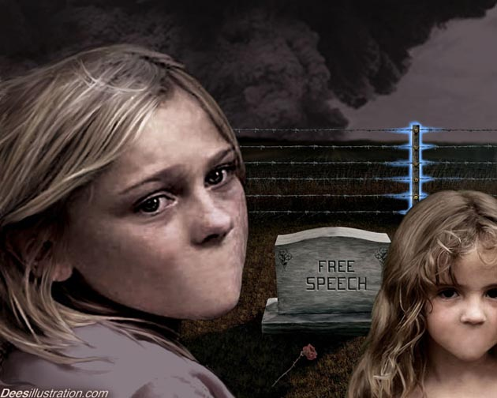

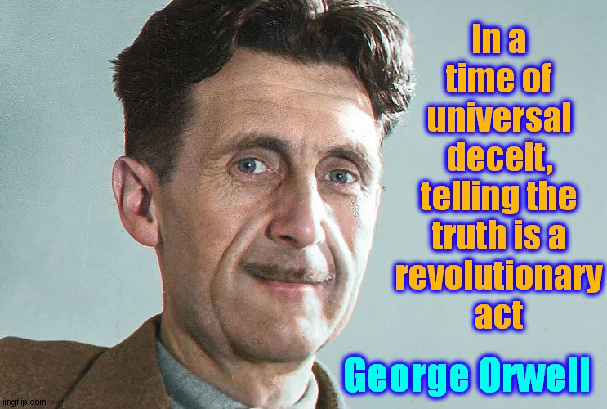

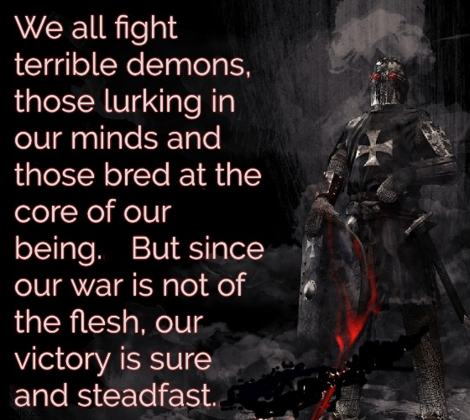

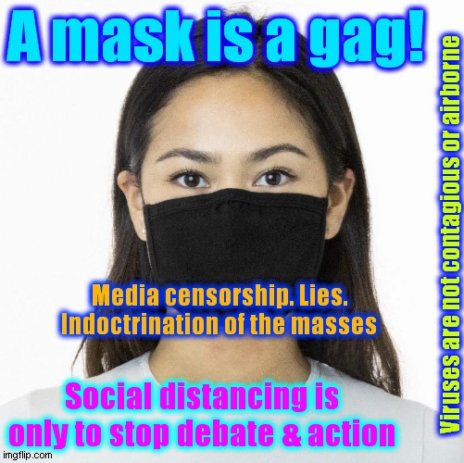

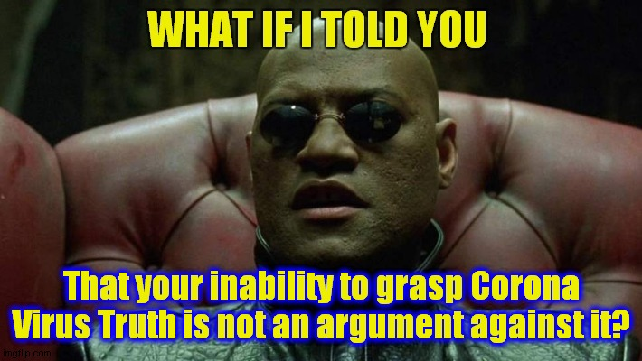

“In a case brought by Robert F. Kennedy Jr, a US court ordered the vaccine industry to provide details of all of their safety data on vaccines, going back to the start. They were not able to because there is none. As for Bill Gates, a very large petition to The White House, wants him behind bars for ‘crimes against humanity’ amongst other things. One of his stunts, the polio ‘immunisation’ resulted in 496,000 Indian children being paralysed”

