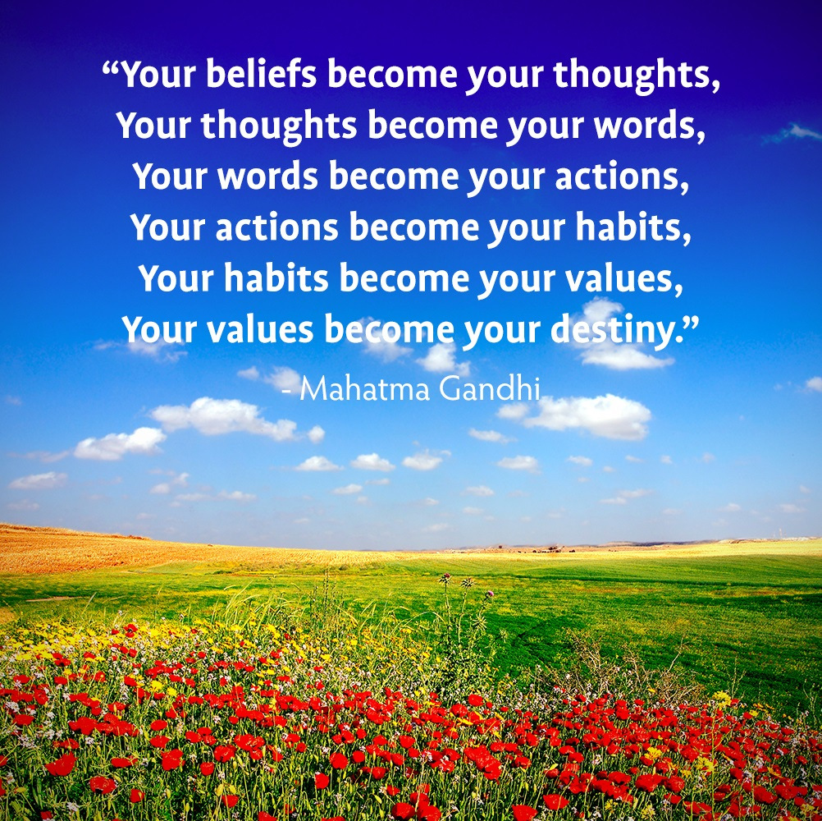
Thought creates Karma

PATTERNS

Patterns of mind
Patterns of life
Patters of love
Patterns of strife

Patterns of cultures
Repeating themselves
Over millennia
But no one delves

Or thinks to change
Or rearrange
Patterns so strange
That can derange

Maldek, Lemuria
Atlantis, Chernobyl
To start a new pattern
We must be noble



It takes 30 days
To eliminate
One old pattern
It’s never too late

It takes 30 days
To establish new habits
100 times slower
Than dogs or rabbits

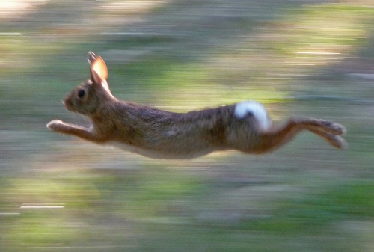

Better not starting
A negative way
Before it takes hold
Obsessions don’t pay

Start off good patterns
And keep them up
Stops the subconscious
From running amuck

Stuck in a Groove?
Can’t make a move?
Set in your way?
Change it today!

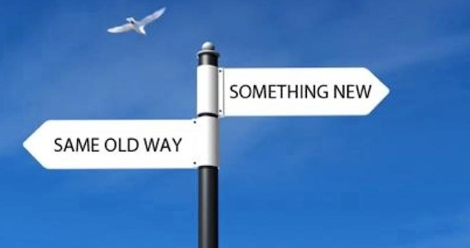

Trying for
A reinvention?
Still can’t do it?
With best intention?

Compulsive drinker?
Or deep thinker?

Stuck in a Rut?
Hard to crack nut?

Bias and fear
The odd one out
The summer soldier
The monk devout

Be yourself
The Spirit within
The habit of love
The habit of sin

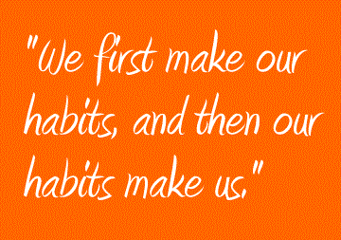

Patterns can last
For thousands of years
Reliving our horror
A billion tears

Changing habits today
Is the only way
Has to be done
Sometime anyway

The sooner the better
Follow Karma
To the letter

Dot every ‘I’
Cross every ‘T’
Depends on you?
No, only on me

Prevention is better than cure
Desires are such a lure

Money’s a drug
Have you caught the bug?

Expensive addictions
Cost us the Earth
Starting bad habits
From moment of birth



Killing an animal
Eating its flesh
Destroying the Earth
Delete and refresh



Inherited patterns
Passed down generations
Fixations of nations
Karmic limitations

Indigo, Rainbow,
And Crystal child
Resetting the patterns
Appearing so wild

Interrupt the pattern
Normality restored
You could have done that
Masters implored..

..Millennia ago
As if we
Didn’t know

You can’t teach
An old dog
Any new trick
Programmable humans
So slow and so thick

Never too late
To change;
What’s new
Feels strange

If Higher Self is strong
And lower self is weak
Maybe our patterns
We can tweak

Lemuria, Atlantis
Nagasaki, Maldek
Wherever we go
We leave a wreck

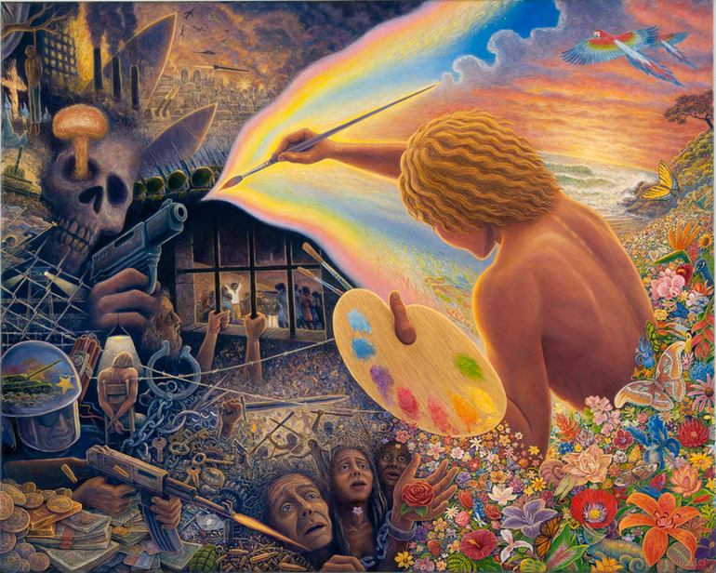

New Age dawning
Words of warning

Change and be free
It’s all up to me

We’re pioneers of patterns
Pushing against the orthodox
Taught by all the Masters
To think outside the box



Popularity’s not our name
We do not seek fame

Proclivity
Propensity
Human habit,
or density

Built into masters,
Mice and men
If we change?
Only when!


A nail is driven out by another nail. Habit is overcome by habit.
Desiderius Erasmus

The advanced civilisations Maldek, Lemuria, and Atlantis, were all destroyed by nuclear weapons by us in a past life. We are now in the fourth civilisation. Each civilisation became less advanced than the previous one. We are now the most backward race in the galaxy. If we were the most advanced, heaven help the other races! We are still following the destructive patterns of our own past lives and of past civilisations - so we need to change our patterns now by great effort - or our future is predetermined. We have choices and urgent decisions to make. Will we share the New Age, or miss out? Will there even be a New Age if we don’t change now? Love, reverence, and respect for all lifestreams are the keys to inner and outer peace for all.

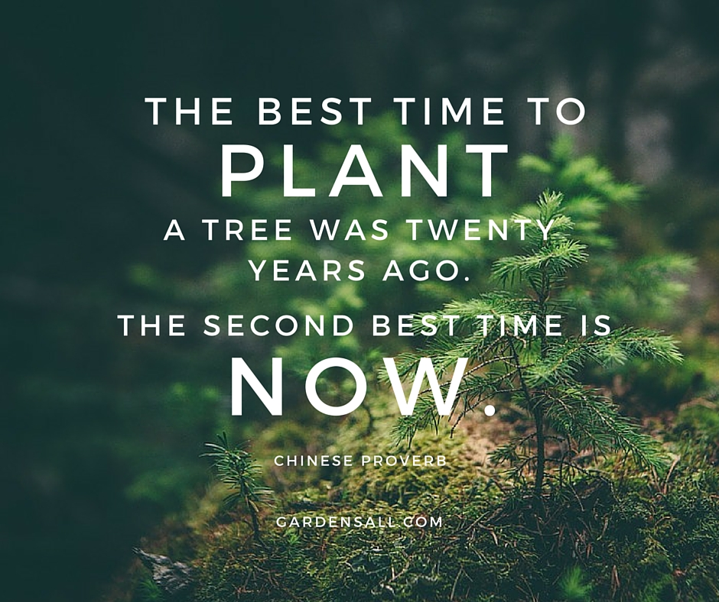

“Become the person you want the world to be” Gandhi

“Everybody wants to be somebody, but no one wants to grow”
Johann Wolfgang von Goethe

Any act often repeated soon forms a habit; and habit allowed, steadily gains in strength. At first it may be but as a spider's web, easily broken through, but if not resisted it soon binds us with chains of steel.
Tryon Edwards

Chains of habit are too light to be felt until they are too heavy to be broken.
Warren Buffett

Each year one vicious habit discarded, in time might make the worst of us good.
Benjamin Franklin

Excellence is an art won by training and habituation. We do not act rightly because we have virtue or excellence, but we rather have those because we have acted rightly. We are what we repeatedly do. Excellence, then, is not an act but a habit.
Aristotle

“It takes about 30-40 days to eliminate an old habit, and about 30-40 days to establish a new habit.

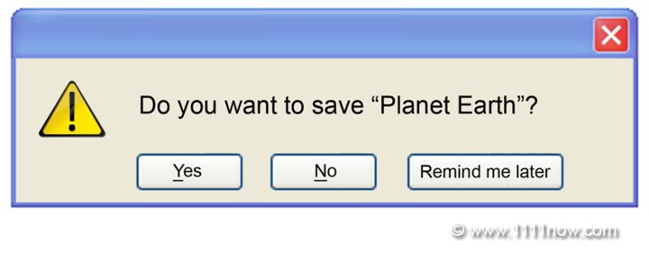

https://www.youtube.com/watch?v=d6BzTCQ6Nqo
A Dream - After the Goldrush - Prelude

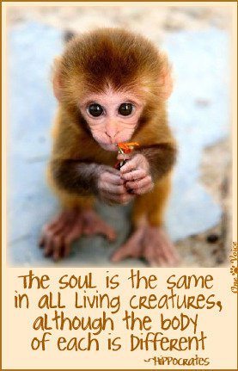

https://www.youtube.com/watch?v=z9lse0JvKr0&playnext=1&list=PL4D8FFF5366F59B35
Scarlatti (1685 – 1757)

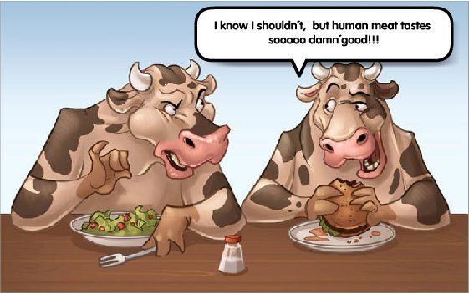

https://www.youtube.com/watch?v=P5Ps6MxMXDg
Talking Heads - Mind

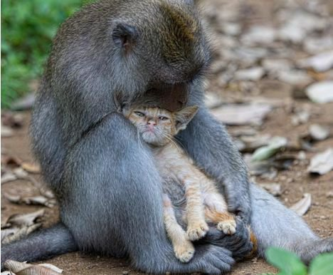

https://www.youtube.com/watch?v=35HYlF74H8g&feature=player_embedded
I am who I am – Guru Singh

