FIX THE SENATE

America faces a number of crises:

- Monied corrosion of the basic tenets of our democracy, leaving government in the clutches of powerful corporations and wealthy elites;
- an economy that no longer creates opportunity or upward mobility for most, with surging costs and raging income inequality;
- an epidemic of gun violence;
- a runaway climate crisis;
- a crippling lack of investment in basic infrastructure; and
- criminal justice, economic, and immigration policies built on rotten foundations of racism.

The 2020 elections are expected cost more than $6 billion, much of it from wealthy donors and corporate interests that oppose progress on these issues. Even if Democrats take back the Senate, they will face a system of outdated, undemocratic, and rigged rules that let a small group of Senators, representing as few as 11% of the American people, block votes and bury virtually any bill or amendment, except those favored by the privileged elite—like tax cuts for the rich.

Wealthy and powerful corporations promote and benefit from this selective paralysis. And we know with certainty that it will continue unless the rules are changed.

Mitch McConnell has spent a decade breaking the Senate to get to this point. Calling himself the “Grim Reaper,” and corrupting the filibuster and other Senate norms and rules, McConnell has vowed to prevent a Democratic president and Congress from moving their agenda—as he did for much of the Obama presidency.

Today’s Senate Governs for the Privileged and Powerful,
Not for the People

In 2008 President Obama was swept into office on a wave of enthusiasm for government that would work for the people. With majorities in both the House and Senate, there were high hopes for progress on a range of kitchen table issues. During a brief four-month window when Democrats had a 60-vote supermajority, they were able to pass Obamacare, which subsequently came within one vote of being repealed by a McConnell-led simple majority in 2017.

McConnell’s transformation of the filibuster during the Obama administration included blocking 79 Obama nominees during 2009-2013, a far cry from the norm in which only 68 presidential nominees had been blocked ever in the entire history of the U.S. Senate. That abuse of power spurred progressive advocates, led by the Democracy Initiative (DI), to call for Senate rules reform that ultimately paved the way for confirmation of 400 executive branch nominees and more than 100 federal judges appointed by Obama.

While those changes made a difference, they did not go far enough, and McConnell has continued to break all Senate norms and rules. In 2016, he led an unprecedented blockade of Obama Supreme Court nominee Merrick Garland, who waited 293 days and never even got a hearing. Then, in 2017, McConnell changed the rules to lower the voting threshold for nominations to the Supreme Court to a simple majority, paving the way for the confirmation of Neil Gorsuch and Brett Kavanagh. Republicans also drastically cut the time allowed for debate on lower court nominations and eliminated backroom “blue slips” that allow a single Senator to block nominees from their home state, allowing record numbers of Trump’s conservative judges to be confirmed.
Tax cuts were once subject to the same 60-vote threshold as other issues. Then, with a party-line vote in the late ‘90s, Republicans changed Budget Reconciliation rules originally intended for deficit-reduction to allow tax cuts to pass with a simple majority. Since then, Republicans have used reconciliation to pass major tax cuts for the rich with a simple majority in 2001, 2003 and twice in 2017. Today’s Senate is built so that the privileged and powerful win and everyone else loses.

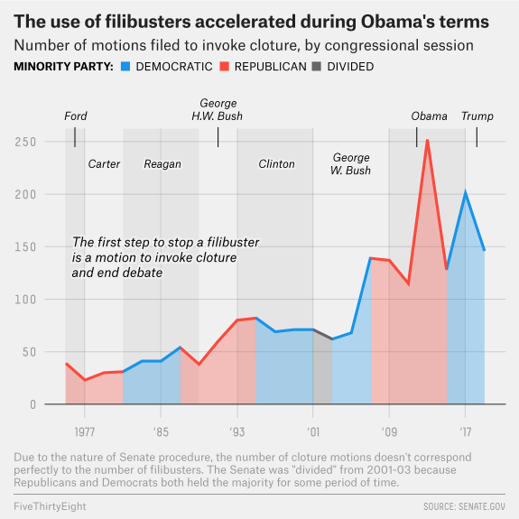

Whether he has been Majority Leader or Minority Leader in the Senate, Mitch McConnell has used Senate rules to obstruct action on broadly supported priorities while pushing through an activist agenda of tax cuts for the rich and conservative judges.

Given McConnell’s track record and his own words, we know with certainty that this obstruction will continue regardless of the outcome of the 2020 election.

Unless the rules are changed.

The Key to Progress: Senate Governance Reform
We have a slew of bold policy ideas to meet the 21st century economic, environmental and social challenges we face, as demonstrated by the record of the House of Representatives since the 2018 blue wave. House-passed bills that haven’t seen a Senate vote include:

- For the People Act (Democracy, Election Protection and Voting Rights)
- The American Dream and Promise Act (Immigration)
- The Paycheck Fairness Act (Worker’s Rights)
- The Bipartisan Background Checks Act (Gun Control)
- The Climate Action Now Act (Climate Change)
- The Strengthening Health Care and Lowering Prescription Drug Costs Act (Affordable Healthcare)
- The Violence Against Women Reauthorization Act (Gender Equity)

None of these bills would get an up-or-down vote in a Democratic Senate under current rules. Some elements of some of the bills might fit into a reconciliation bill, but most would not.
To meet the challenges we face, and to break the cycle of voter disappointment and cynicism bred by legislative paralysis and broken promises, the Senate must be able to govern for the people. That means being able to debate, amend and pass legislation with a simple majority – and taking away Mitch McConnell’s “veto” power, the legislative filibuster, which has blocked progress on literally every major issue we care about while he pushes through conservative judges and tax cuts.

There will come a time to debate how best to restore a functioning Senate and preserve its character, but if they take back unified control in this year’s election, Democrats must eliminate the filibuster.

Now is the time for Democrats to show the people that they have a shared commitment to enacting new rules that end Senate paralysis.

The Senate has been Locked Up and the Old Keys are Gone
Some long for when the Senate was a more deliberative body with moderating, bipartisan coalitions. The fact is, government never worked for all people. Restoring a culture of collegiality and bipartisanship to the Senate is worthy of longer-term discussion. But the current rules requiring 60 votes to pass most policy initiatives are crippling, especially with our government facing a growing crisis of legitimacy.
No Path to 60 Votes
In the current political climate, there is no realistic path to garnering 60 votes for priorities like climate change, infrastructure, income inequality, gun control, democracy, and voting rights. Even if Democrats flip the 3 or 4 seats required to take back control of the Senate, getting to 60 would still require at least 9 Republican votes. Garnering 60 votes for progressive legislation that takes on Wall Street, oil and gas, or big Pharma is all the more difficult when you consider that it can cost more than $50 million to win a U.S. Senate seat, favoring the election of wealthy, self-financed candidates and those who are most successful at rubbing shoulders with and raising money from the privileged elite.

Senate Rules Make Partisan Gridlock Worse
Some have asserted that the filibuster fosters bipartisanship, and while that may have once been true, today it actually hardens partisan lines and discourages cooperation by making it easier for a minority of senators to block whatever the other side wants. Both sides have learned well that blame for the failure to govern never falls on the minority. Once, the threat of a filibuster may have been used to make sure the minority could shape legislation, but now it is used almost exclusively to block legislation and even discussion of major issues altogether.

Current Rules Do Not Protect Progressive Values from a Republican Majority
As McConnell has shown repeatedly, he will change norms and rules as he sees necessary to advance Republican power and the agenda of his wealthy patrons. He has not yet addressed the legislative filibuster because Republicans already changed the rules to advance their two primary priorities. If in the future he feels it is in Republican interests to end Democrats’ ability to filibuster, he has proven time and again that he will do it.

America’s Future Hangs in the Balance

Inaction and gridlock breed voter cynicism and contempt toward government. People grow apathetic and don’t believe their votes matter. They have heard too many promises and experienced too few results.
There is strong public support for our values of inclusion and justice and opportunity for all. Policies built on those values can meet the challenges we face. We must ensure that the Senate can vote on those policies so America can rise to this moment.

November 2019

