Stating the Obvious

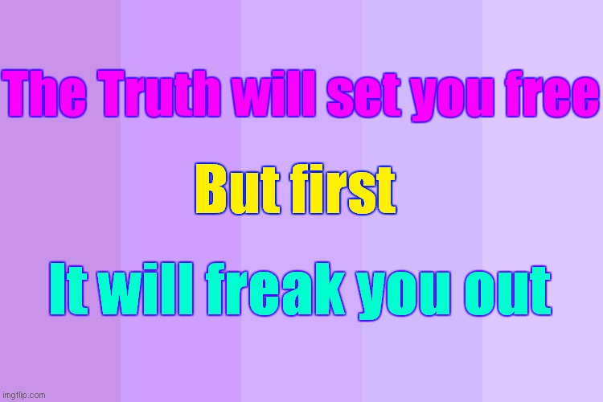

The fake pandemic is sensed by everyone to be such a huge life-changing event that people really are freaking out & staying in denial over this subject more than any other subject. They know at some level of consciousness that it means a global dictatorship & the end of Rights and Freedoms and life as we know it, unless we act immediately, en masse, and in unity and cooperation

Observe your own reaction to this truth

2020 has been predicted to be a special time when people will have to choose the left or right Path. Its time for change

Love and Truth - or fear

Decide

More vital information on last page

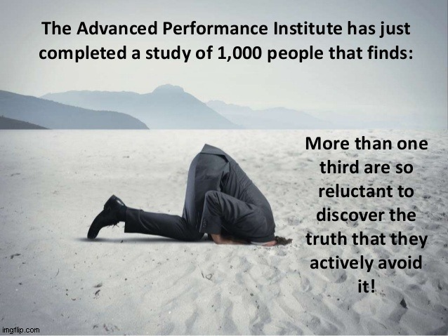

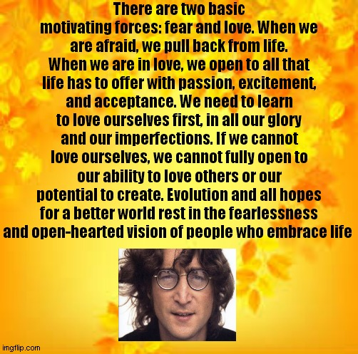

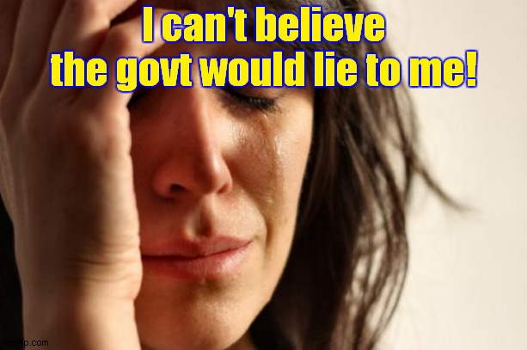

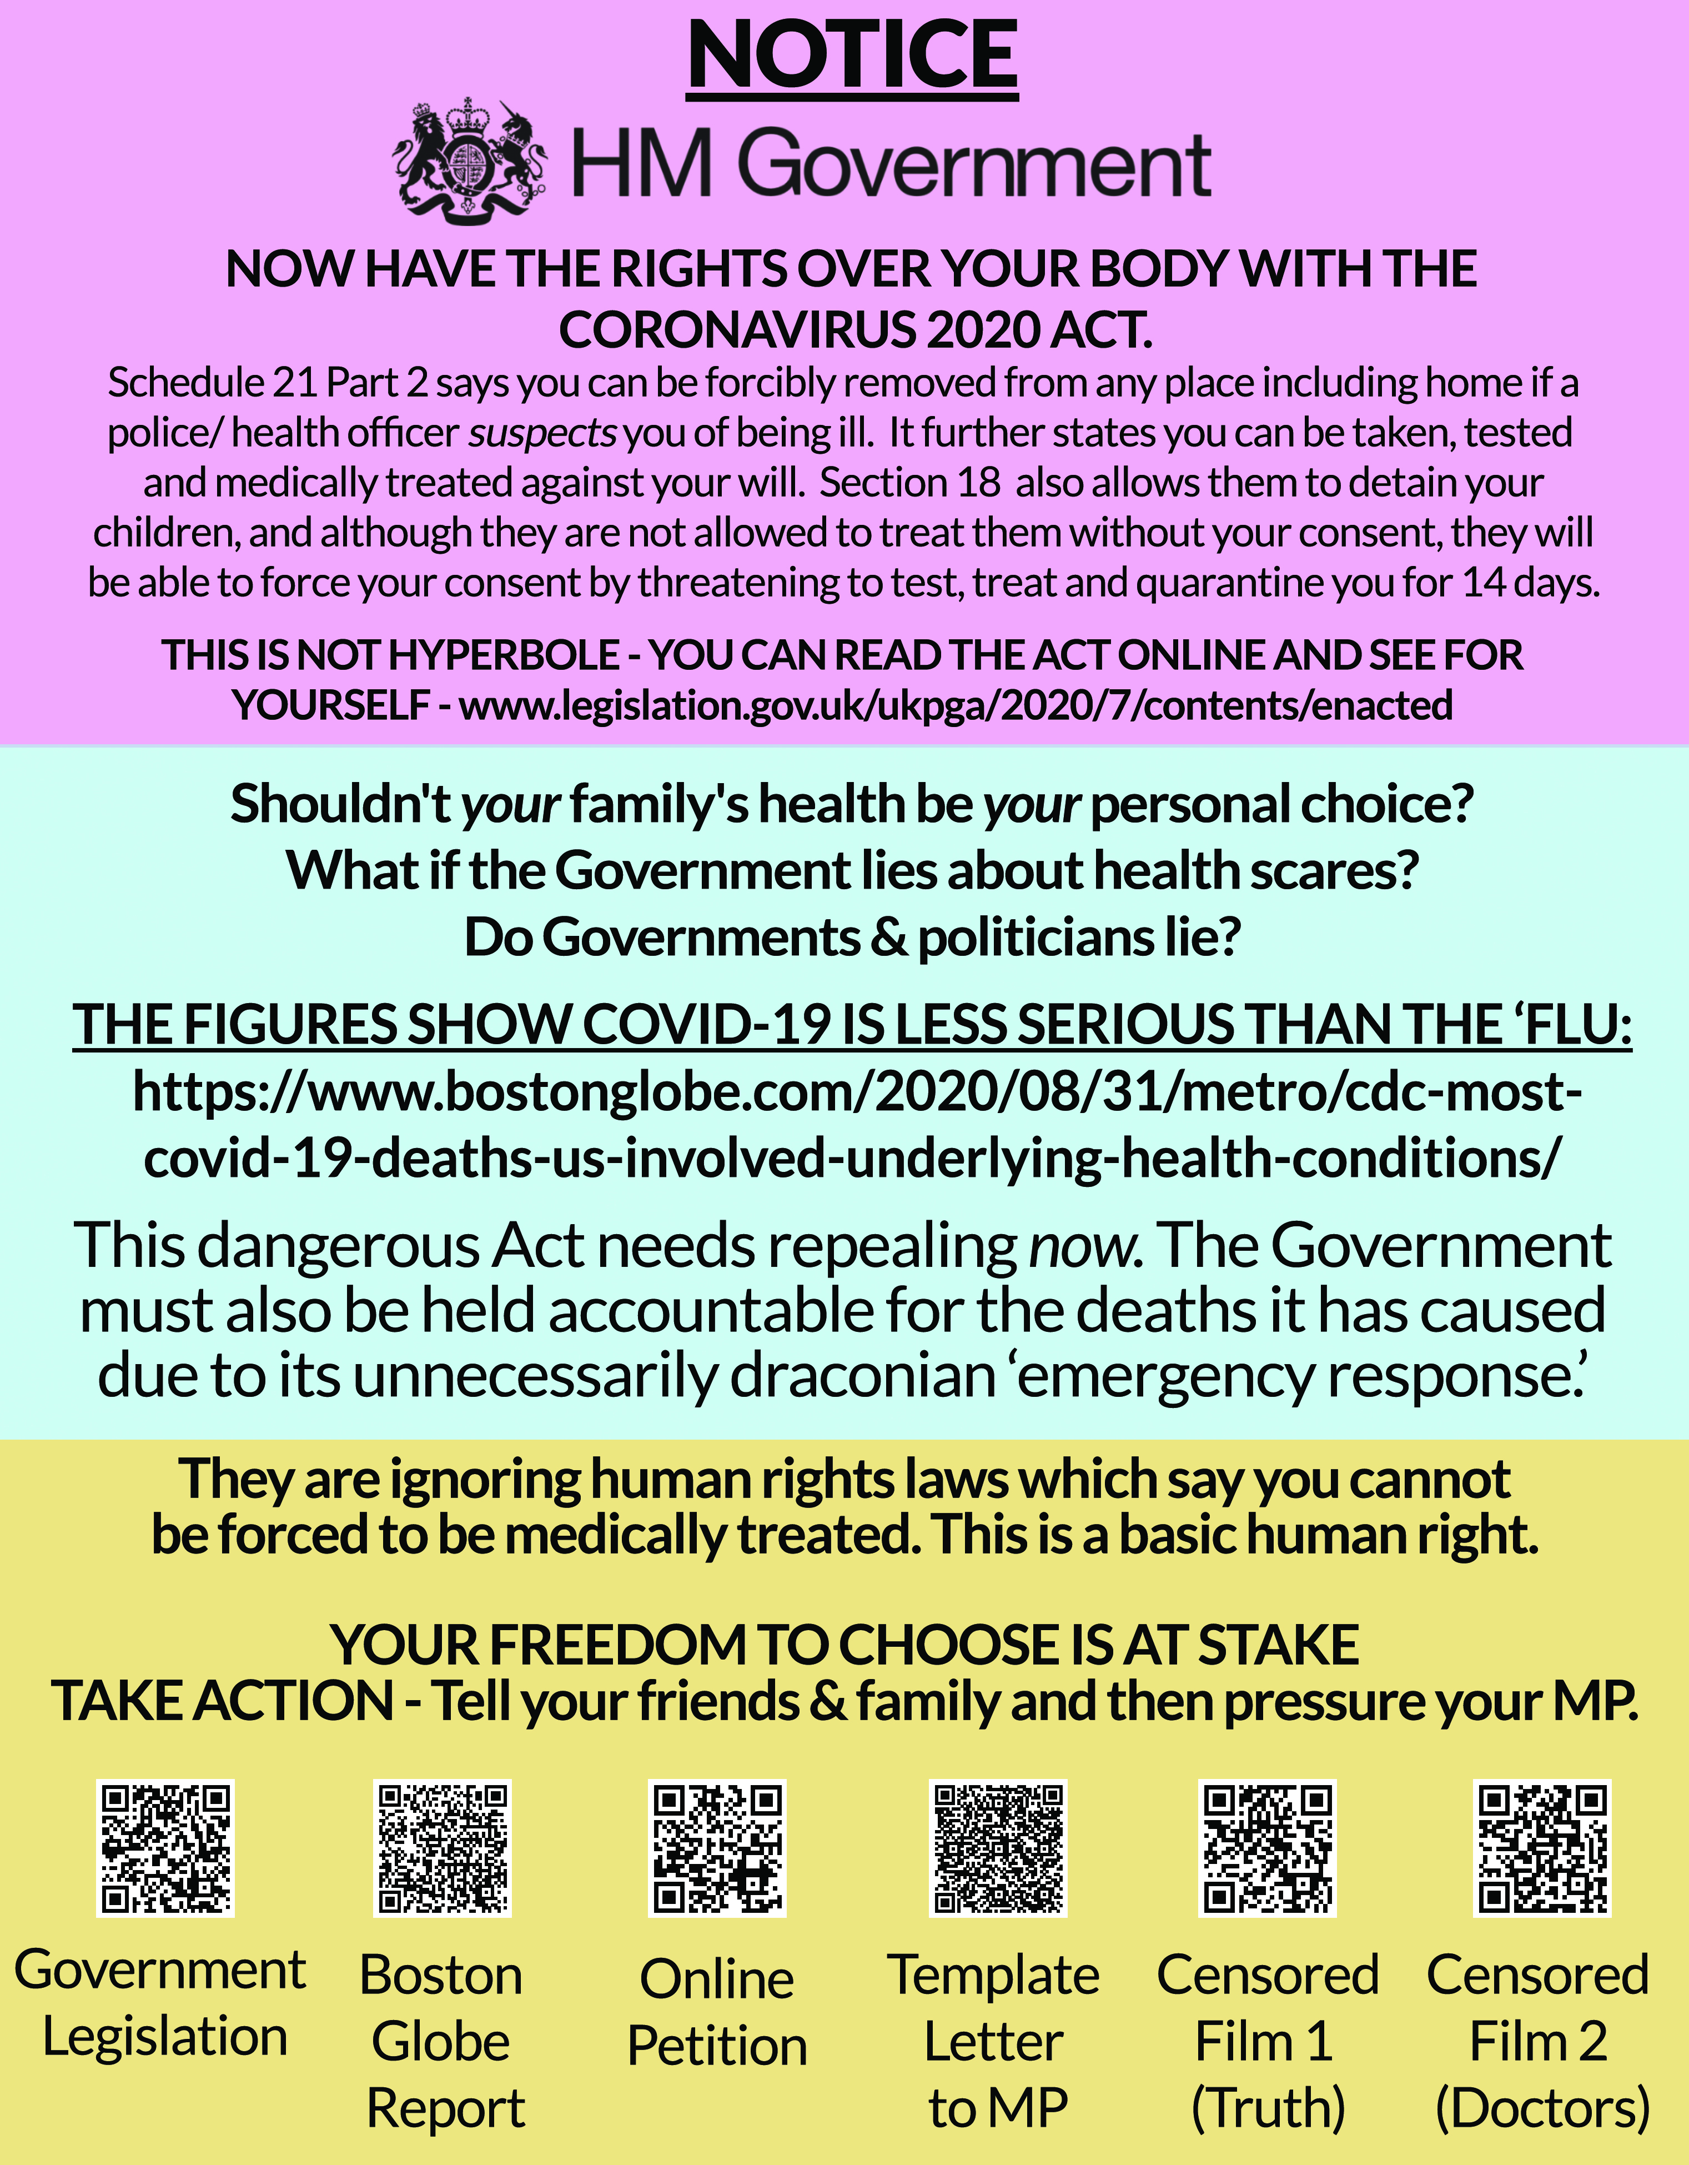

http://thelightpaper.co.uk/index_htm_files/Reject-Refuse-Resist.pdf

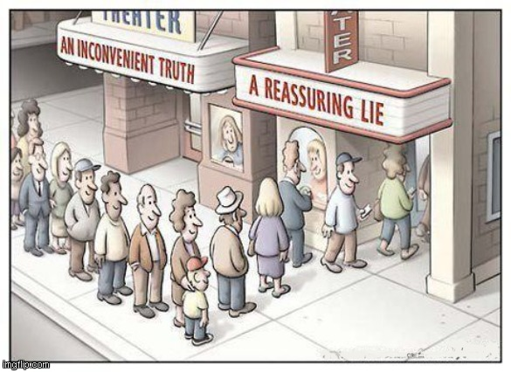

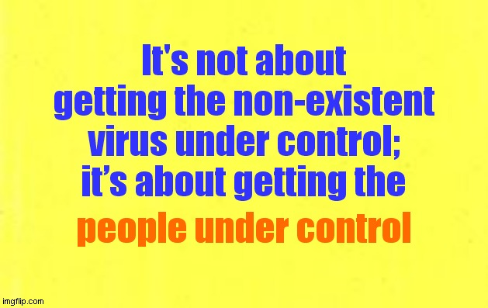

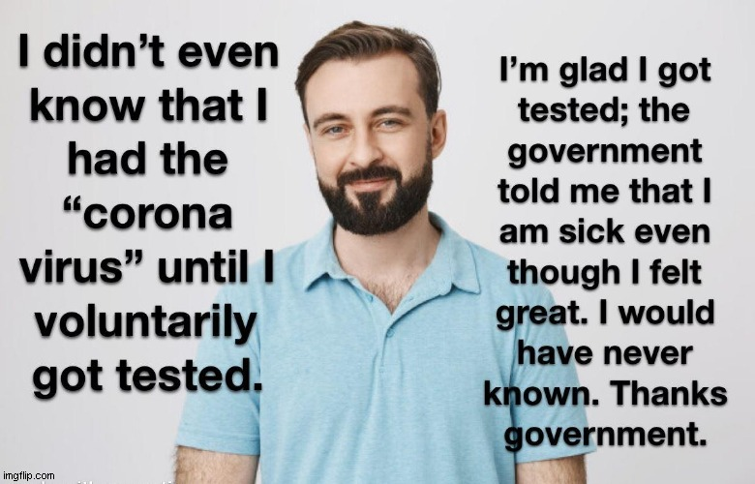

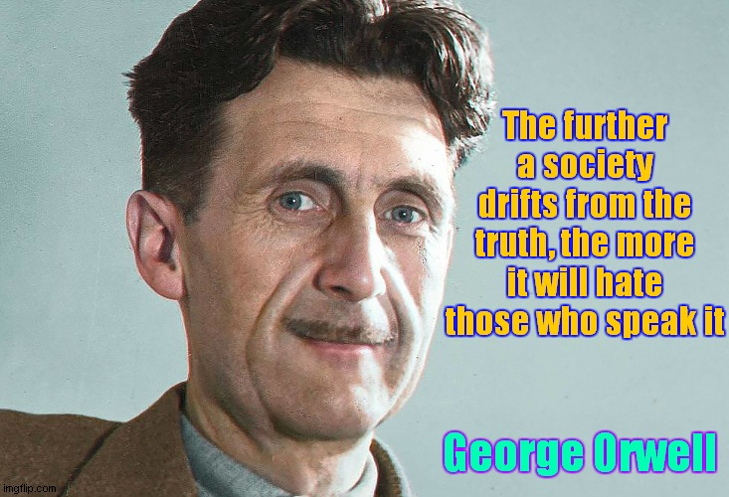

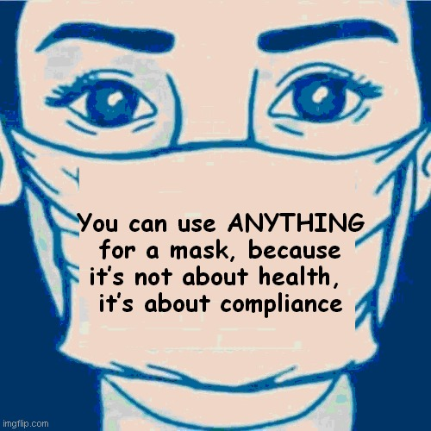

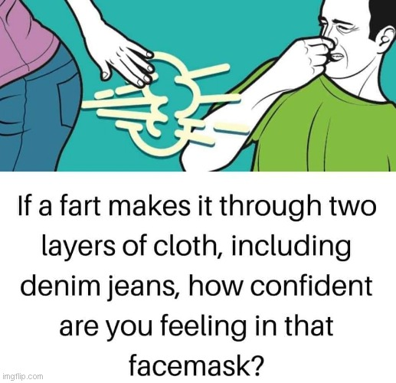

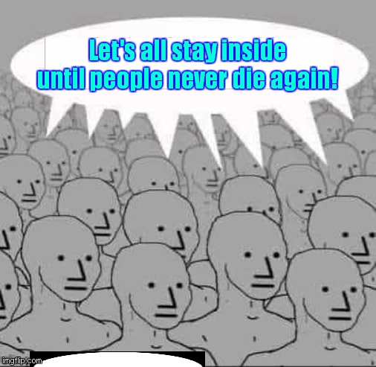

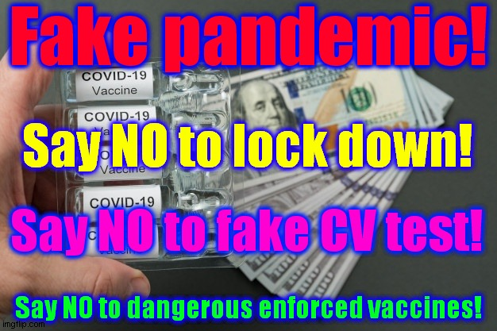

Tests give false positives just to artificially inflate disease rates.

Deaths from cancer or any other disease, old age, accidents, suicides, murders, etc, are all recorded as Covid-19 on death certificates just to artificially inflate death rates.

This is why statistics show that fewer people appear to be dying from any of the above

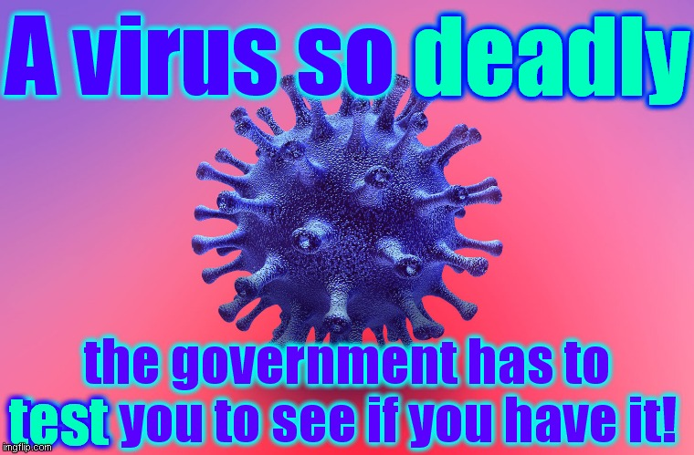

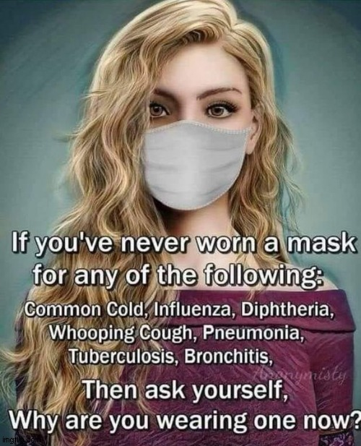

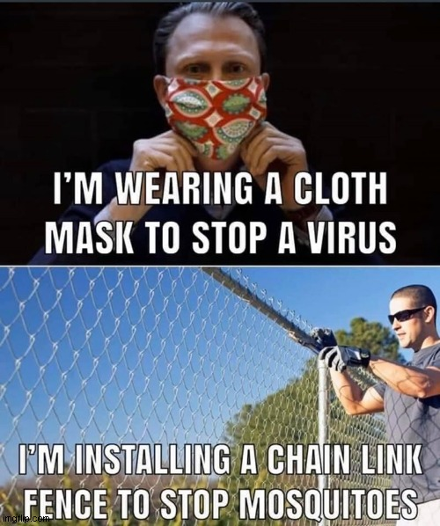

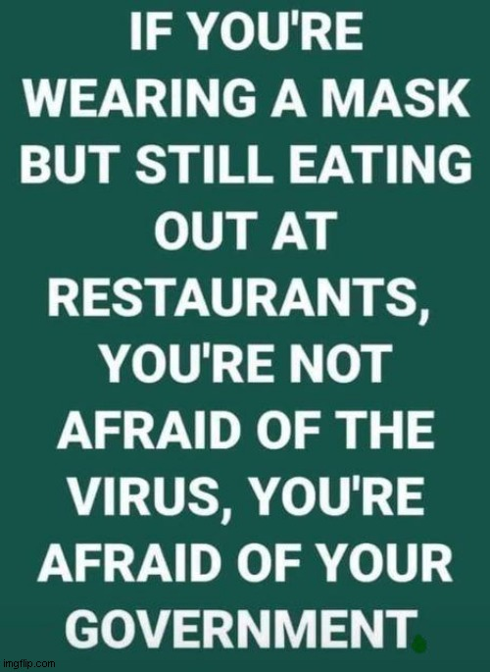

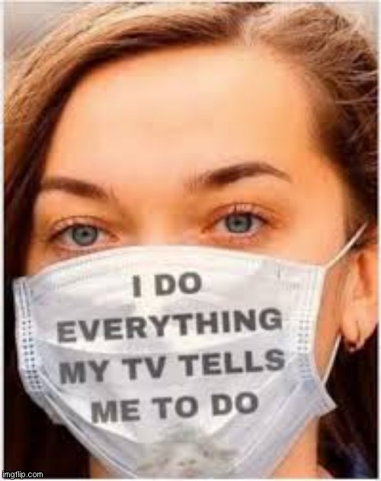

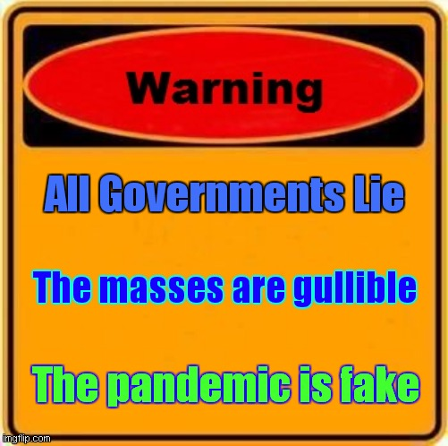

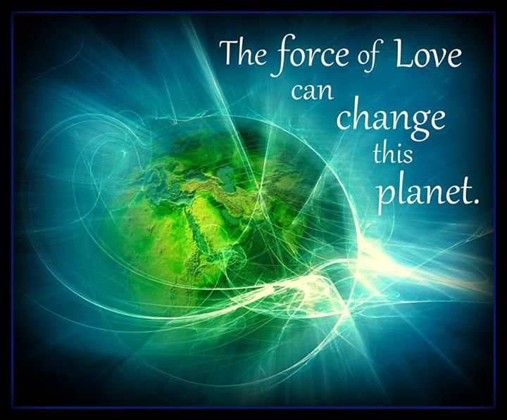

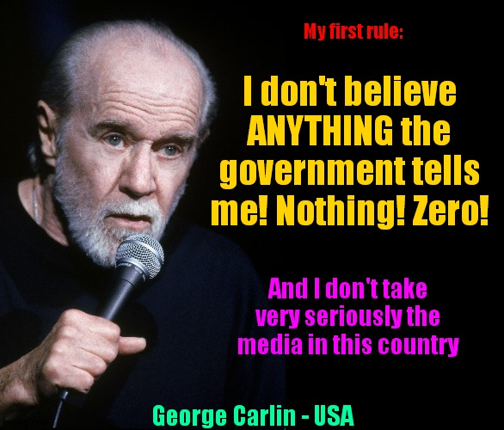

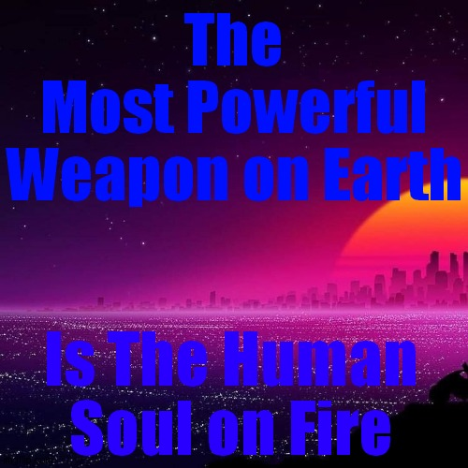

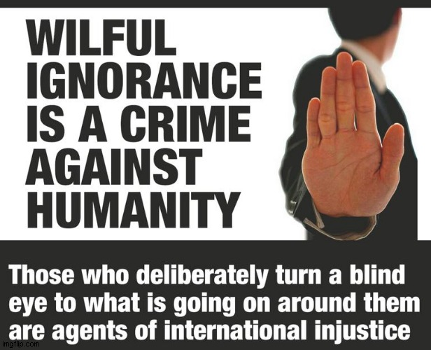



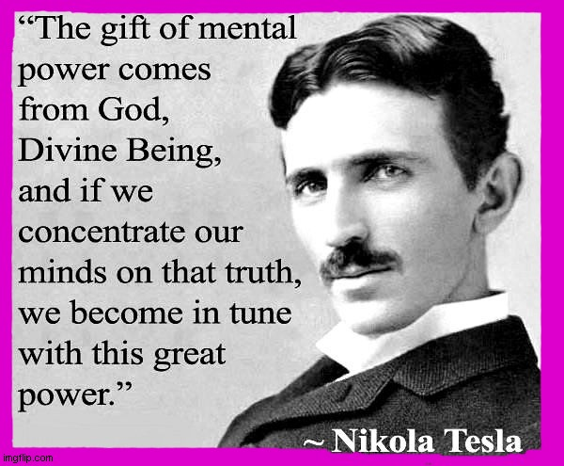

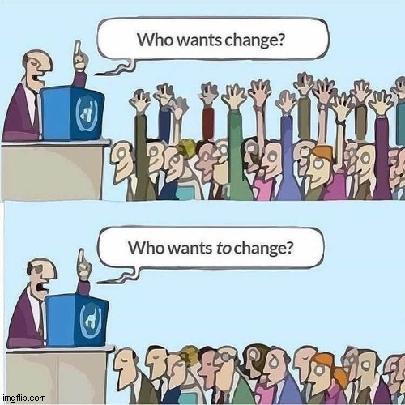

“Everyone thinks of changing the world, but no one thinks of changing himself”

Leo Nikolaevich Tolstoy

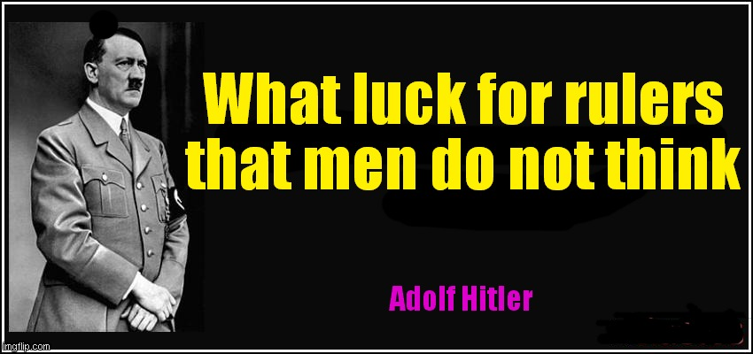

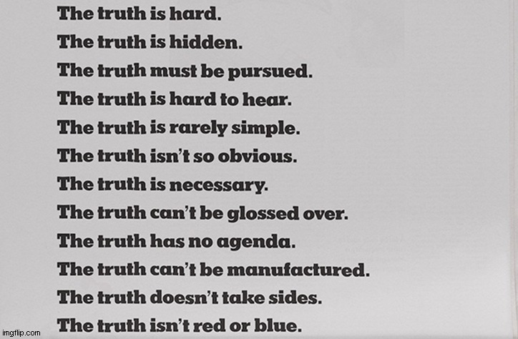

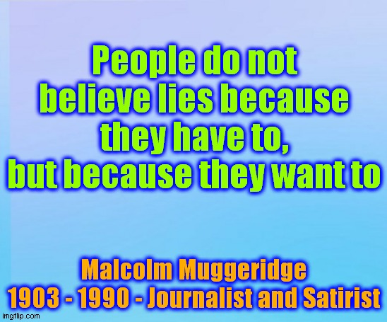

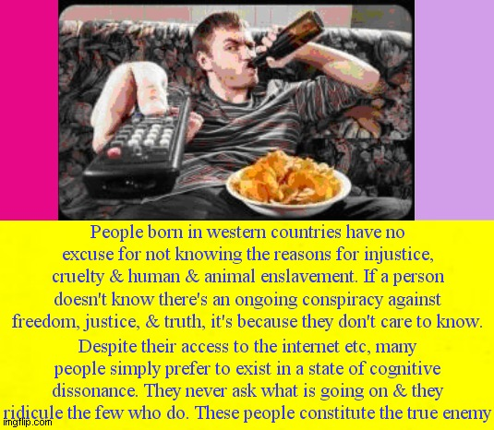



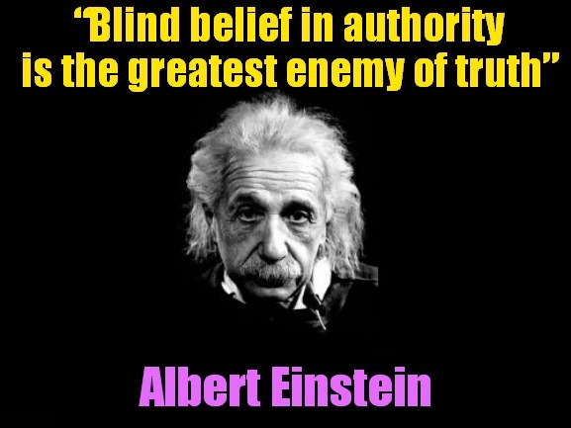

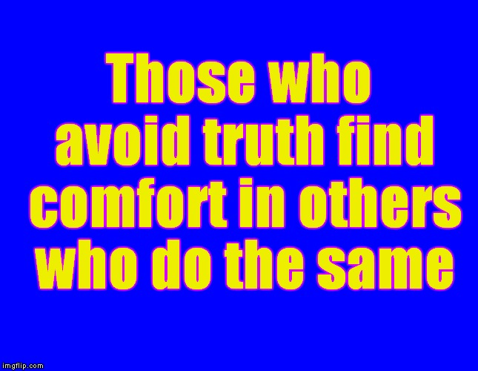

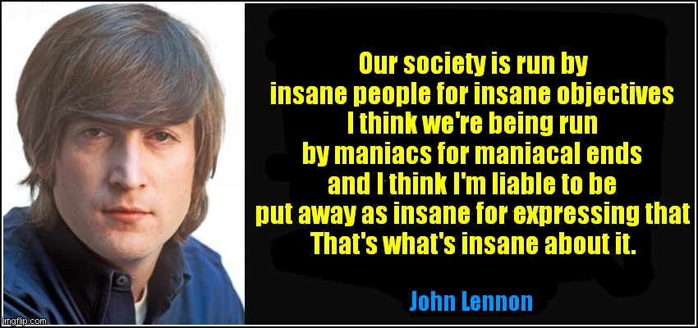



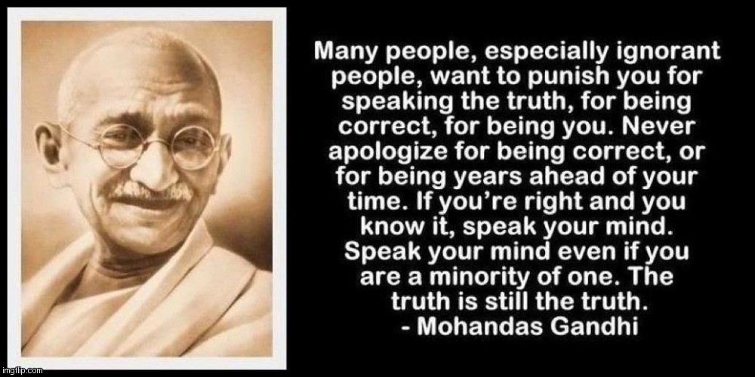

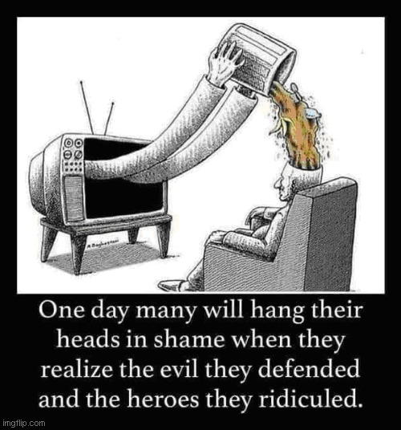

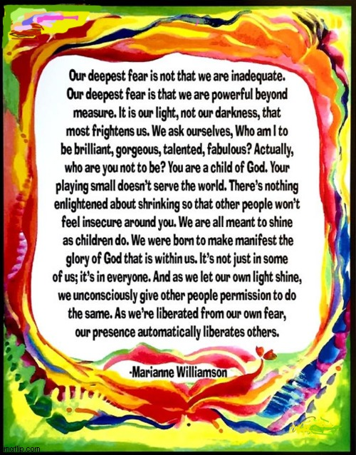

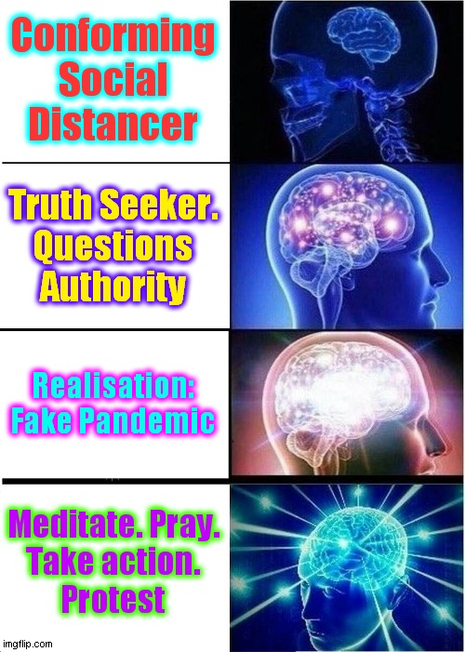

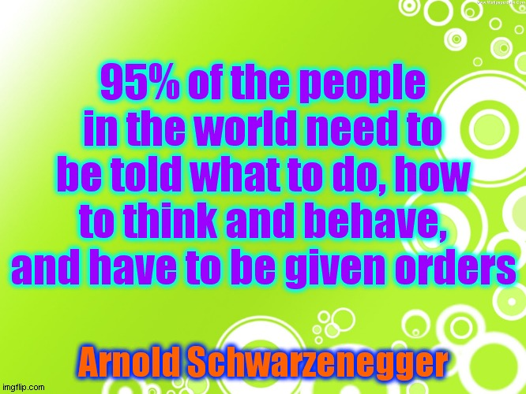

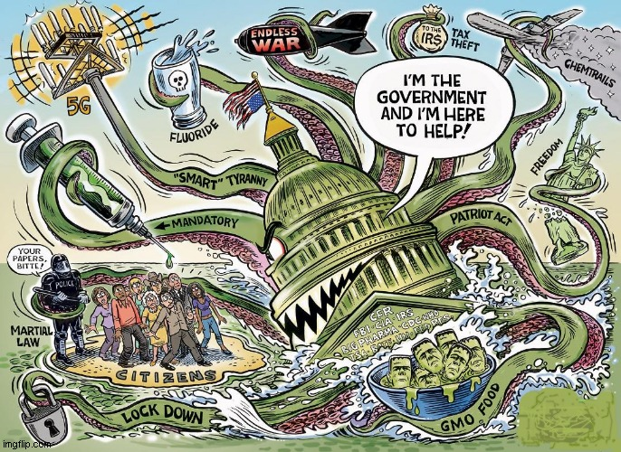

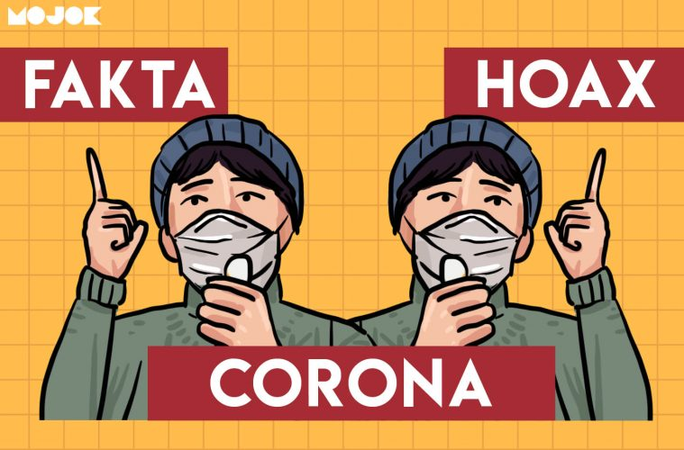

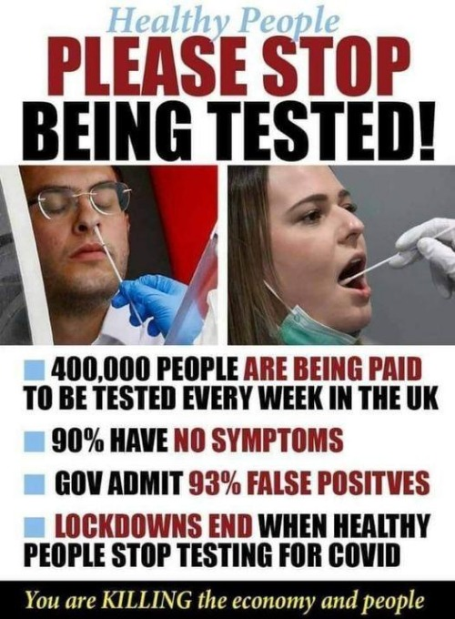

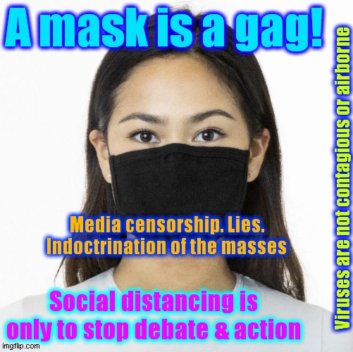

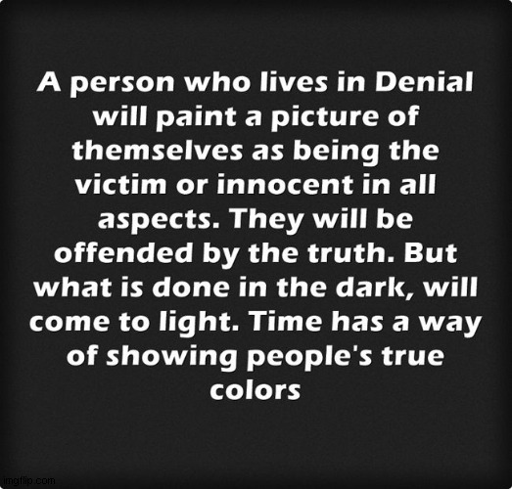



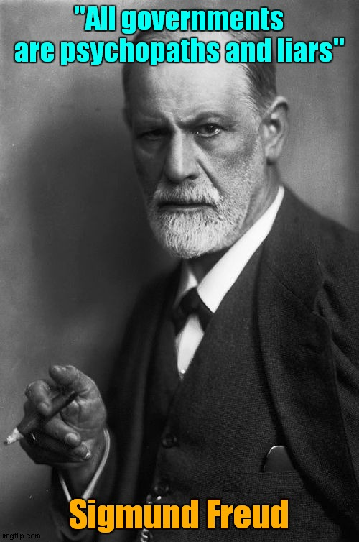

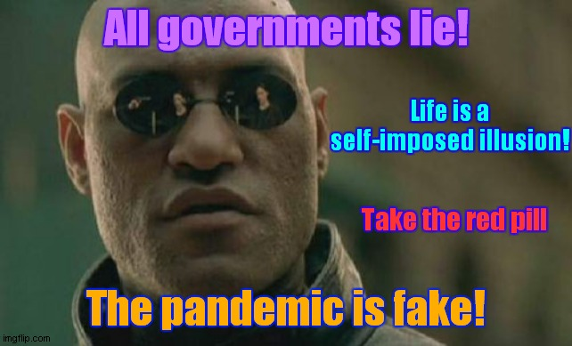

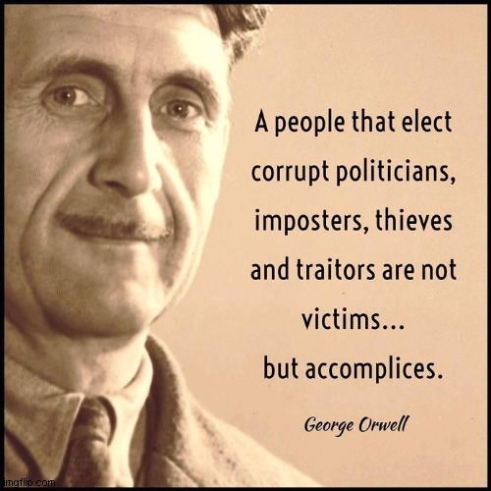

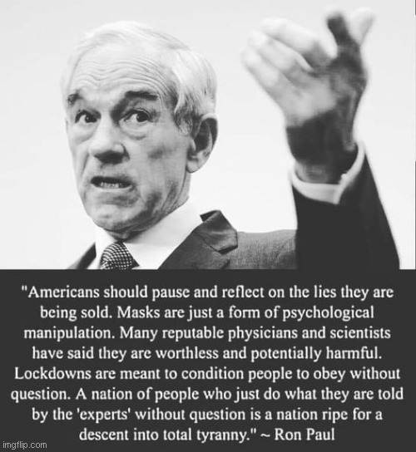

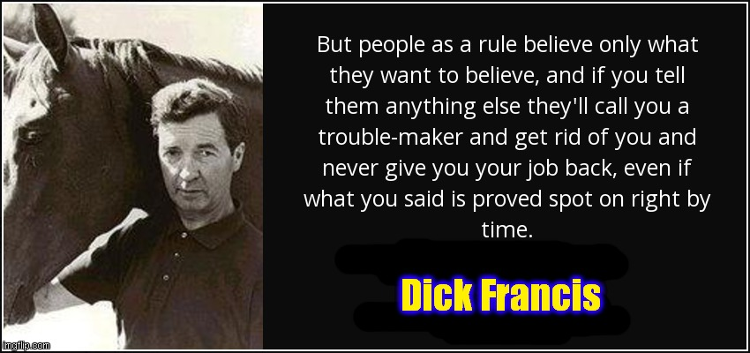

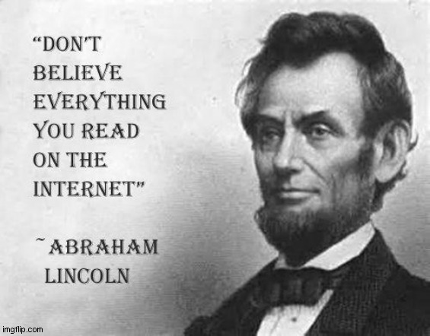





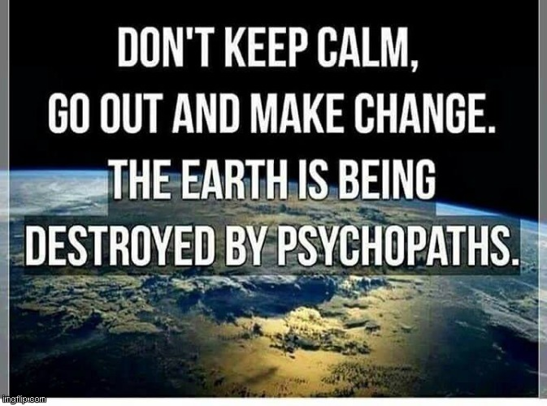

300 species go extinct every day! - 100,000 annually! - due to pollution; mainly chemtrails!
People should be panicking over THIS, not a non-existent virus.

https://actionnetwork.org/groups/pollution-solution - Chemtrail Truth

https://www.youtube.com/watch?v=WfGMYdalClU - Man - Steve Cutts - 3 min - Brilliant!

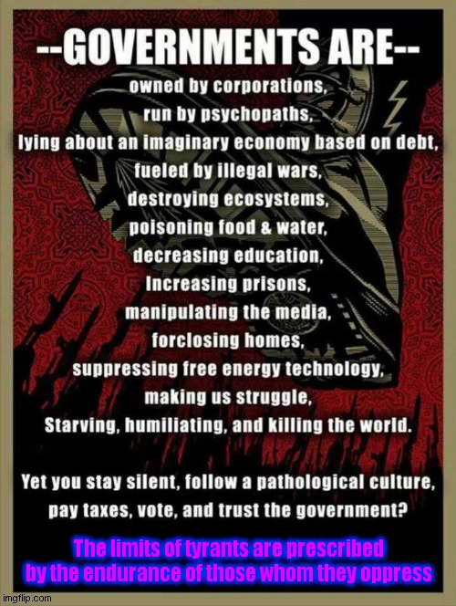

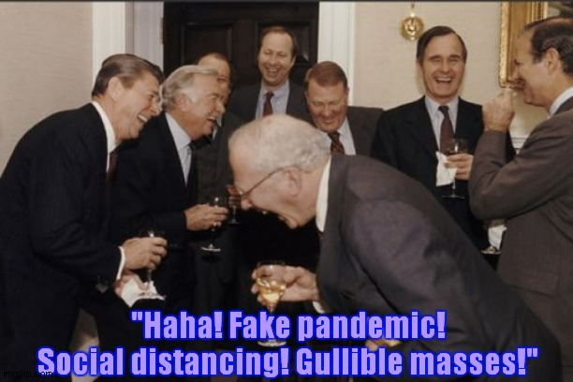

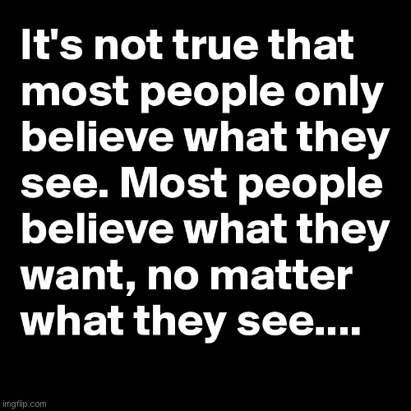

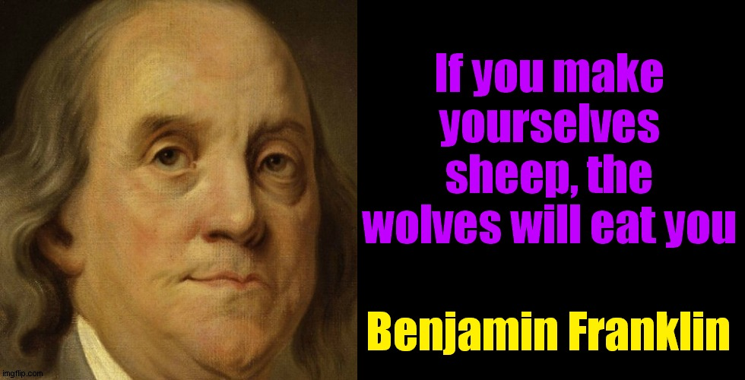

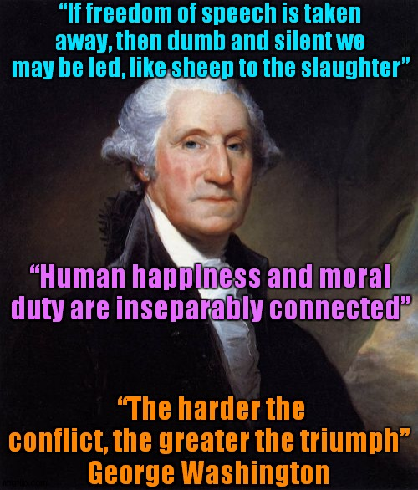

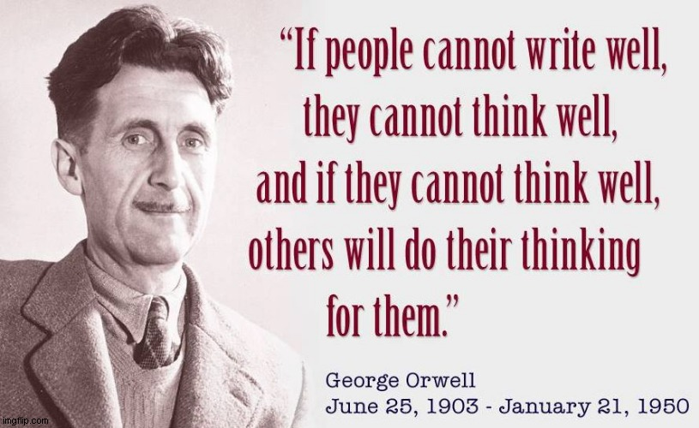

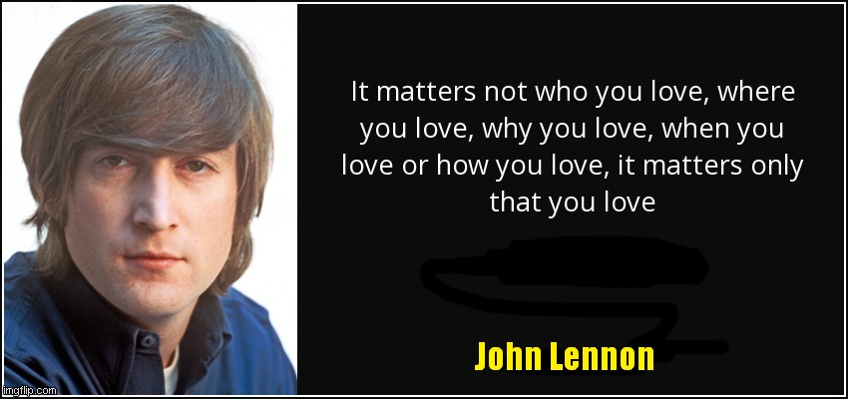

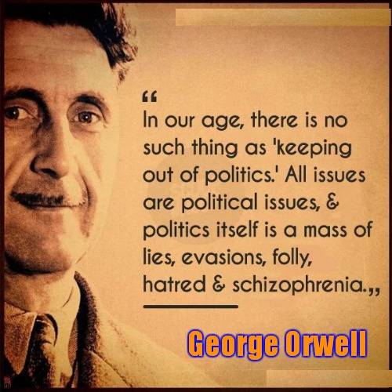

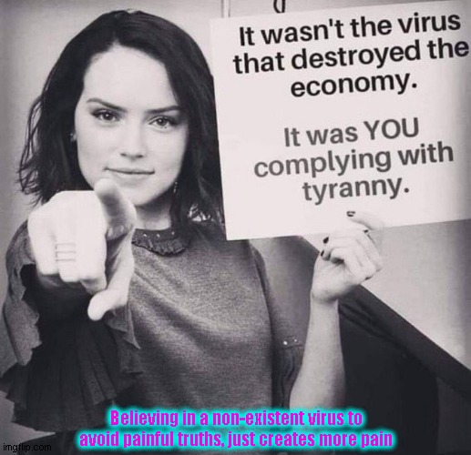

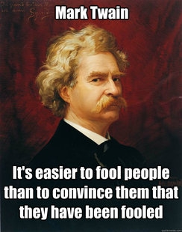



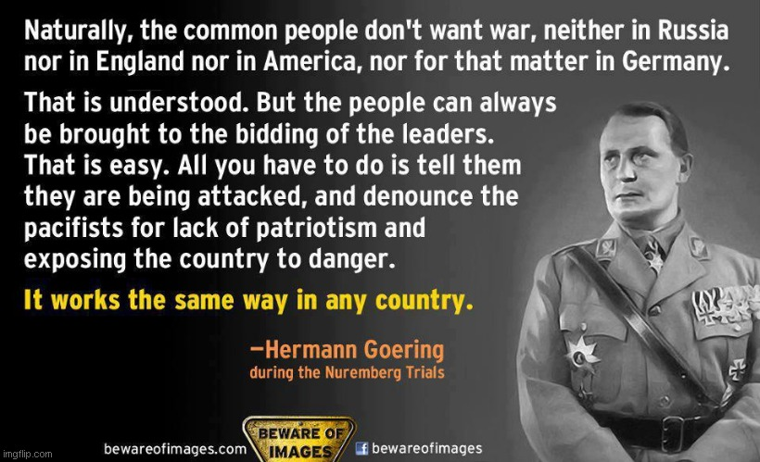





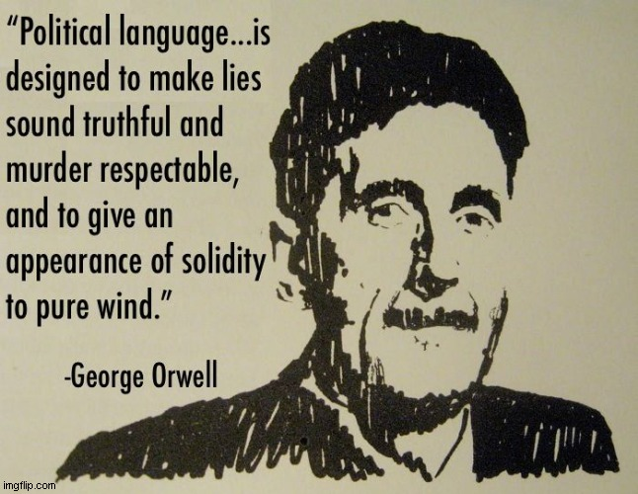

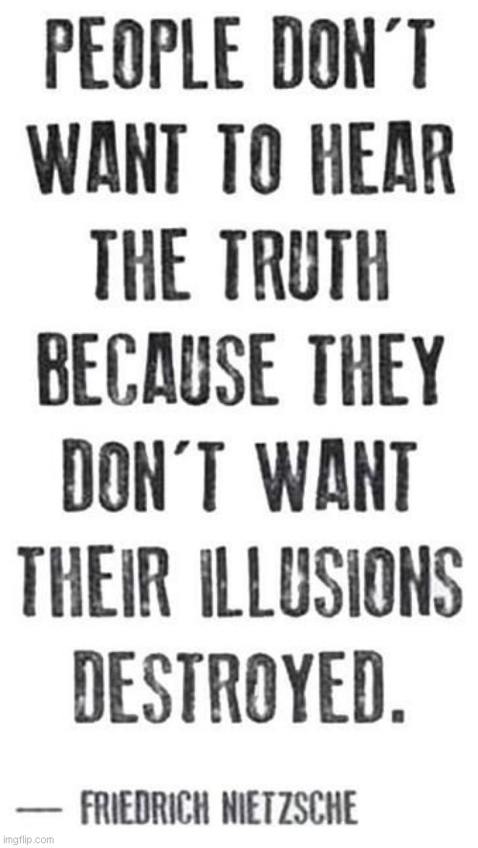

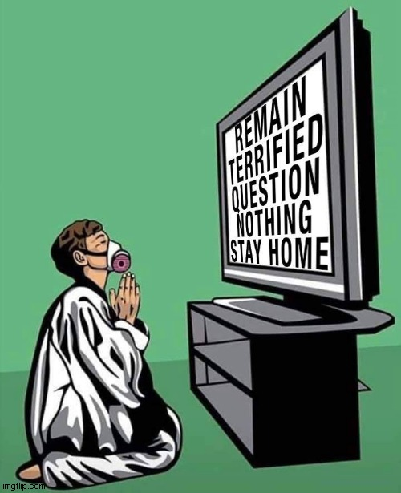

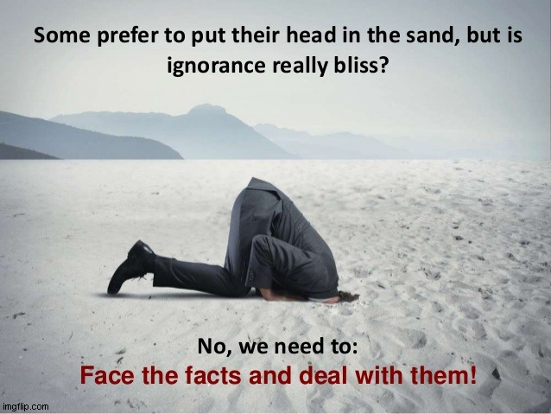

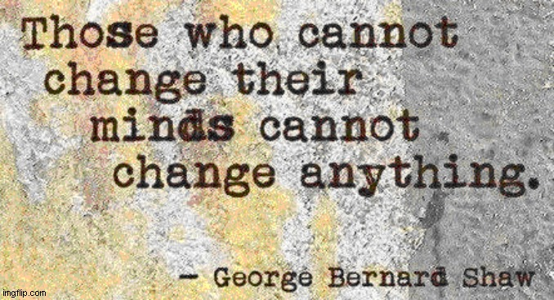

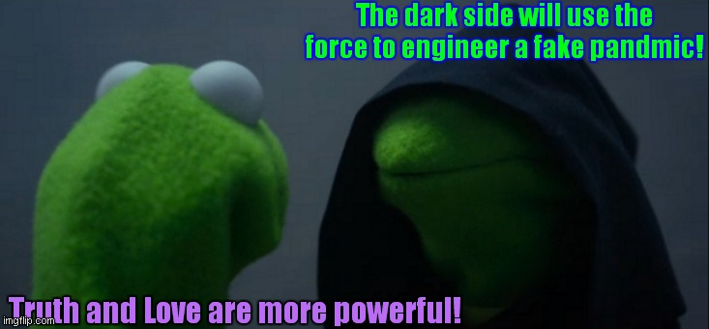

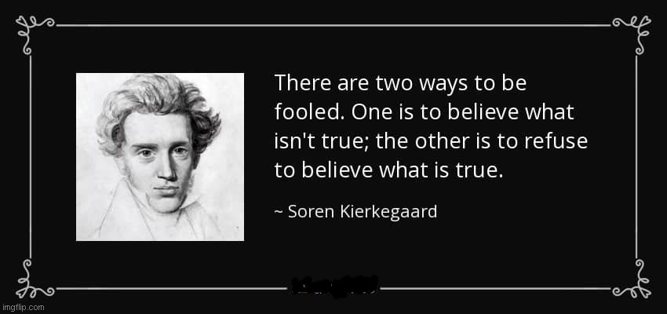

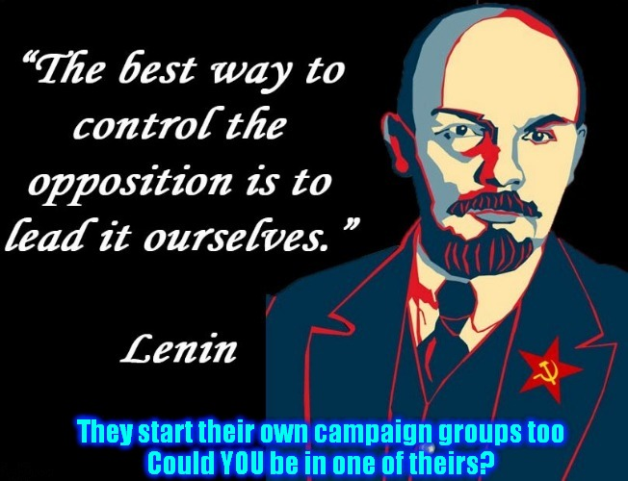

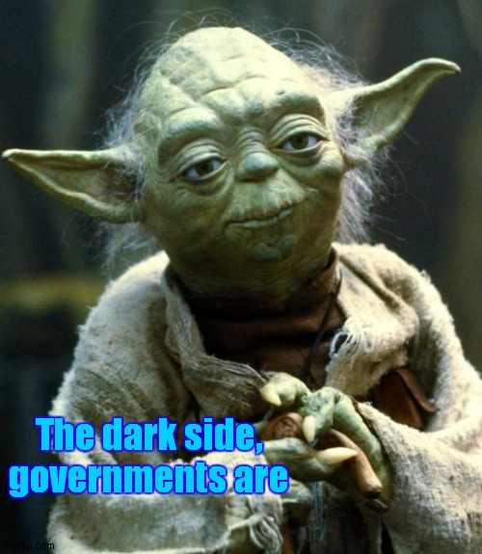



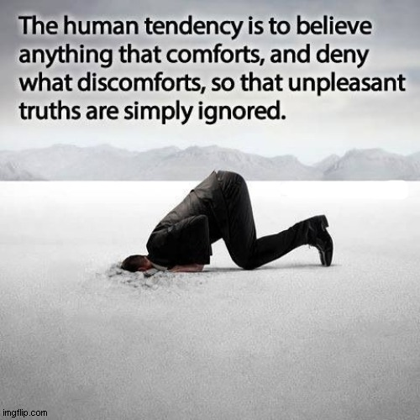

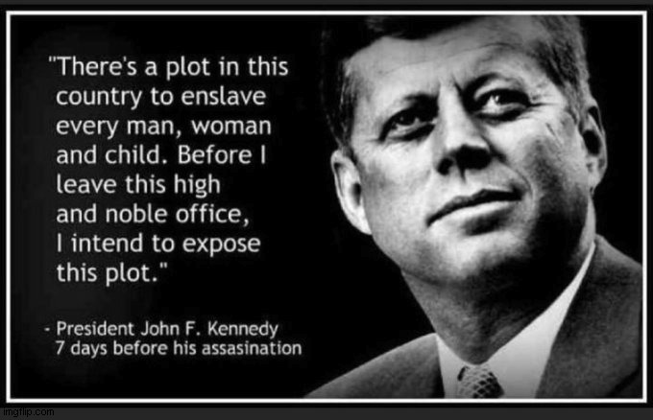

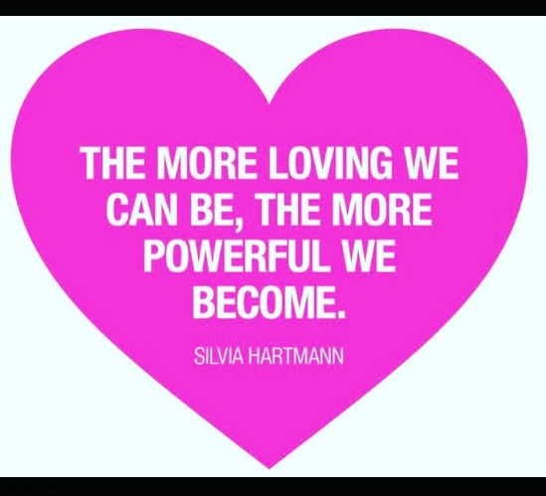

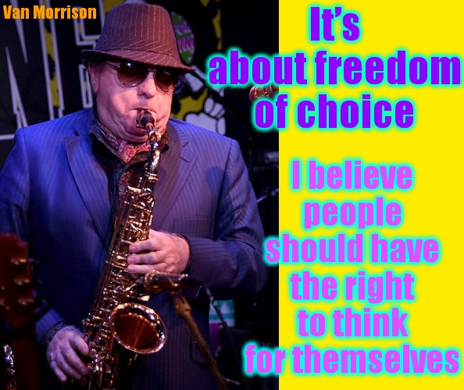

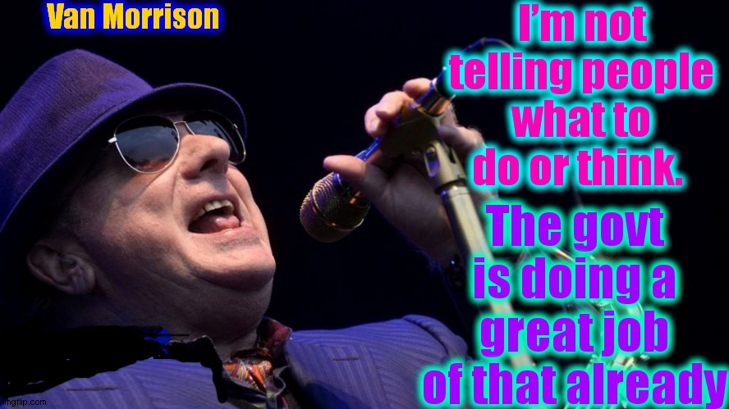

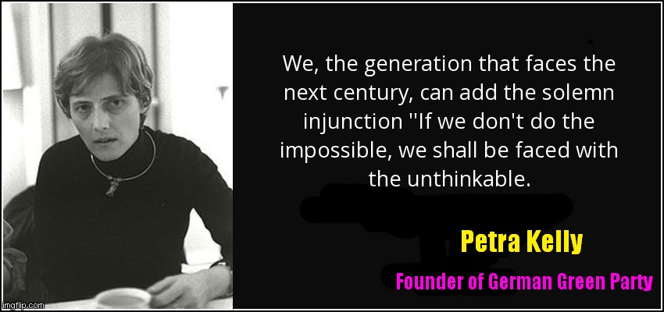

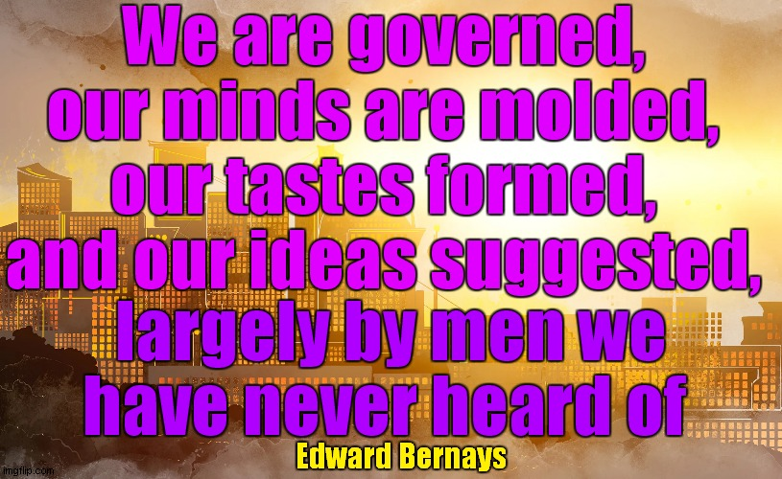

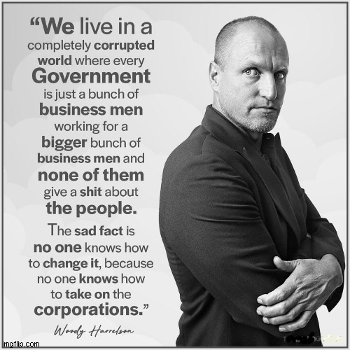



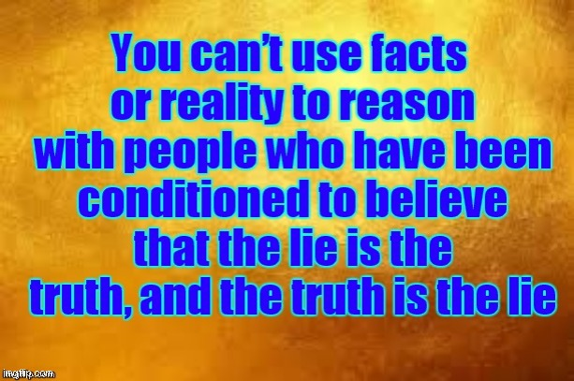

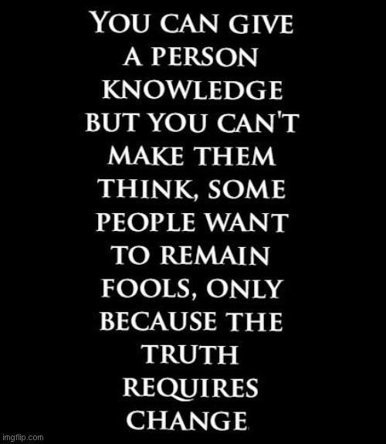

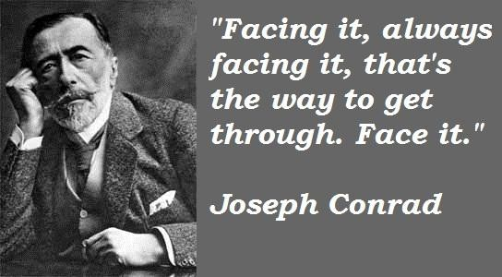

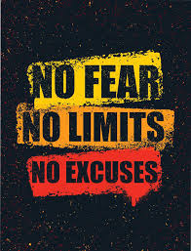

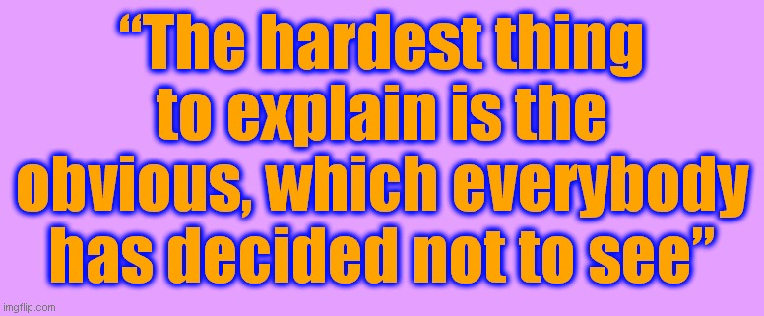

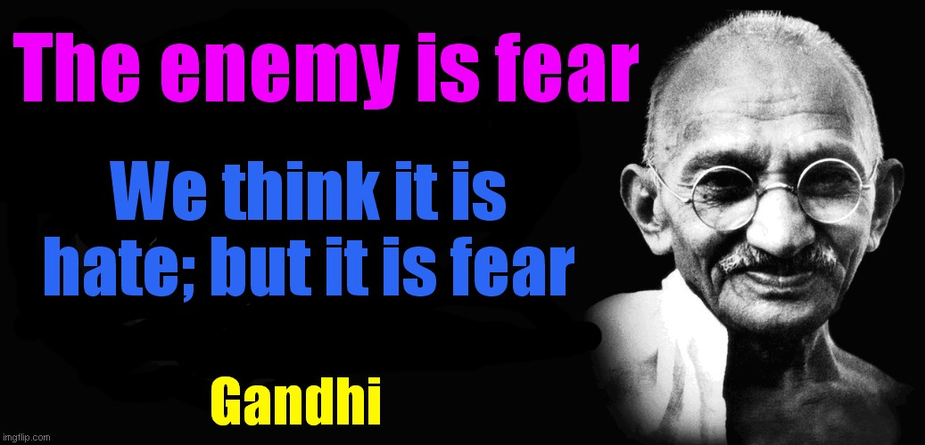

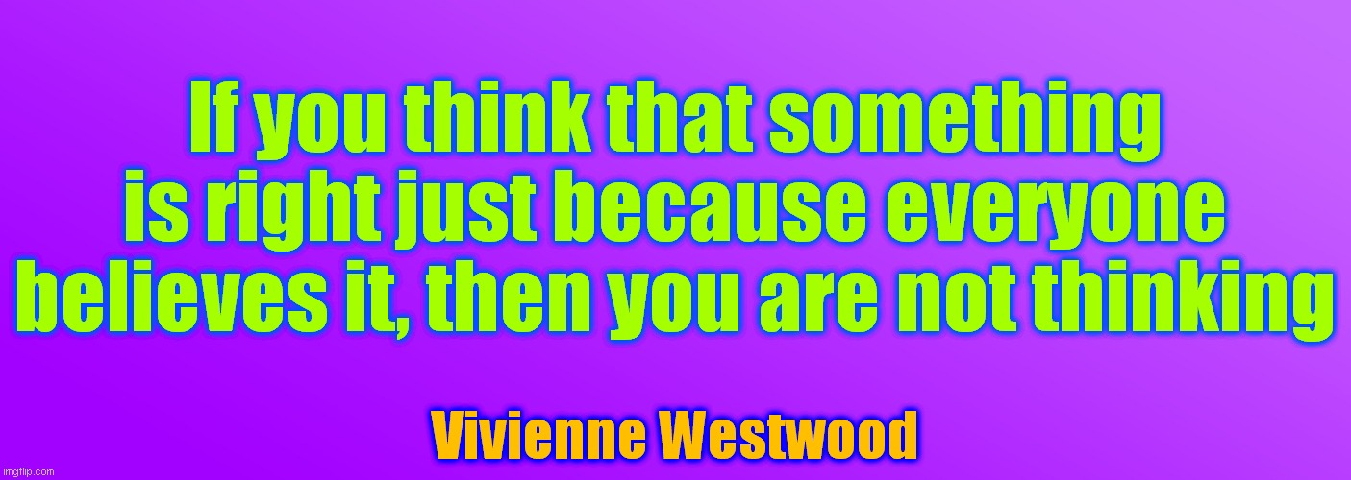

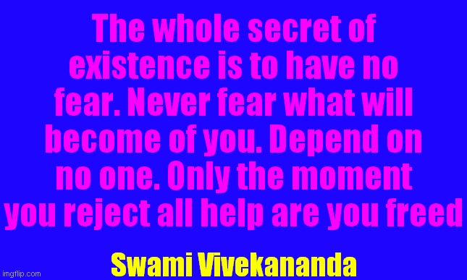

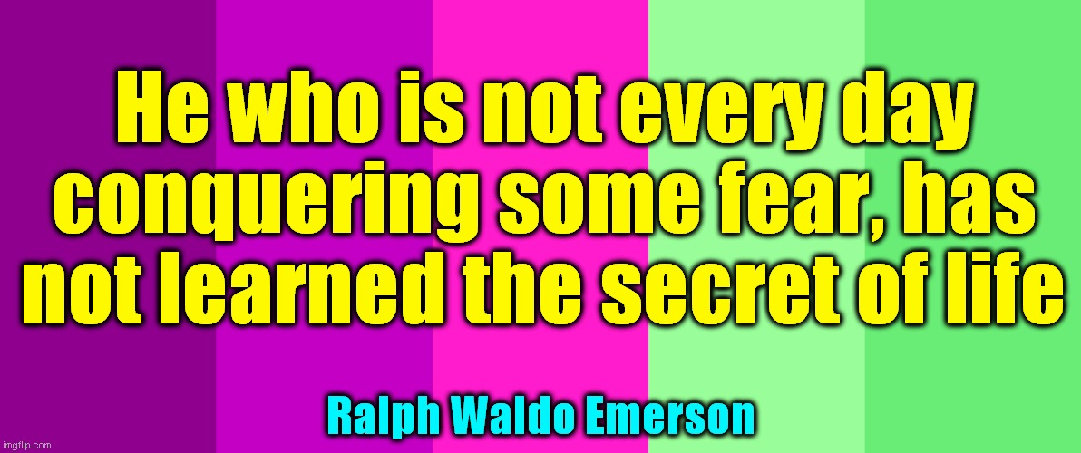



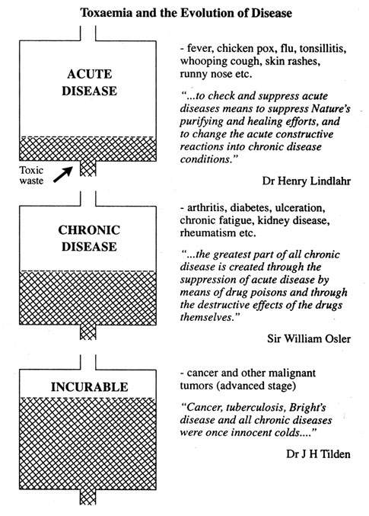

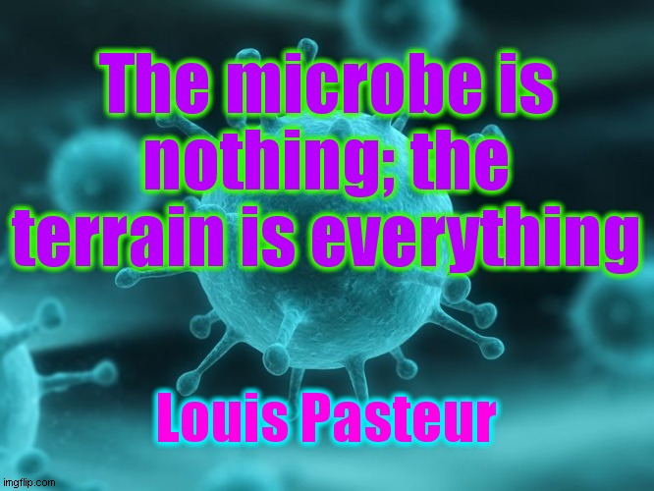



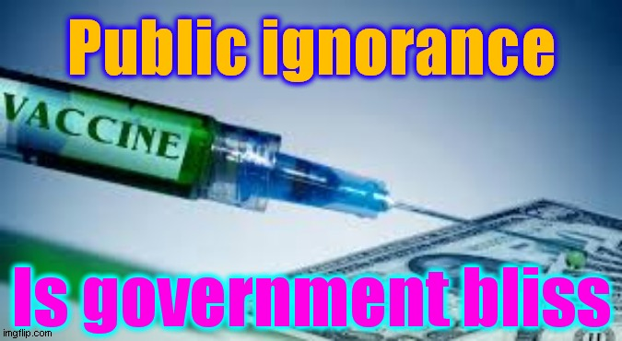

The flu vaccines in 2019 were made more toxic than usual to help create the illusion of a pandemic in 2020.

Also, the flu vaccine and any other vaccine being given in 2020 may be the Covid vaccine which contains harmful microchips, nano-bots (nano robots), and substances which alter your DNA permanently, which is very dangerous. This may lead to another engineered ‘pandemic’. The planned response to this will be more vaccines, which means more profit for the evil drugs industry/government combined. Refuse ALL vaccines!

Before Edward Jenner died, he correctly stated that all vaccines are unsafe and ineffective, but people were already exploiting them for profit. Greed, ego, fear, guilt, bias, blind belief in authority, and wilful ignorance, keep this fact hidden. Jenner’s vaccines killed his own son, along with several dairy maids.

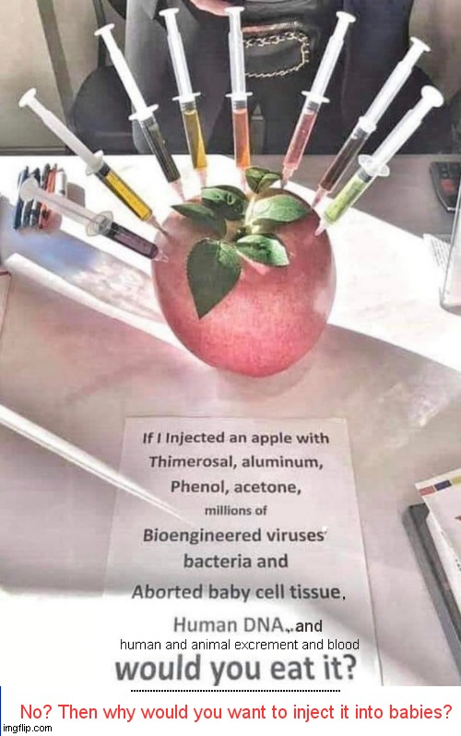

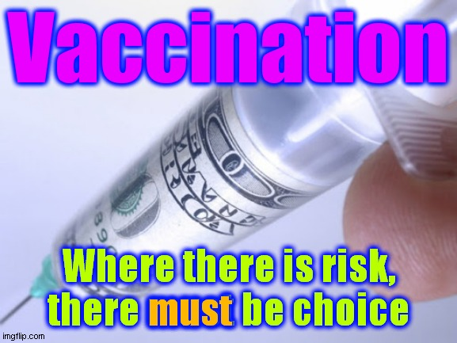

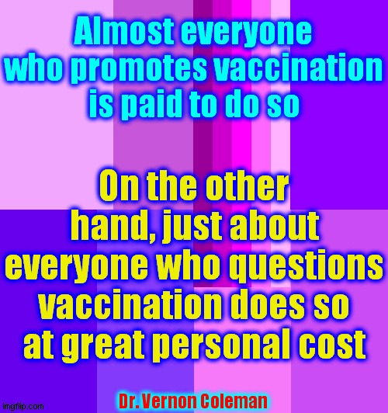

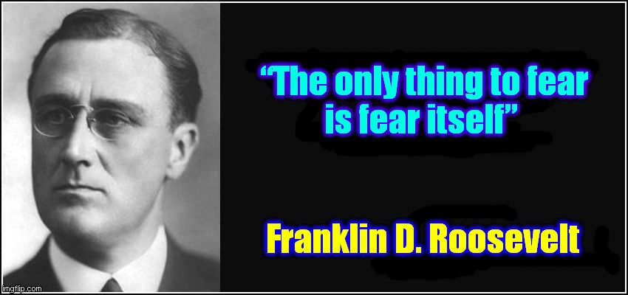

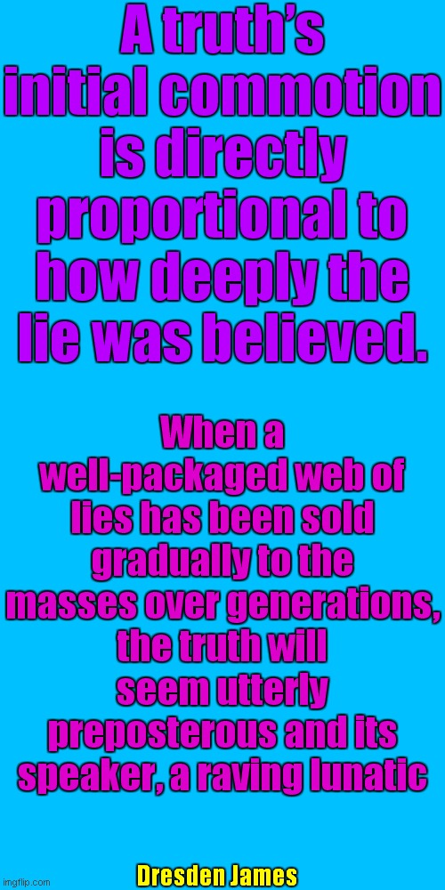

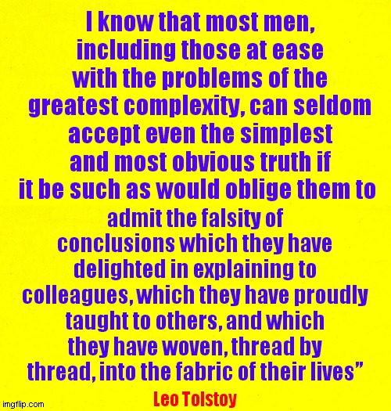

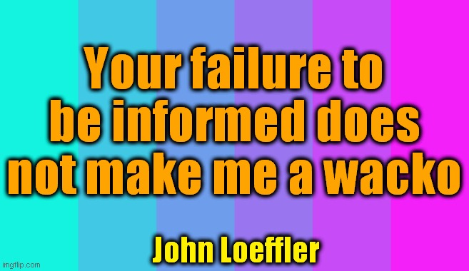

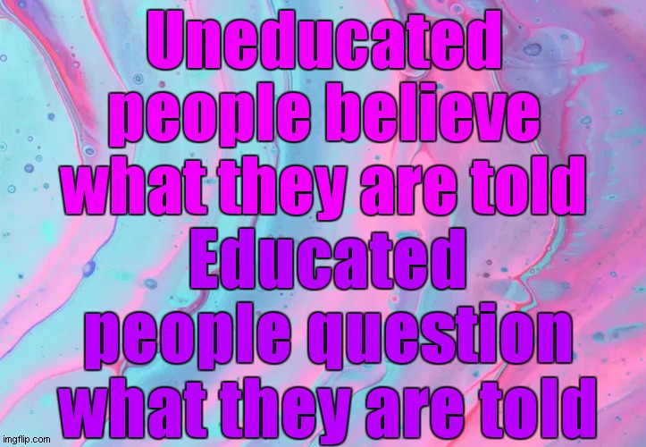

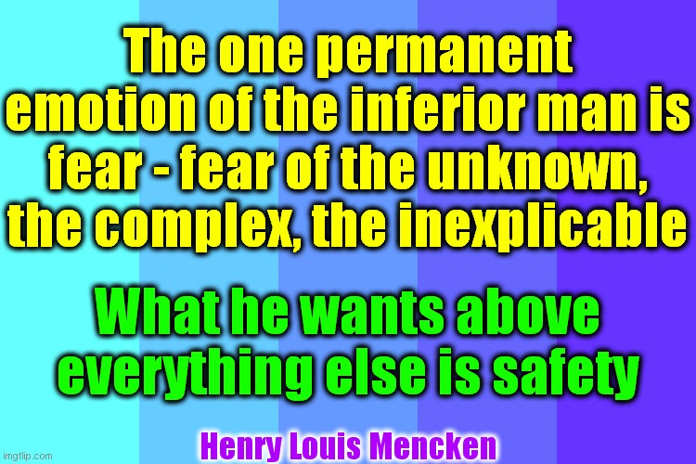

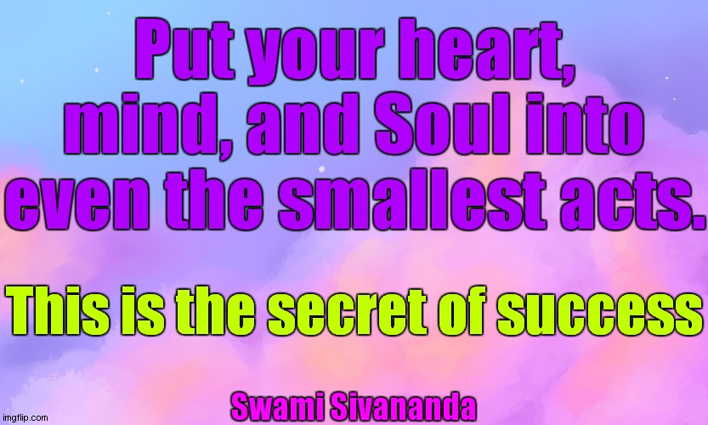

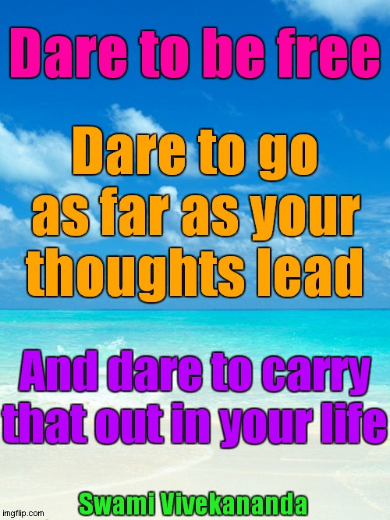

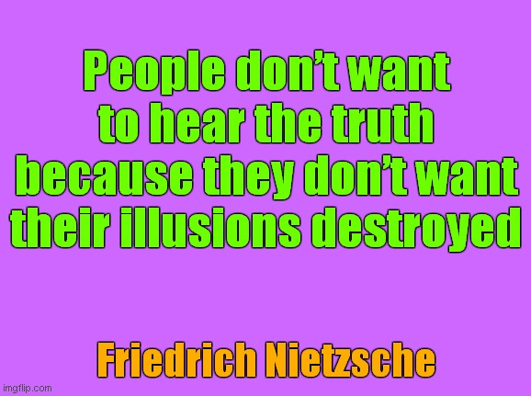

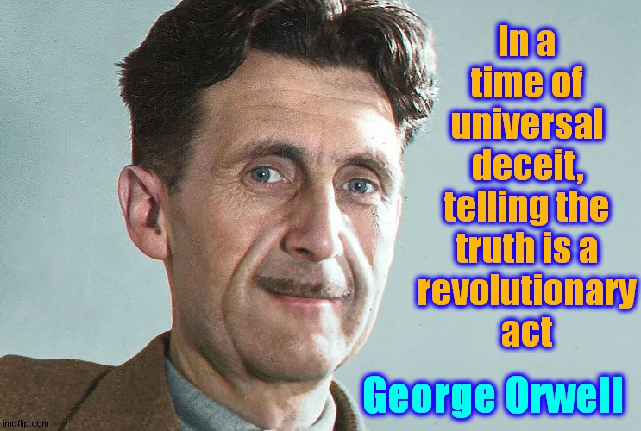

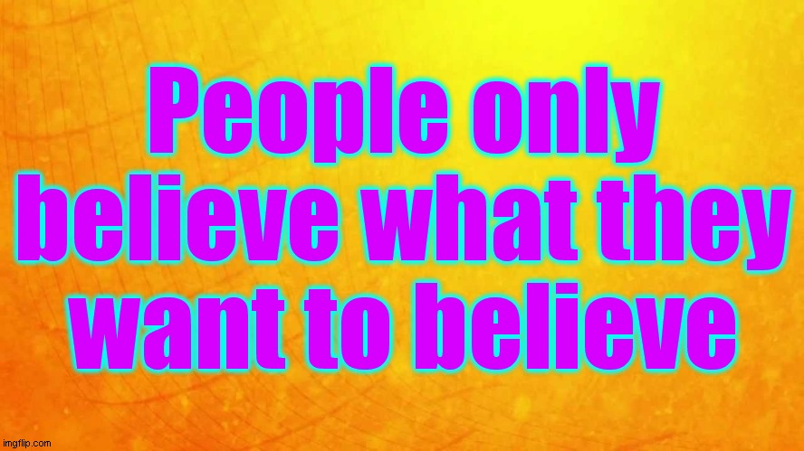

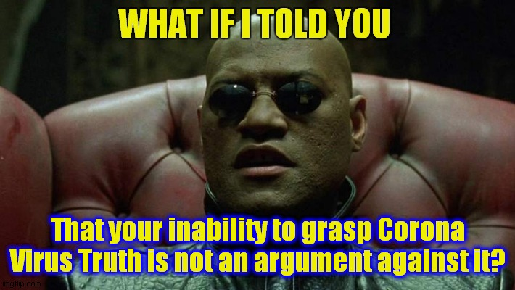

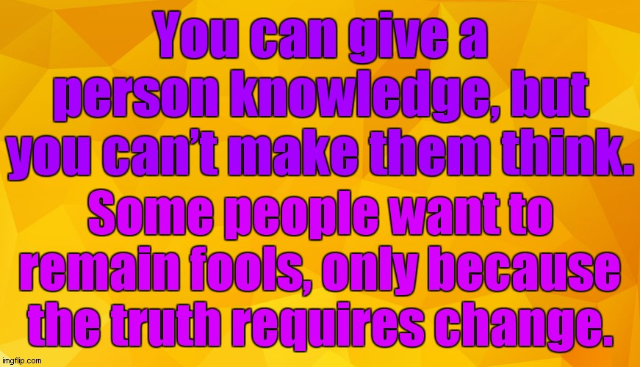

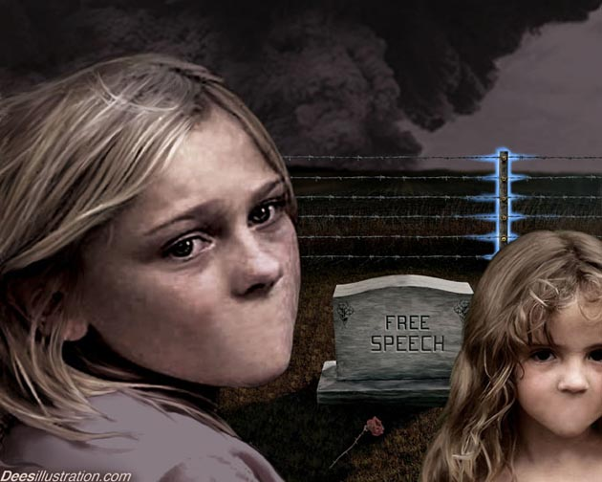

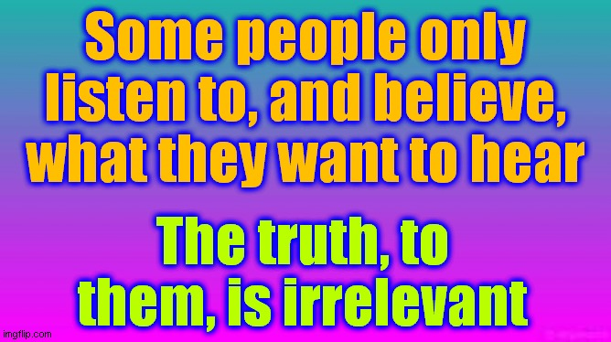

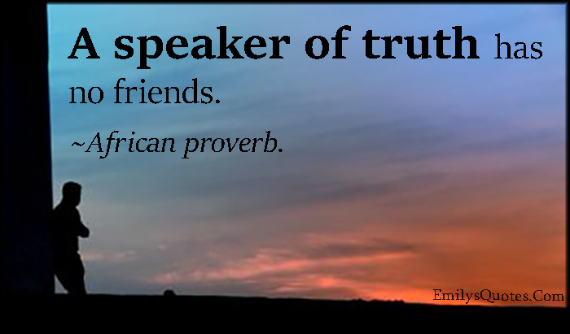





IF you want it

We can change this planet from dark to Light very quickly, just with the power of positive thought and the energy of Love

Choices. Urgent decisions

Love or fear. Peace or engineered war. Face reality, or deny and suffer. Mask or Truth

Open or close the Heart and mind

It sounds too simple, but inner and global change is just a Compassionate thought away

We have to change sometime. The sooner the better. Time is very short

The Mental Revolution starts with you

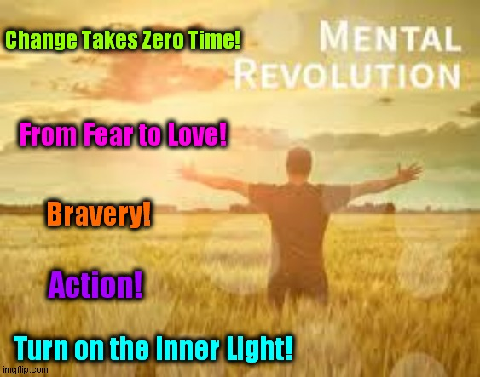


A simple choice. Which life and planet do you choose?

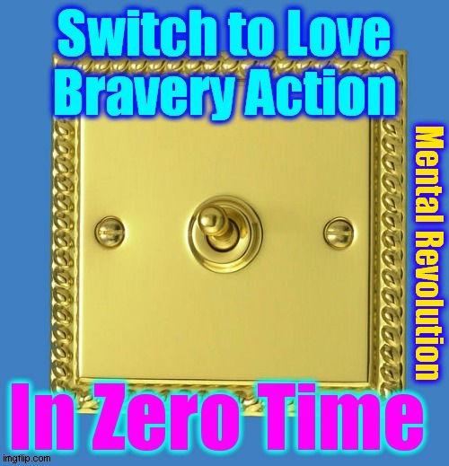

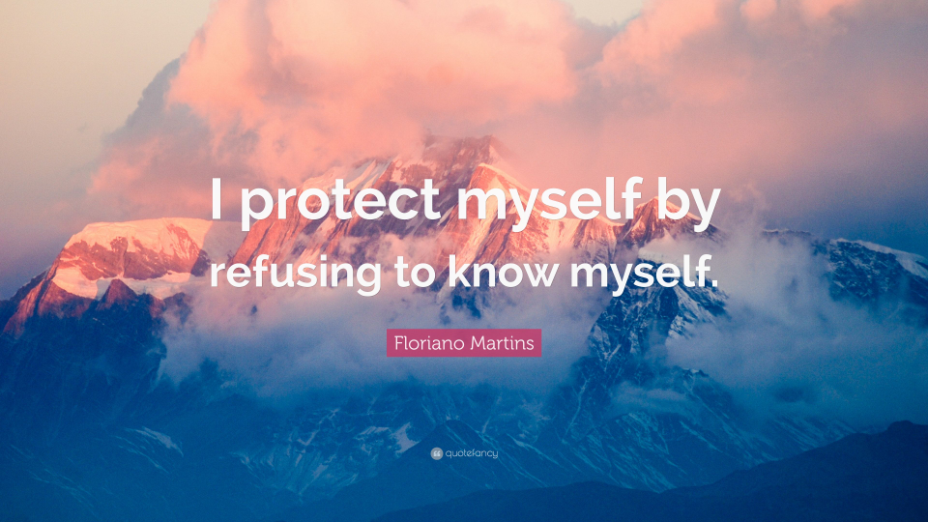

“Until one is committed, there is hesitancy, the chance to draw back, always ineffectiveness concerning all acts of initiative and creation. There is one elementary truth, the ignorance of which kills countless ideas and splendid plans; that the moment one definitely commits oneself, then providence moves too. All sorts of things occur to help one that would never otherwise have occurred. A whole stream of events issues from the decision, raising in one’s favour all manner of unforeseen incidents and meetings and material assistance which no man could have dreamed would have come his way. Whatever you can do or dream you can, begin it. Boldness has genius, power, and magic in it. Begin it now”
Goethe

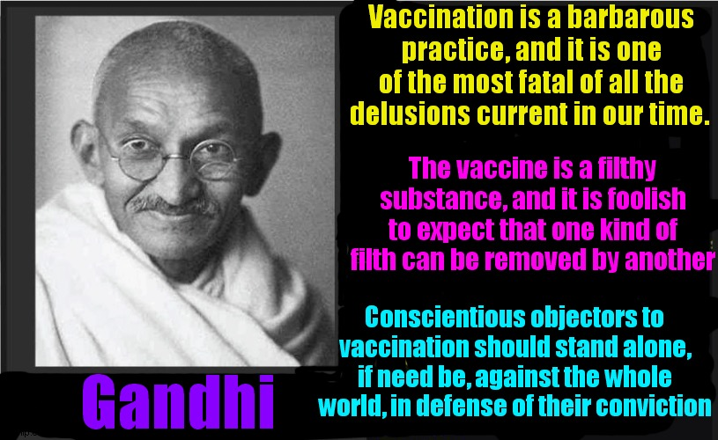

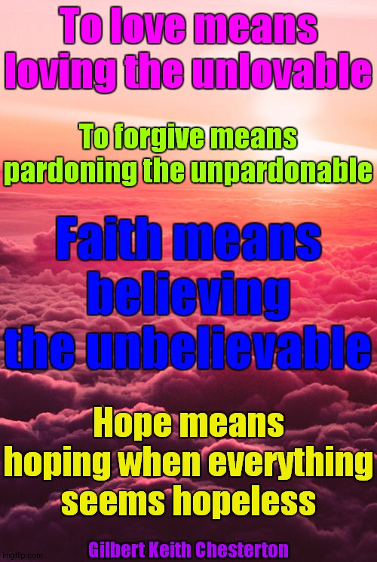



Vital Information

https://actionnetwork.org/user_files/user_files/000/042/961/original/VAX_HOPEWOOD_CHILDREN.doc
The Hopewood Children

https://actionnetwork.org/user_files/user_files/000/042/894/original/VAX_1918_INFLUENZA_EPIDEMIC.doc
The 1918 Spanish Flu

https://actionnetwork.org/user_files/user_files/000/042/760/original/VAX_50_THINGS.doc
50 Things Doctor Forgot to Tell You

https://actionnetwork.org/user_files/user_files/000/042/761/original/V_V_V_long_version_-_26_page.doc
V V V

https://actionnetwork.org/groups/corona-virus
Corona Virus

https://actionnetwork.org/forms/news-2
Corona Virus - News Updates

https://actionnetwork.org/user_files/user_files/000/045/370/original/A_Nations_Prayer_for_Healing_-_YELLOW.doc
A Nation’s Prayer for Healing

https://actionnetwork.org/user_files/user_files/000/049/363/original/VACCINATION_BOOKLET_-_ASSAULT_ON_THE_SPECIES.doc
“Assault on the Species” - Pat Rattigan - Excellent Free Vaccination Booklet

http://www.vacinfo.org/uploads/7/9/8/5/79856028/dispelling_vaccination_myths.pdf
“Dispelling Vaccine Myths” - Alan Phillips - Excellent Free Vaccination Booklet

“Health - The Only Immunity” - Ian Sinclair - Excellent Vaccination Book

https://actionnetwork.org/user_files/user_files/000/044/487/original/PANDEMIC_WOMAN_12_MIN.mp4
Brilliant Summary of Corona Virus - 12 min

https://actionnetwork.org/user_files/user_files/000/043/402/original/POEM_-_CORONA_MISNOMER.doc
Poem - Corona Virus

https://actionnetwork.org/user_files/user_files/000/043/501/original/CV_WIFI_KILL-SHOT.doc
Wifi Kill-Shot

https://actionnetwork.org/user_files/user_files/000/044/011/original/CV_MASK_LEAFLET.doc
Masks

https://www.youtube.com/watch?v=BiqDZlAZygU
Rowan Atkinson on Free Speech - Brilliant!

https://online.anyflip.com/inblw/ufbs/mobile/index.html?fbclid=IwAR0TAB5tGlMSBgjQx0ymd3_m0ZYbjIzL5QkVBv4DbdmJyGpEPWXyvY3xOoE
Global Covid Report Booklet - Excellent!

https://uk.yahoo.com/news/covid-19-could-more-deadly-122511468.html
Deaths Not Due to Covid - Thousands of coronavirus deaths recorded by ONS not due to Covid, new figures show

https://principia-scientific.com/the-covid-19-pcr-test-is-key-to-the-pandemic-fraud/
The CV Test and Pandemic Fraud - The COVID-19 PCR - The test is Key to the Pandemic Fraud - Principia Scientific International. The polymerase chain reaction (PCR) test - used as the bellwether for coronavirus - is not fit for purpose. Herein, we summarise the discredited COVID-19 testing and encourage you to do your own research and become better informed as to how misdirection, incompetence, and scientific fraud is gravely harming our personal and societal well being.

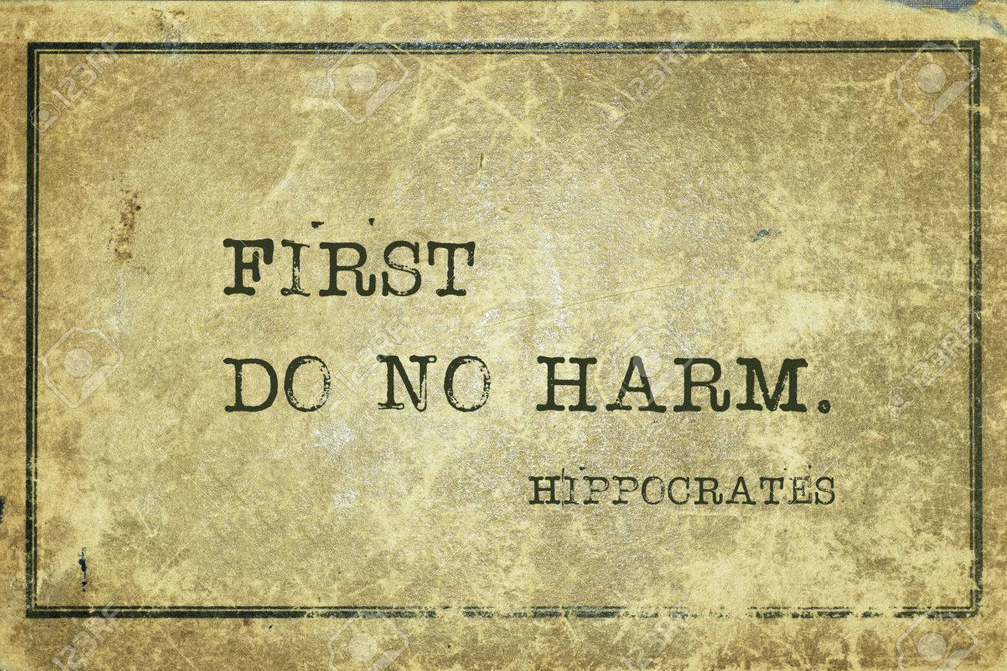

“In a case brought by R. F. Kennedy Jr, a US court ordered the vaccine industry to provide details of all of their safety data on vaccines, going back to the start. They were not able to because there is none.

As for Bill Gates, a very large petition to The White House, wants him behind bars for ‘crimes against humanity’ amongst other things. One of his stunts, the polio ‘immunisation’, resulted in 496,000 Indian children being paralysed”

We have more drugs and vaccines than ever. And we have 20,000 new diseases, and rising.

Quotations

“In the beginning of a change the patriot is a scarce man, and brave, and hated and scorned. When his cause succeeds, the timid join him, for then it costs nothing to be a patriot”
Mark Twain

“Everyone thinks of changing the world, but no one thinks of changing himself”

Leo Nikolaevich Tolstoy

“These are times that try men’s Souls. The summer soldier and the sunshine patriot will, in this crisis, shrink from the service of his own country; but he that stands it now, deserves the love and thanks of man and woman. Tyranny, like hell, is not easily conquered”
Thomas Paine

“If you believe the government, you are lying to yourself”
Author unknown

“Truth must be repeated again and again because error is constantly being preached round about”
Goethe 1749 -1832

“It is easier to fool people than to convince them that they have been fooled”
Mark Twain - 1835 - 1910

“Truth. The only thing that people don’t believe”
Author unknown

“Right is right, even if everyone is against it; and wrong is wrong, even if everyone is for it”
William Penn

“Facts do not cease to exist because they are ignored”
Aldous Huxley

“An error does not become truth by reason of multiplied propagation, nor does truth become error because nobody sees it”
Gandhi

“People do not like to think. If one thinks, one must reach conclusions. Conclusions are not always pleasant”
Helen Keller

“Ignorance: the root and stem of all evil”
Plato

“The mind is like a parachute; it only functions when it is open”
Author unknown

“Do not believe in anything simply because you have heard it. Do not believe in anything simply because it is spoken and rumoured by many. Do not believe in anything simply because it is found written in your religious books. Do not believe in anything merely on the authority of your teachers and elders. Do not believe in traditions because they have been handed down for many generations. But after observation and analysis, when you find that anything agrees with reason and is conducive to the good and benefit of one and all, then accept it and live up to it”
Buddha

“An empire is an immense egotism”
Ralph Waldo Emerson (1803 - 1882)

Video

https://www.youtube.com/watch?v=WfGMYdalClU - Man - Steve Cutts - 3 min - Brilliant!

https://www.youtube.com/watch?v=kr04gHbP5MQ&feature=share&fbclid=IwAR1v5o0Fj34tKmHtKTHtf3QR4oalLgD8D1BjUVsb1B94786L3Vq-79v7VXw&ab_channel=Dr.ReinerFuellmich
Dr. Reiner Fuellmich - Lawyer - Crimes against Humanity - 49 min - Legal action to be taken. Their lies are being exposed. Fantastic news!

https://www.youtube.com/watch?v=dL4NbokoVtY&feature=youtu.be
Liberation! The Economics of Hope - 36 min. - Hon. Paul Hellyer - Former Minister of Defence for Canada - Message from a senior Canadian Statesman warning that your Lives and Liberty are in imminent danger

https://www.youtube.com/watch?v=5M2J7TmAV6Y&feature=youtu.be
Vaccines - Judy Mikovits - Cover-Ups, Corruption, Damage, and the CDC - 2 min

https://www.youtube.com/watch?v=ta3pfqhB4WU&feature=youtu.be
Kate Shemirani - Nurse Whistleblower - 17 min



Please subscribe so you can receive regular updates on CV, 5G, Vaccines, etc

https://questioningcovid.com - CV (Corona Virus)

http://thelightpaper.co.uk/ - Truth Paper - CV etc

https://nomorefakenews.com/ - CV

https://actionnetwork.org/forms/news-2 - CV etc

https://cairnsnews.org/ - CV etc

https://www.standupx.info/ - CV

https://www.dollarvigilante.com/ - CV

https://londonreal.tv/ - CV

https://www.facebook.com/groups/687838581942643/ - Wake up Hull - CV

https://standforhealthfreedom.com/ - CV etc

https://www.5g-ilan.com/ - 5G - ILAN Brings Lawyers and Experts Together

https://stop5ginternational.org/ - 5G

https://whatis5g.info/ - 5G

http://c4st.org/5Gappeal/ - 5G

https://www.takebackyourpower.net/ - Josh del Sol - 5G, Smart Meters, CV, etc

https://the5gsummit.com - Josh del Sol - 5G

hera@nemesisawake.com - Subscribe - Vaccination, 5G, CV, chemtrails

https://childrenshealthdefense.org/ - Vaccination, health, etc

https://davidicke.com/ - Vaccination, 5G, CV, chemtrails

http://www.weatheraction.com/ - CV

https://www.stopnewnormal.net/ - CV

https://twitter.com/piers_corbyn/status/1293009825333420033 - CV

https://www.greenmedinfo.com/ - Health, Vaccination

https://vaccines.news/ - Vaccination

https://thetruthaboutvaccines.com/ - Vaccination

https://healthglade.com/ - Vaccination

http://www.worldpeacediet.com/ - Veganism: Animal - Human - Nature - Planet

https://grow.foodrevolution.org/ - Environmental Solutions

https://www.goodofthewhole.com/ - Cultivating Wholeness

https://theshiftnetwork.com/ - Inner & Outer Transformation

https://www.medicalmedium.com/free-reports/virus-protection - Health

https://www.medicalmedium.info/free-report-downloads/VIRUS-PROTECTION.pdf - Health

https://www.medicalmedium.com/medical-medium-101.htm - Health

https://www.heartmath.org/ - Meditation & Collective Consciousness

Music

https://www.youtube.com/watch?v=8go8sES28ko - Caitlin Byk - New Normal

https://www.youtube.com/watch?v=otCpCn0l4Wo - MC Hammer - Can’t Touch This

https://www.youtube.com/watch?v=oeAN8Xxz0q4 - Dr. Lee - Can’t Touch This - Covid Parody

https://actionnetwork.org/forms/music-2 - More Music

Mass Extinction

300 species go extinct every day! - 100,000 annually! - Due to pollution; mainly chemtrails!
People should be panicking over THIS, not a non-existent virus.

https://www.youtube.com/watch?v=WfGMYdalClU - Man - Steve Cutts - 3 min - Brilliant!

https://actionnetwork.org/groups/pollution-solution - Chemtrail Truth



https://www.youtube.com/watch?v=AJf4zF1aOmQ
Karunesh - Inner Journey

