Greening Rochdale Borough
Rochdale Green Party’s 2021 Manifesto for Rochdale
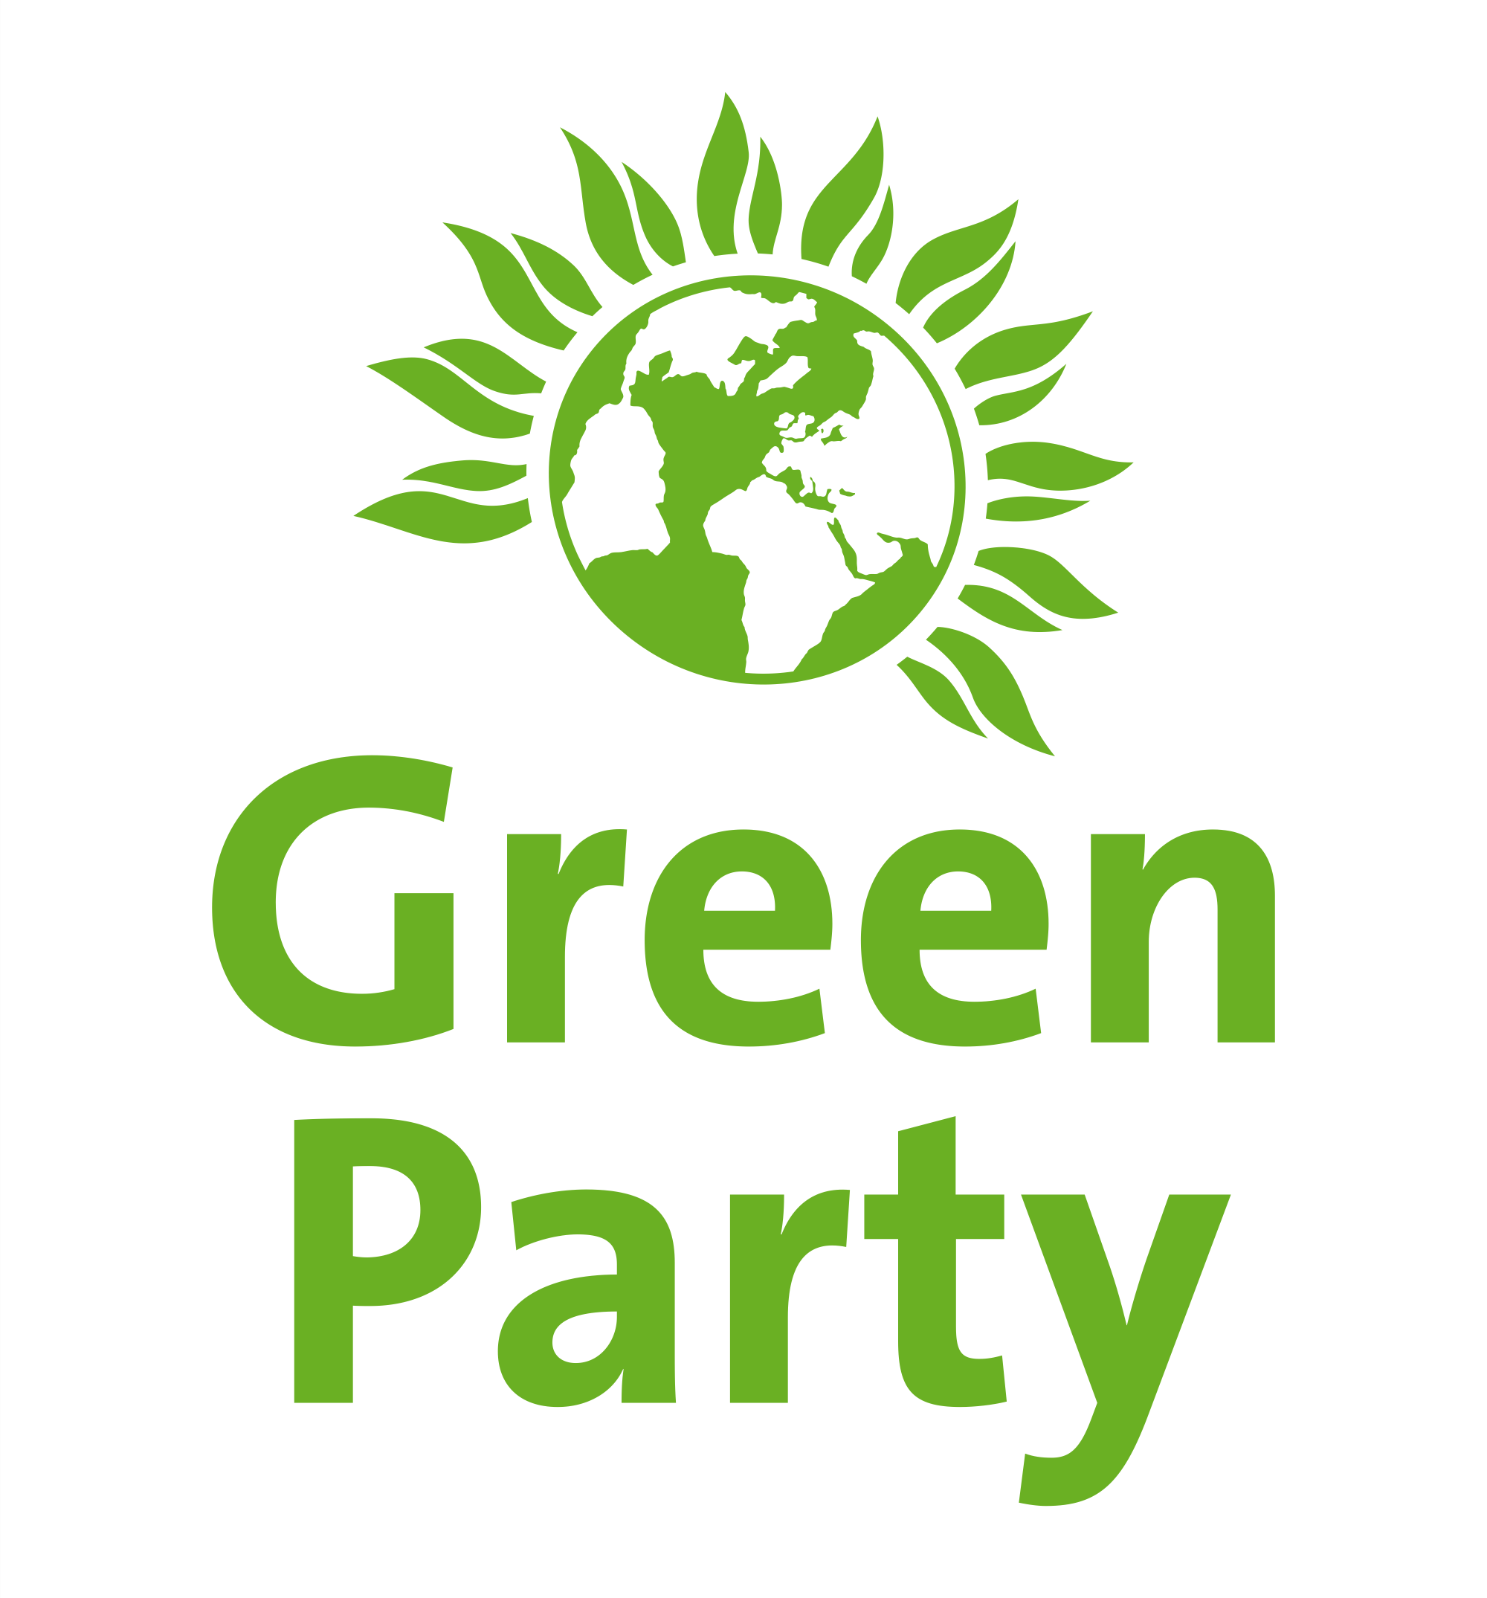
Rochdale Green Party
Covering Rochdale, Middleton, Heywood, Littleborough, Castleton & Milnrow townships
Facebook: https://www.facebook.com/rochdalegreenparty/
Twitter: @rochdalegreens
Website: rochdale.greenparty.org.uk
Green Party of England & Wales: www.greenparty.org.uk
(where links to policy documents can be found)

2nd April 2021 Edition

Greening Rochdale Borough

Contents

01 Foreword
02 The Climate Crisis and Decarbonisation
03 A More Equal Society and the Ending of Austerity
04 Travel & Transportation
05 Leisure & Culture
06 Housing
07 Local Democracy
08 Economy
09 Environment
10 Planning
11 Education
12 Policing & Community Safety
13 Health
14 Clean Air
15 Conclusion
*Section order does not indicate any order of priority

01 Foreword
The Green Party wants to see the world become fairer, healthier and environmentally sustainable. While we think globally, we seek to act locally throughout the Borough of Rochdale, including those districts and towns that were not always included in the current administrative district of Rochdale.
We believe that these values require
- the reform of our energy use to end the emission of substances harmful to the climate and atmosphere,
- the conservation of our natural and material resources, and
- building a society
- where wealth and incomes are more equally distributed among all our people,
- where good public services help lift our fellow residents out of austerity and marginalisation,
- which is more user friendly to the quality of life, and
- where decisions are made on the basis of whether they will benefit people, the community and the planet.
These values inform all of Rochdale Green Party’s local policies. All the issues we highlight in this manifesto are interconnected – a fact it is important always to bear in mind.
This manifesto is not set in stone, but is more of a working document. We welcome the comments and input not just of Party members but also of members of the public.
Local government has been undermined in recent years by unremitting central government budget cuts causing deep austerity among residents who were already deprived. The Government has continued to centralise power and responsibility away from local democratically accountable bodies, like Rochdale Brough Council. It has done this notwithstanding claiming to devolve responsibility, for instance, by the Greater Manchester devolution deal.
We believe the changes we want to see are achievable and if taken would see the borough develop into a more equal, sustainable and enjoyable place to live. We recognise that we do not have a monopoly on good ideas, and are keen to work with all who wish to achieve similar aims.

O2 The Climate Crisis and Decarbonisation

Rochdale Borough full Council agreed a declaration of the Climate Emergency on 17th July 2019.
But it took until 28th January 2021 for the Council to follow up this urgent Declaration with the first meeting of the Climate Change Working & Sustainability Group (CCWSG) established to advise the Council with its response to the Climate Emergency!
We welcome that the CCSWG endorses the UN Sustainable Development Goals in its planning process. We are pleased to record that the Green Party endorses this approach too.
Rochdale Green Party will adopt a constructively critical approach to the work of this group, and seeks
- that its work be enhanced and empowered, better financed and recognised as urgent, and its recommendations be prioritised for urgent and full implementation,
- that the work of the group be understood to concern not just the Council’s activities but the life and work of the entire borough
- the widest possible consultation on the plans developed by the CCSWG for the Council (not least because the work of the group concerns the whole life of the borough),
- That the CCSWG’s approach is transparent to the public at large, and
- That the Council’s scrutiny and support for the plans prepared by the CCSWG demonstrate the seriousness and paramount importance of the group’s work

The policies that Rochdale Green Party submits this group and the council as a whole should follow and develop are (non-exhaustively) set out in this document.

We are pleased that the CCSWG has made a start, and look to the Group expanding their work and include the proposals set out in this document

03 A More Equal Society and the Ending of Austerity
Conservative Governments have pursued a policy of austerity for over 10 years leading to the impoverishment of many local citizens and to the growing of income and social inequality, of hunger, hardship and of social divisions. Levelling up has been promised but no serious progress has been made to implement this promise: benefits still remain cut, public services remain decimated, Housing unaffordable and poorly paid jobs all to common.
The Green Party firmly oppose austerity policies and argues for these cuts to be reversed, for Council Services to be improved and restored. Examples are:
- Youth services and services for vulnerable people and refugees should be restored and advice agencies refunded.
- Support for local professional and amateur sports clubs should be restored including help offered for example in their search for grounds and training facilities.
Rochdale Green Party also seeks to promote the empowerment of working citizens by supporting the Rochdale Trades Council and agreeing paid time off for union duties.
Food Banks and food insecurity are now a daily reality with significant numbers of local people increasingly relying on food banks to meet their needs. This is an indictment in itself of Government policy and austerity. It is shameful in one of the richest countries of the world.
Rochdale Green Party campaigns for Benefit Cuts to be reversed, including the notorious ‘bedroom tax’ and continuing cuts to housing support. It is a scandal that benefit recipients are forced into poverty when their rent is not fully covered by benefits. Either the benefits needs to be increased or the rent needs regulating to correspond with the benefit element designed to fund it
Rochdale Green party campaigns for every citizen to be entitled to a Basic Income above the level of benefits, not just to end poverty and hunger, but also to acknowledge our common human dignity as individuals. Our candidates are being asked to pledge their support to the establishing of such a basic Income scheme.
EU Citizens
EU citizens deserve to be supported now that the UK has left the EU. For that reason, we would:
- Ensure that EU Citizens across Rochdale are welcomed, valued, and supported in this post Brexit era. We will work together to develop the best approaches for this.
- Campaign for a local-led advice service for EU citizens about permanent residence or British citizenship,
Asylum Seekers and Refugees
Asylum Seekers are those who seek asylum in the UK sanctuary from war or from oppressive social, political or religious conditions and regimes in their home countries.
Refugees are those whose application for asylum has been granted
Rochdale should be a welcoming place and home for asylum seekers and refugees. The Borough has a proud history of co-operation and promoting community cohesion and that is why we acknowledge the role of local charitable bodies in helping asylum seekers and refugees.
Asylum seekers are subjected to lengthy delays waiting for the Home Office decision in their cases, during which they are not allowed to work and have to live in poverty. They need help coping with life in the UK; they often have medical problems stemming from their treatment before they arrived, but are treated now in the UK by Home office officials and their agents who are still too often affected by a hostile culture.
Their problems do not cease when they receive Refugee status. Often refugees who have had responsible and well-paid jobs in their home countries find it hard even to get work in the UK.
We seek to help them integrate and re-establish their lives and will campaign to speed up Home Office decision-making, to ensure they are treated with respect and dignity and to ensure their reasonable needs are met.

04 Travel and Transportation
This section should be read in conjunction with the section on Clean Air below.
Making big reductions in transport-related carbon emissions isn’t just a matter of ‘going electric’. It is also about how we can reclaim our streets and local environment for everyone to get around: those who need a wheelchair or mobility scooter; children wishing to cycle to school; carers struggling with pushchairs to avoid cars parked on the pavement.
Rochdale Green Party will reimagine our walkways, open spaces, cycleways, roads, transport services, and change the way planning decisions and other Council decisions are made so that it is easier, more attractive and safer to walk or cycle and use public transport, rather than private vehicles to move both around the borough, and in and out of it.
We will support the development of a local Active Travel Forum which will contribute towards the operation of the Borough’s Climate Change Working & Sustainability Group, and promote the wide involvement of all the Borough’s communities in creating safe and effective spaces in which we can move around and inhabit.

We will
Active Travel - Walking and Cycling
- Foster the construction of new cycle and walk ways and the separation of such ways from routes used by vehicular transport. These will include green corridors connecting central Rochdale with its suburbs
- Support the development of an integrated traffic management plan and cycle network to favour active travel such as walking and cycling.
- Make walking safer by redesigning junctions where necessary.
- Support the construction of cycle lanes throughout the Borough and note that there are plans to create a new cycle route from Castleton station through Castleton to the Royal Toby Hotel, replacing parking along the route with the Cycle Lane. We recognise that this will be inconvenient for those accustomed to park on the road and we seek to find reasonable solutions for those who feel they will be affected

Buses, Trains and Trams
- Expand bus lanes making bus use more attractive and faster than car transport
- Support buses and rail being brought back under public control.
- Improve integration of the transport system. We will push for more bike storage at train and tram stations and for more bike storage on trams.
- Use any additional Council powers to ensure that public transport is cheap, regular and runs along the routes that people want to travel.
- Focus subsidies on a public transport service that meets community needs, not those of private operators and, thus, that it is affordable to use.
- Campaign for more train and tram carriages, particularly at peak times.
- Promote greater disabled access on public transport and in car parks, as well as greater enforcement of existing laws. We want to achieve a fully accessible transport system.
- Foster the reopening of disused railway lines for trains or trams.
- Continue to argue that the national transport budget unfairly favours London.
- Support an outer ring tram network for Greater Manchester

Safe streets
- Promote planning which combines residential, commercial and leisure uses in the same space in order to reduce the need to travel and to promote stronger communities. We support the development of Active Travel Neighbourhoods which make it safer for everyone, especially, children to move around their local neighbourhood in safety
- Campaign for the introduction of Vision Zero, which aims to cut road deaths and accidents.
- We will also strive to find ways to better enforce existing traffic rules and regulations.
- Work with communities to encourage neighbourhood safety schemes, so local residents can work together to all feel safer on our streets.
Pollution
- See our section below re Clean Air
Transition from fossil fuels
- Move to electrify all Council vehicles as soon as possible and provide additional charging stations in all carparks
- Promote electrification of private and commercial vehicular transport in the Borough by promoting the provision of more charge points

05 Leisure & Culture
Rochdale Green Party will:
- Oppose any future library service downgrades and branch closures.
- Encourage the preservation of green spaces by opposing development on them. We encourage any ongoing developments to incorporate more green space as part of their planning, along with ecologically sustainable building methods.
- Explore options for the creation of new allotments.
- Argue that local arts spending should encourage participation with and funding for locally-based organisations, whilst engaging with a national audience
- Strengthen the theatre and art provision in the Borough
- Encourage healthy sports and leisure activities

06 Housing
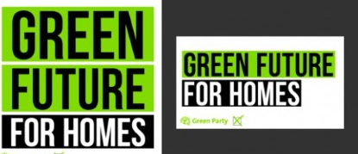
Rochdale Borough has significant demand for affordable housing and a large amount of old housing which will need renewing over the next few decades
Rochdale Green Party will:
Sustainable homes
- Work towards building quality council homes that meet high standards of carbon neutrality, design and accessibility.
- Develop a scheme to demonstrate the benefits of retro-fitting houses to become carbon-neutral.
- Seek ways of renovating and bring back into use homes that remain empty.
- Support the retrofitting of homes in Rochdale to remove fossil fuel-based heating and install high standards of insulation and renewable energy
- Promote improving the quality of housing stock to help reduce household bills with energy efficient and water-saving upgrades. This is a HUGE ‘big ticket’ issue i.e. the retrofitting of tens of thousands of private houses ( let alone ‘social’ housing) to make them more energy efficient. What does the Party say nationally about this? Ground source heat pumps are very expensive and can’t be used everywhere. Just see some research about the possible use of microwave technology to provide heating and thus getting rid of gas. If this isn’t tackled in a big ay then the effort to achieve carbon neutrality will fail.

Expand housing
- Continue to campaign against government rules which make building new social housing harder.
- • Consult with homeless people on policies for housing provision. Local authorities will advise and assist groups of homeless persons to make proposals about the use of empty land and property, and to put those proposals into effect.
- • Support bringing back into use empty private sector homes in the Borough
- Argue that social housing is a good thing: it is owned collectively by our community, to provide homes for us when we need them. Any 'Right to Buy' programme must therefore ensure that any housing that is sold gets straightaway replaced with new social housing.
Tenants
- Give social housing tenants greater control over the management of their homes and neighbourhoods, and to improve the culture of the housing officials they deal with.
- Continue to oppose the ‘bedroom tax’ and cuts to housing support.
- Support the development of housing co-ops and co-housing projects in the borough.
- Establish a not-for-profit letting agency to ensure that everyone receives support while finding a home.
- Ensure the operation of compulsory licensing of private landlords is enhanced as a means of ensuring decent housing standards and tenancy conditions.
- campaign for the restoration of rent tribunals and rent assessment committees to control or cap rents to ensure they are truly affordable.
- Call for a Housing Scrutiny Committee to be established as a way to improve the response to the Borough’s housing problems.

07 Local Democracy
Rochdale is composed of a number of areas which have their own identity which was reflected before 1973 in independent Councils. The Green party maintains the principle that decisions should always be made at the political level closest to the people affected. Consistent with this value is that we should revitalise and emphasise the roles of local township councils and forums.
Rochdale Green Party will:
- Support genuine devolution of powers from Westminster which are based on the results of an open public consultation.
- Continue to argue for proportional representation voting to be adopted at Council level.
- Encourage the public to engage more in local affairs, for instance by asking questions at Council meetings, Township Meetings and local forums
- Encourage Council and Township meetings and local forums to permit virtual attendance at meetings, where attendance in person may be impractical or inadvisable (eg on health grounds)
- Establish local community forums for Heywood and Middleton where they do not currently exist
- Seek to end the top-down Cabinet model of power at Rochdale Council in favour of more involvement by other elected councillors
- Reports of these proceedings must be presented to formal Council committee meetings, where members of the public have a right to comment and see who makes what decisions.
- In the consideration of contracts entered into by or on behalf of the Council, ensure all contracting parties are (a) unionised and pay their workers above the Minimum Living wage and (b) have a plan to reach carbon neutrality in their business by 2035.
- Where Council is involved in or contributes to local ceremonies of remembrance or otherwise, we will work to ensure these ceremonies are widely accessible to person of different religious beliefs and of no religious belief. (This includes prayers uttered before the Full Council Meeting).
- Cooperate with Friends of the Earth, XR Rochdale and other voluntary associations directly or indirectly involved in tackling climate change and consider whether a Citizens Assembly might improve the Borough’s response to the Climate Crisis.
- Establish a local question time of Council leaders with the local press, voluntary organisations and citizens asking questions.

08 Economy
Our economy, and the financial system that underpins it, should stop destroying the natural systems of the planet on which we all depend.
Rochdale Green Party will
- Continue to argue that the wealth of Rochdale should be better distributed across the Council area.

Business
- Argue for the establishment and development of firms in Rochdale at the forefront of the development of hydrogen-based power solution
- Work to help Rochdale residents, businesses, Council and other services and transport speedily to transition to carbon neutrality
- Promote local economic development especially by SMEs (small and medium-sized enterprises), cooperatives and social entreprises
- Ensure resources continue to be available to support people starting co-ops and social enterprises.
The Council
- Argue that in every decision, policy and step the Council makes we should promote the sustainable future of our planet which we all live on and share. Every such step, policy or decision needs scrutinising to ensure it contributes to carbon neutrality by 2035, and does not delay it
- Argue that the Council should procure more services from local businesses which recognised unions and have a plan to achieve carbon neutrality by 2035.
- Foster a borough where firms with sustainable businesses will want to open and flourish and so create good jobs for citizens
- We want to see all Council Services generating their own electricity and phasing out the use of fossil fuels. Council buildings should be checked to ensure the highest standards of insulation are installed
- Continue to argue that the cuts to public services are fundamentally unfair.
- Argue for a truly ethical council procurement policy

Pensions
The Council is a member of the Greater Manchester Pension Fund (GMPF) as its vehicle to manage the pensions of all its current and retired employees. This pension fund continues to invest in fossil fuel extraction. Rochdale Green party supports the campaign to persuade the GMPF to disinvest in such unecological and risky investments

09 Environment
Rochdale Green Party will:
- Call for carbon literacy training to be provided to all council staff and citizens.
- Acknowledge that investing in carbon-neutral energy has been made harder by the government, but we still support the roll-out of green technology across the public estate.
- Call for Rochdale Council to work to ensure the Greater Manchester Combined Authority shift its waste system to give greater emphasis to recycling and reuse of waste, with a view to phasing out incineration and land fill.
- Support plans to plant a forest on the hills around Littleborough to counter flooding and as a carbon sink, and argue that the same tree-planting should be extended to the hills above Rochdale and Milnrow as part of a project to create a continuous forest habitat across the North of England,
- Encourage Rochdale Council to monitor air quality on a regular basis and to make this data freely available, especially in or near busy roads such as the M62, A627(M) and busy main roads with particular focus where playgrounds, schools and homes are adjacent to such highways.
- Argue for greater scrutiny of environmental issues by the Council and ensure that the issue of climate change is not ducked by the Council but given central and paramount priority in every decision the Council makes.
- Develop a plan for the Borough which ensures carbon emissions are urgently cut to zero in order to prevent the worst effects of climate change.
- As part of this plan, develop targets to cut emissions based on scientific expertise. If these targets are not met an investigation should be held to find out why.
- Prioritise the work of the CC&S Working Group in implementing plans to mitigate the effects of climate change in Rochdale.
- Develop a robust strategy to deal with extreme weather events, such as floods, based on independent scientific evidence.
- Stop all building in the Roch flood plain and introduce an urgent project for tree planting on the hills around Rochdale Borough
- Support plans to build additional flood control basins along the River Roch.
- Enable local groups and Friends of Open Spaces to adopt spare pieces of land for tree planting
- Oppose the development of valuable natural and wooded land such as Mill Fold Gardens in Littleborough
- Oppose any applications to frack for shale oil or gas in the Council area or beyond.
- Campaign to get Government funding to decontaminate the Turner Brothers site in Spotland, the Akzo site in Littleborough and other such sites

10 Planning
Planning decisions are critical for the future of our Borough. Every decision needs to comply not just with health and safety and building regulations, but buildings must be carbon neutral and space must be left for trees, for leisure, for walking and cycleways to be inserted where none now exist.
No permission should ever be granted to construct housing or other building right up to the pavement edge of a site. Housing developments must always be separated from roads and highways with a strip of trees and other vegetation and a cycleway.
The Rochdale Green party will
- Argue against developers waiving their responsibility to provide a certain proportion of affordable housing.
- Argue that ‘affordable’ relates to energy use as much as to structures and require developers to include non-fossil solutions to heating and energy supplies in their proposals
- In the longer term, promote mixed-development planning across the Borough, so that more people can work, relax and play near to where they live. This will strengthen local communities and help to reduce travel times and costs, decrease local air pollution and reduce global warming emissions.
- Oppose the grant of planning permission to build on green belt or green field sites and advocate the use of brown field sites (of which there remain plenty in the Borough). If necessary quality high rise building must be resorted to, to cater for the demand for new housing
At all times decision-makers need to bear in mind that structures will likely be in place for many generations of local residents.

11 Education
Rochdale Green Party will:
Schools
- Oppose Government policy which prescribes the building of new academies and free schools rather than Council run schools.
- Encourage the Council to work with all schools to reduce class sizes and increase ventilation, so learning environments can be healthier environments.
- Oppose all new faith-based schools on the grounds that they are socially divisive and only a minority of our residents attend a church, mosque, synagogue, gurdwara or temple
- Support the education of children to understand all the main religious and non-religious belief systems held by local residents
- Support the implementation of the compulsory teaching of British Sign language (BSL) to all children between the ages of 7 and 13, and the provision of facilities to provide continuing classes for those wishing to specialise in BSL thereafter
- Consult to develop ways which Rochdale Council can ensure the individual educational needs of disabled people are better met.

Teachers and Staff
- Oppose the use of unqualified teachers in classrooms.
- Support skills training services, nursery care and schools staying in or returning to the public sector.
- Support the development of teacher networks for mutual support and Professional Development.

Students
- Support efforts to head off the radicalisation of students by extremists from whatever quarter
- Support the establishment of a Co-operative University and that its home should be in Rochdale

12 Policing & Community Safety

Rochdale Green Party will:
Anti-Social Behaviour and Hate Crimes
• Ensure greater visibility of Local Action Teams dedicated to tackling anti-social behaviour.
- Work closely with Greater Manchester Police, and local communities to ensure that hate crimes of any kind are recorded and that an adequate strategy to tackle these crimes is developed.

Violence against Women
- Argue for the establishment of domestic abuse drop-in sessions across the borough.
- Support greater education of boys and men on how to ensure the safety of women in public and private spaces
- Support ideas such as providing free night-time public transport for women

Working with the Police and Police Scrutiny
- Work with the Police to set borough-wide and local priorities for improving the quality of life of citizens.
- Seek to establish more effective links between community police and mental health services.
- Work with Greater Manchester Police to bring disproportionality down to the national average. Any disproportionate rates of contact between the police and certain communities should be investigated.
- Restore the local community forums which have been closed during the pandemic, and if the pandemic returns to continue holding them by zoom or by some similar electronic platform
- Review the manner in which the Council scrutinises of the police service in the Borough, to supplement the work of local townships committee and community forums, to scrutinise local police policy and monitor the number of police officers in the borough to ensure that there are adequate numbers of police officers and police community support officers

13 Health - and the Pandemic

Rochdale Green Party will:
Hospital provision
- Argue for a fully equipped general Hospital with a full Emergency Dept and maternity services be established in the Borough.
- Argue for an Infection Control Hospital be built equipped and appropriately staffed for the winter peak demand, epidemics and pandemics
Health care Spending
- Aim to implement a properly funded devolution plan which is focussed primarily on addressing the main specific health issues facing the borough.
- Develop an effective health care programme which tackles deprivation and destitution.
- Encourage greater spending on mental health.
- Encourage greater funded social prescribing activity
- Ensure individual social care budgets are conducted on a needs basis.
- Commission services with local not-for-profit providers wherever possible.

Community Health
- Argue that Track & Trace be placed in the hands of the local Council’s Medical Officer of Public Health and be fully funded for this
- Acknowledge that health is created outside the Health Sector
- Promote a borough-wide insulation programme aimed at preventing illnesses connected to living in cold and damp housing.
- Promote healthy eating by supporting schemes such as cooking lessons and working with retailers to provide greater access to healthier options.
- Look into introducing stricter rules aimed at preventing new takeaways being built near schools or where there are already a high proportion of takeaways.
- Ensure transparent decision-making on health spending and options.
- Support Age Friendly initiatives.
- Work to ensure there are more fully accessible public toilets.
- Launch a new campaign to ensure that more people caring for friends and relatives get the support they need.
- Review health processes and outcomes for disabled people, especially those with learning difficulties and mental health service users, to eliminate systematic discrimination, avoid premature deaths and prevent inappropriate treatments in the hospital system

14 Clean Air
Clean air is not just a local issue. Our vision is for Clean air throughout Borough, Greater Manchester and beyond, and for safe, hospitable streets and public spaces.
According to a recent study air pollution affects 94% of Britain’s roads
Roads, which occupy less than 1% of the country, “form vast, pervasive and growing networks, causing negative environmental impacts”, the scientists said. This causes serious harm booty the human health and to birds, mammals and insects
We bear in mind that
- we should be able to safely breathe the air
- we should feel safe and welcomed in the streets and other public places
- we should be given more opportunity to gain the mental and physical benefits of exercise
- Greater Manchester has the worst asthma admission rates in the UK
- Air pollution across Greater Manchester causes early death and poor health to thousands of car drivers, passengers and pedestrians every year.
  - Health conditions exacerbated by air pollution cause an estimated 1200 early deaths a year in Greater Manchester - that’s 1 in 23 deaths.
- In urban areas, our streets are unsafe and inhospitable
  - In 2018 there were 748 people killed and seriously injured on the roads of Greater Manchester
- Cycling and walking improve our mental and physical health, as well as reducing air pollution from motor vehicle traffic.
- Greater Manchester’s current ambition for air quality improvement needs supercharging for all of us and our children.

We support the following Five actions to help achieve Clean Air:
- Ensure walking, cycling, and public transport are the main ways of travelling
  - Increase the number of safe pedestrian crossings
  - Create a protected cycle lane on all major roads.
  - Invest in secure bike parks in car parking spaces - a bike parking space for every car parking space
  - Bring buses under the control of Greater Manchester Combined Authority to provide an accessible, comprehensive, fairly priced and green integrated bus transport.
  - Safeguard and improve rural public transport routes
  - Support ‘cross Greater Manchester’ routes and create an ‘Outer Circle’ tram network.
  - Fine owners of cars parked on pavements when they create an unsafe space for pedestrians.

- Create safe and hospitable neighbourhoods
  - Support school governing bodies, parents and local residents in introducing School Streets wherever requested.
  - Promote Play Streets for residents to take control of their streets.
  - Expand Clean Air Days - closing roads to motor vehicles
  - Ban ‘idling’ outside schools and in school car parks.
  - Implement low traffic neighbourhoods
  - Protect and create local green spaces to help clean our air and encourage healthy activity
  - Give advice to owners of wood burners on new regulations governing fuel types

- Discourage journeys by private car in urban areas
  - Increase traffic calming and 20mph speed restrictions
  - Ensure Planning decisions avoid car dependent housing and business developments
  - Promote electric and low emission car sharing and car clubs in workplaces and neighbourhoods
  - Allow exemptions for disabled blue badge holders
- Reduce business and industry’s impact on clean air
a. Press ahead with the Clean Air Zone (CAZ) for commercial vehicles and lobby central government for increased funding to support this.
b. Consolidate business deliveries for businesses and encourage deliveries by bicycle.
c. Oppose business development on green belt land and other green spaces that are vital for reducing air pollution.
d. Oppose the building of Energy Recovery Waste Incineration facilities
e. Support an Ultra Low Emission zone in Rochdale Borough
- Increase Local Involvement
  - Encourage and support local action groups campaigning for clean air to find solutions which are right for their communities.
  - Establish an annual car free day
  - Create an annual ‘Have your say’ survey about how citizens of Rochdale feel about their area and transport.
  - Create Local Community Health and Environment Councils (CHEC) with elected members to investigate and monitor environmental impacts of local planning and the operation of commercial and industrial enterprises.

How will we measure progress?
- 50% of all journeys to be by public transport, cycling or walking by 2030 - 10 years ahead of current plans
- 50% reduction in pollution levels as measured by Manchester Metropolitan Air Monitors by 2030
- Reduction in asthma admissions to hospital per 100,000 people (currently 558 in Greater Manchester)
- Survey of residential areas on how the changes affect people's quality of life
- Fall in road accidents for cyclists and pedestrians (377 were seriously injured or killed in Greater Manchester 2018)

15 Conclusion
The next decade will be a crucial time both locally and the UK as a whole. Will we change course sufficiently quickly as a Borough, as a country and as a globe, to head off the damaging climate and ecological crisis? And can we make these reforms while at the same time improving the health, sense of fairness & community cohesion and the quality of our society and living experience?
Rochdale Green Party believes we must all play our part, by changing our own lifestyles as well as promoting new policies in the Council and in other bodies that affect the wellbeing of our fellow residents.

Rochdale Green Party calls upon the people of Rochdale Borough to support our programme for current and future generations both locally and throughout the world.

Rochdale Green Party
Facebook: https://www.facebook.com/rochdalegreenparty/
Twitter: @rochdalegreens
Website: rochdale.greenparty.org.uk
Green Party of England & Wales: www.greenparty.org.uk
(where links to policy documents can be found)

This is a working, living manifesto:
Comments and suggestions can be submitted to convenor@rochdale.greenparty.org.uk

The Appendix follows
The United Nations Sustainability Goals

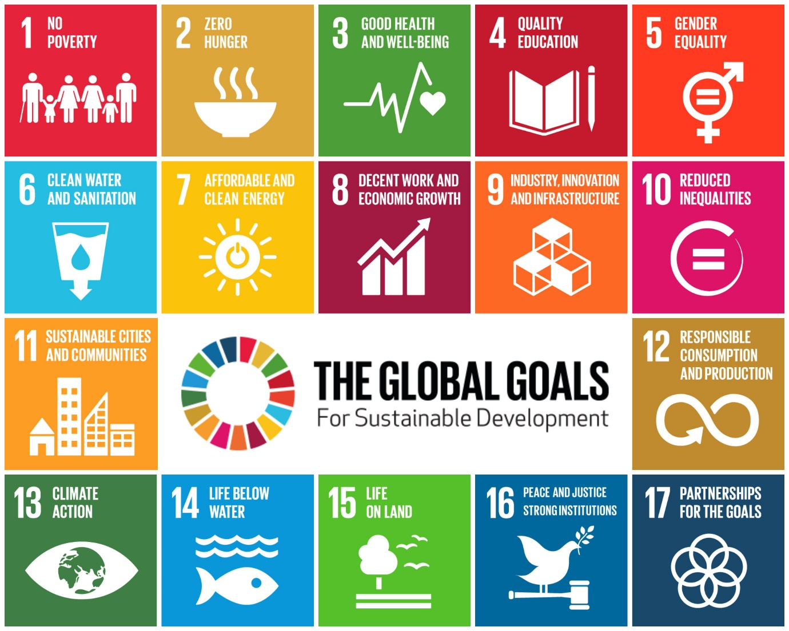

Published on behalf of Rochdale Green party by Guy Otten,
both c/o 14 Wellington Lodge, Littleborough, Rochdale OL15 9BZ

These are set out in the Appendix
•. This is a HUGE ‘big ticket’ issue i.e. the retrofitting of tens of thousands of private houses ( let alone ‘social’ housing) to make them more energy efficient. Ground source heat pumps are very expensive and can’t be used everywhere. Just see some research about the possible use of microwave technology to provide heating and thus getting rid of gas. If this isn’t tackled in a big way then the effort to achieve carbon neutrality will fail.
Source: https://www.sciencedirect.com/science/article/pii/S0048969721006574
See the work being done by Living Streets

