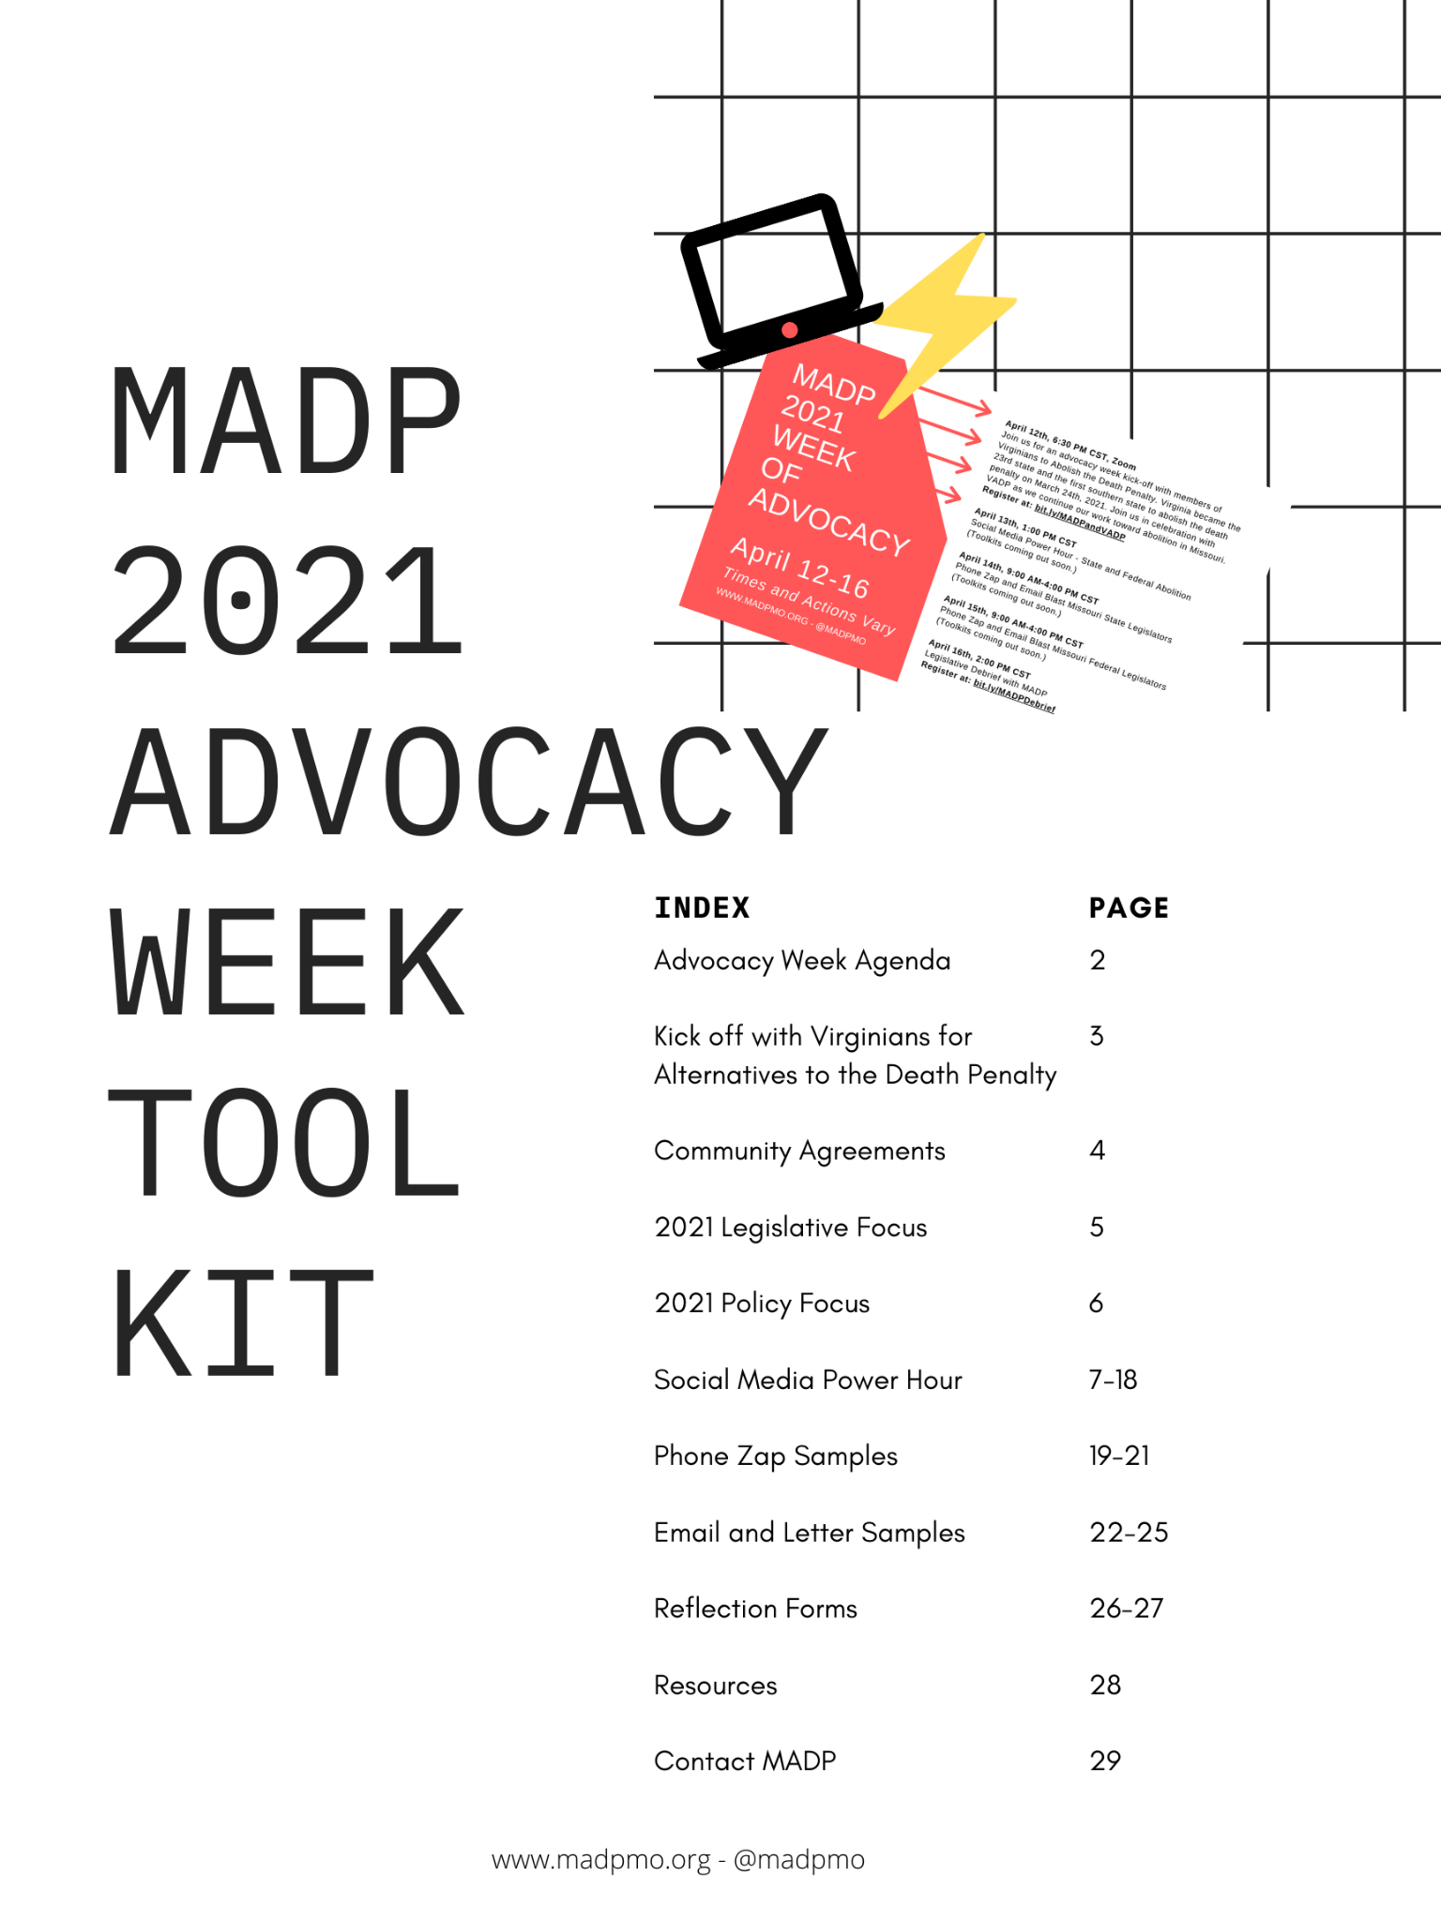
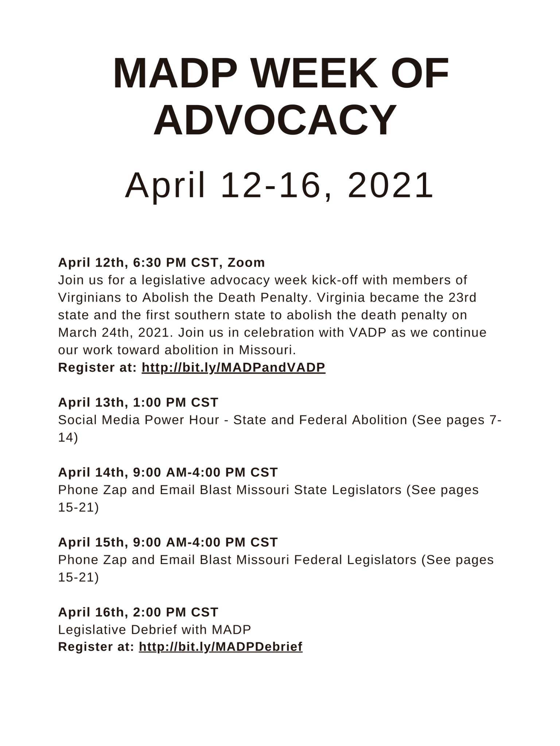
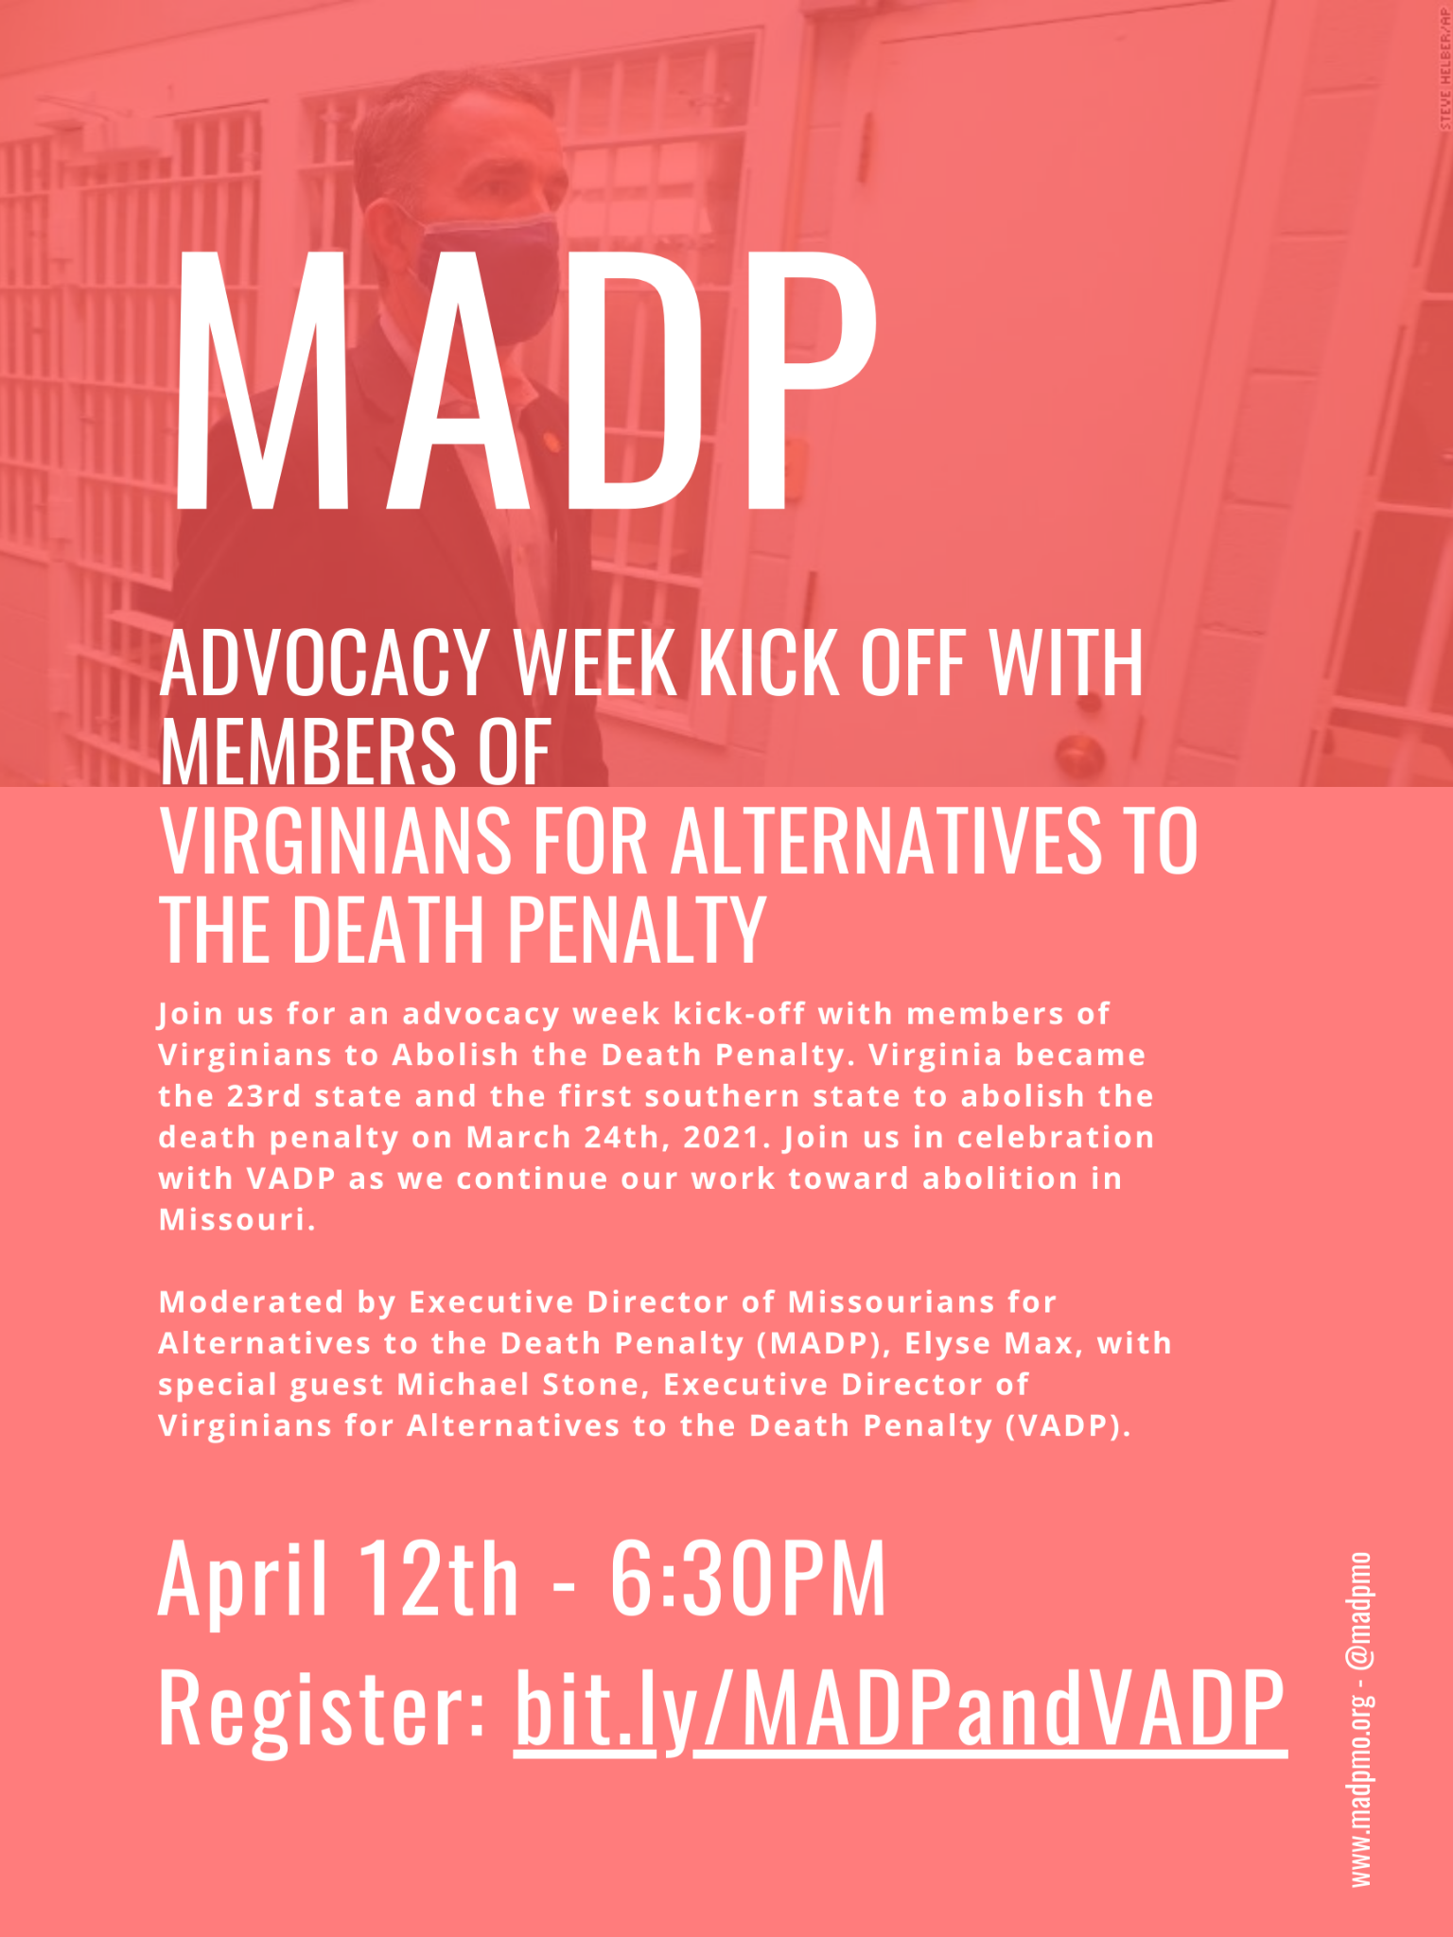
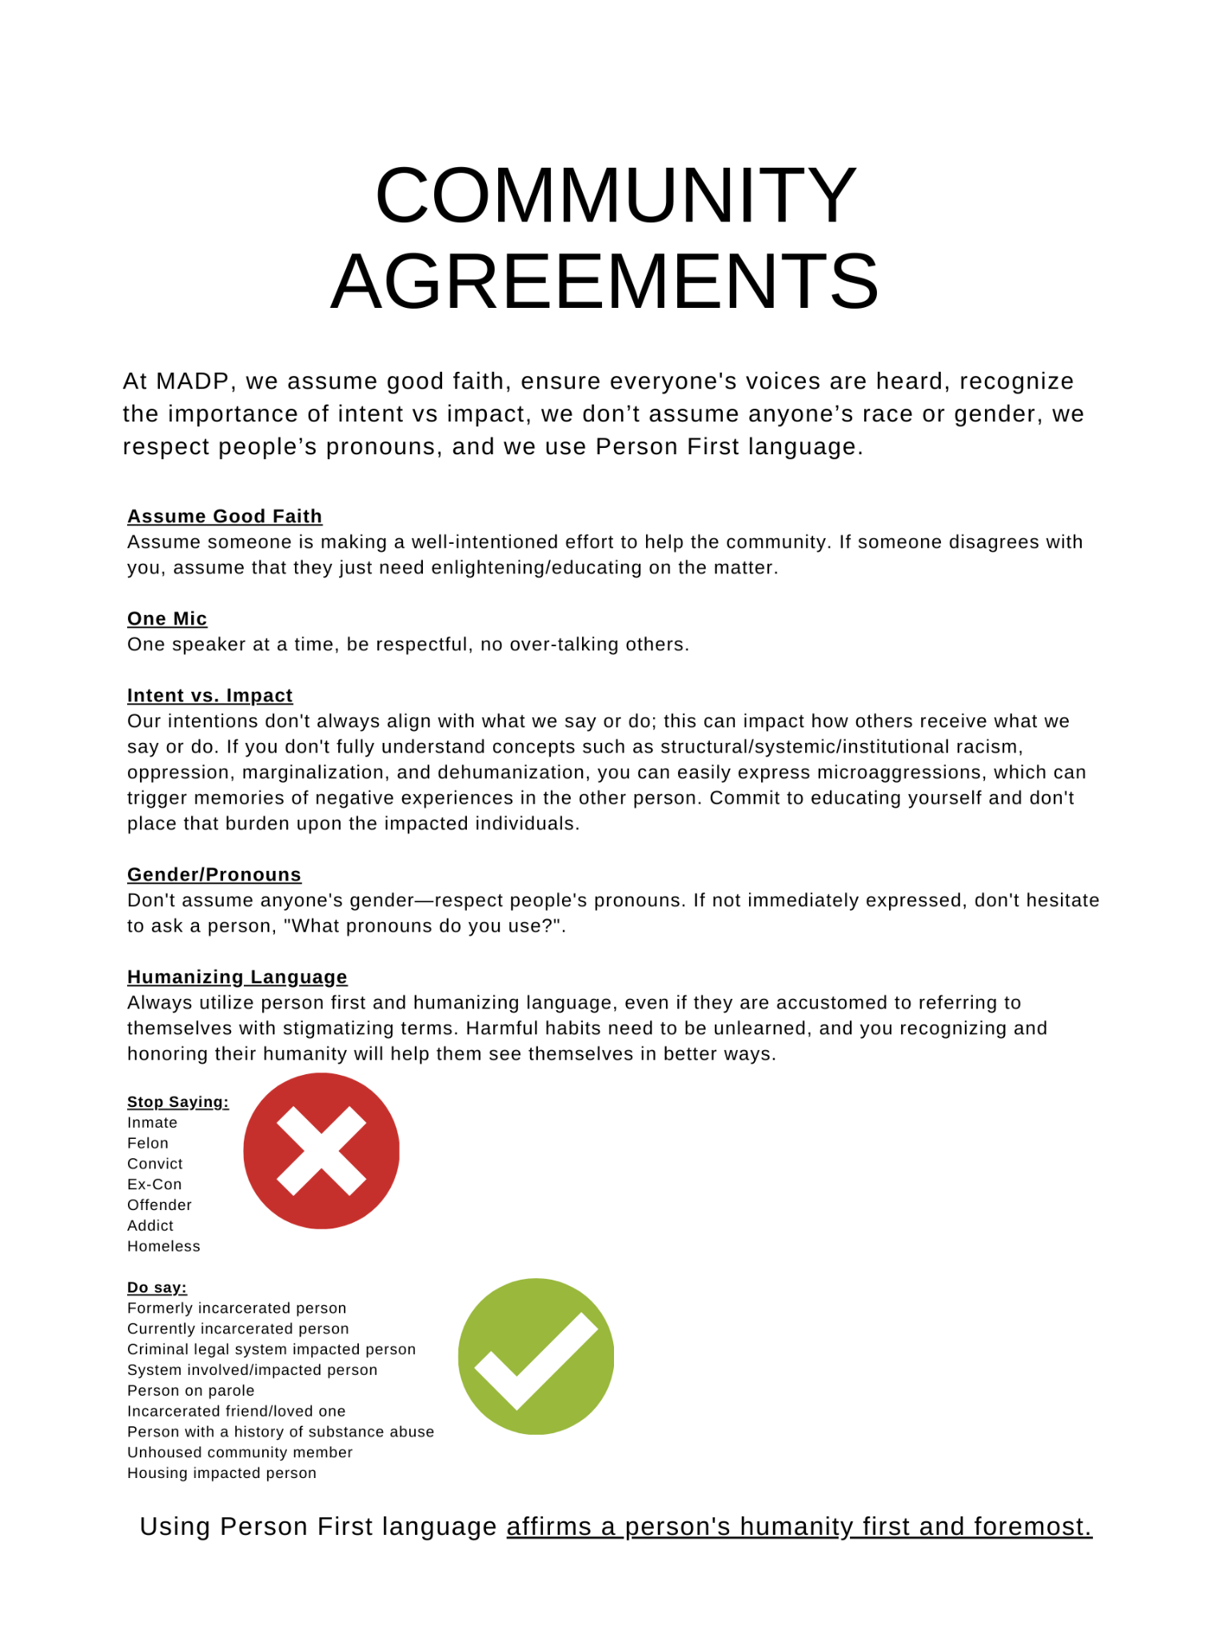
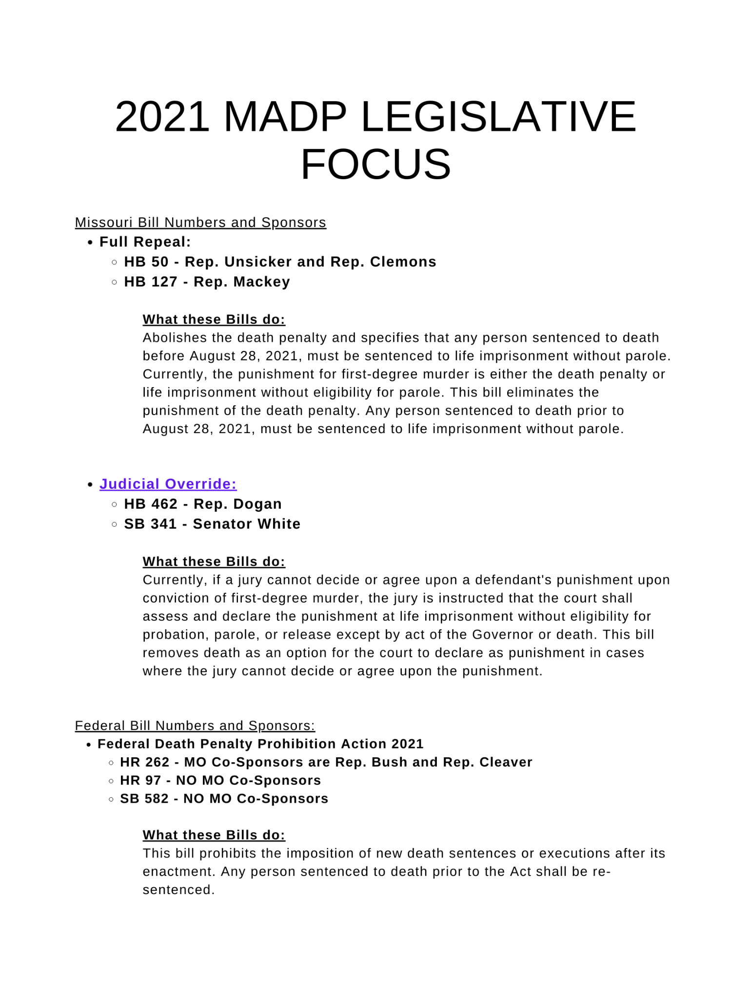
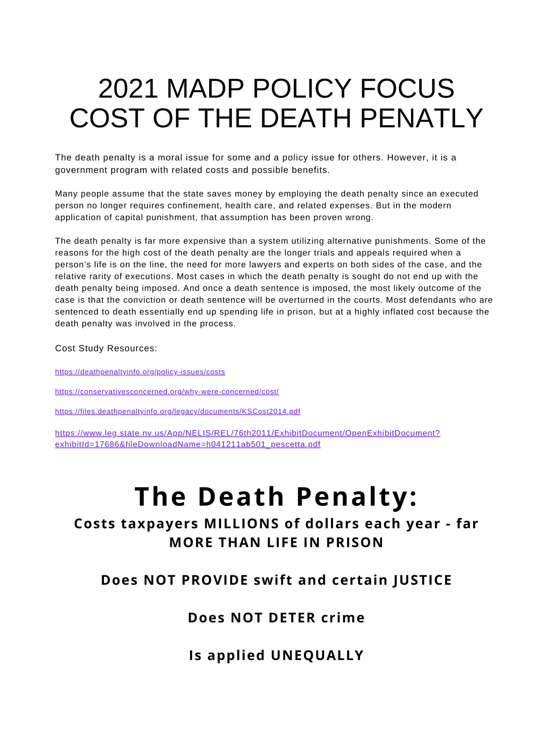
MADP Social Media Power Hour Graphics + Sample Posts
Pair these Graphics with our Sample Posts on pages (13-14) to make more of an impact!
PLEASE USE ON APRIL 13th from 1PM-3PM CST!

Feel free to add in more content on abolition from www.madpmo.org about policy issues of the death penalty.

Be sure to use the hashtags and tags: #ShowMeJustice #AbolishTheDeathPenalty @madpmo

Scroll down to get graphics for twitter, facebook, and instagram.

Twitter:
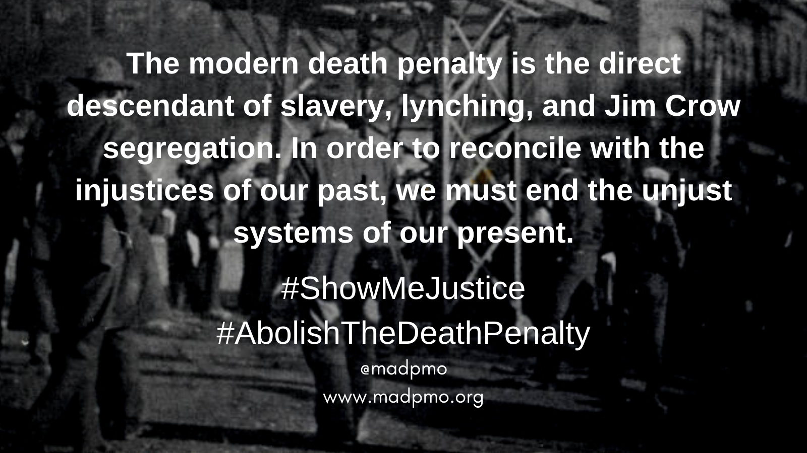
Twitter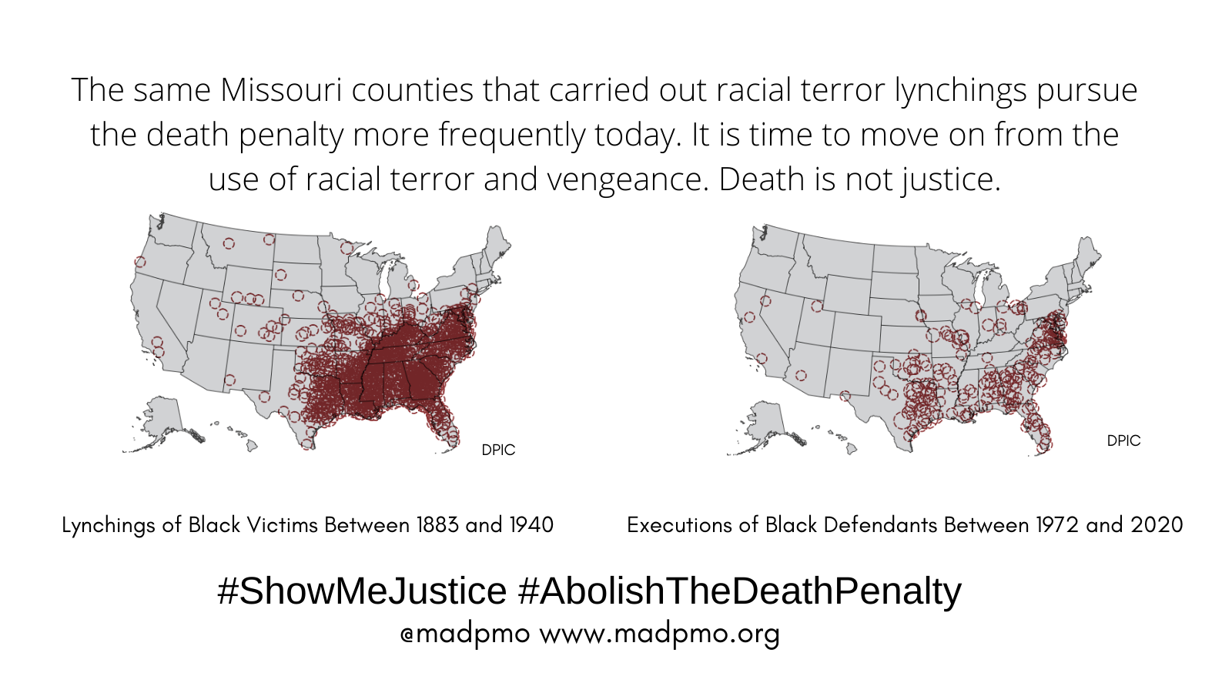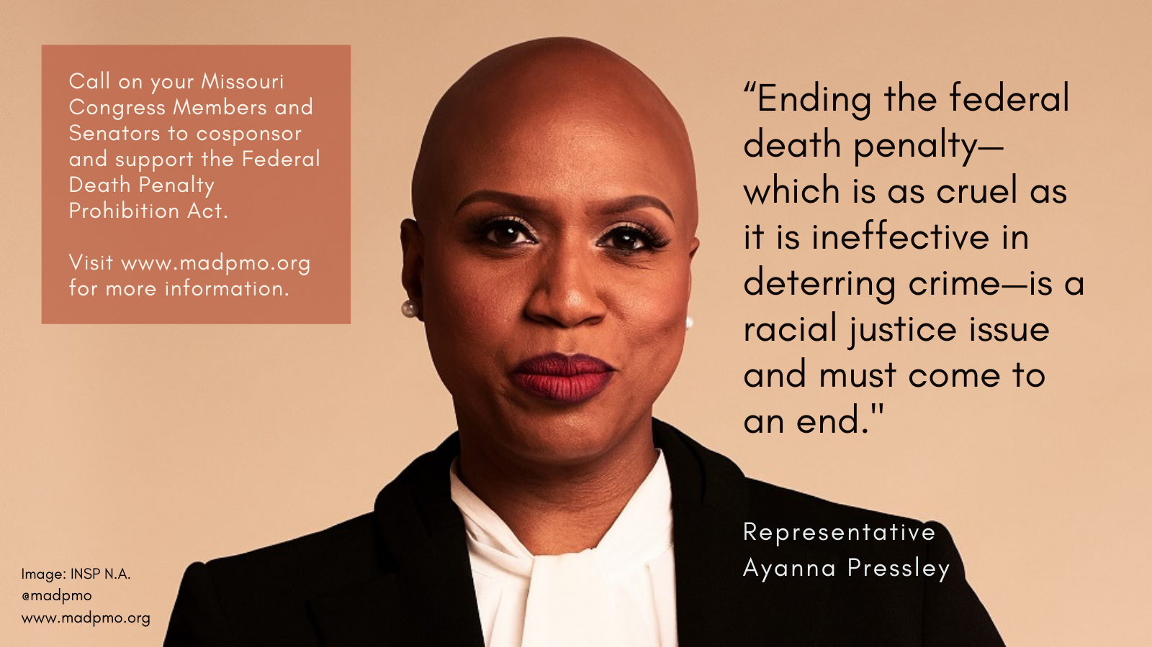
Twitter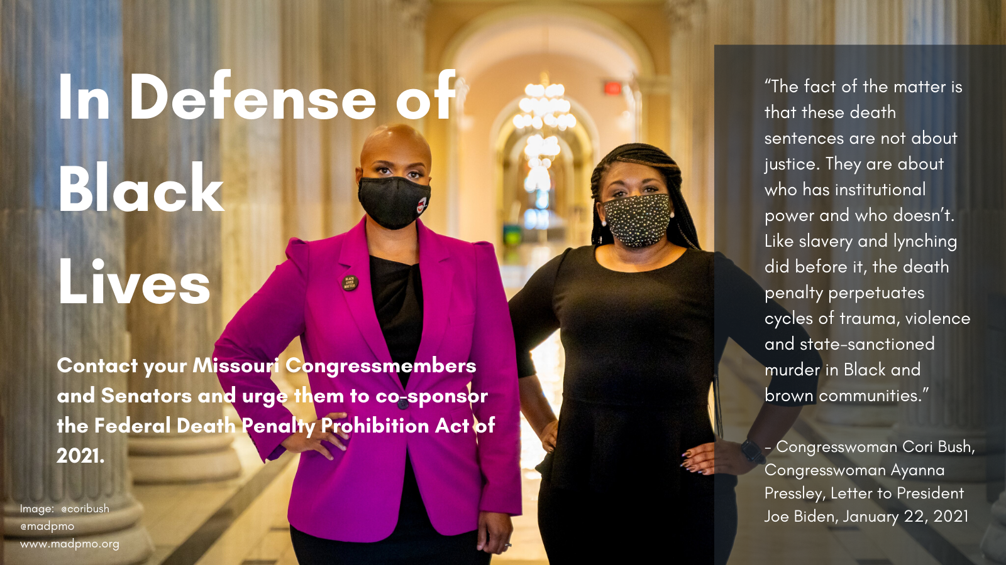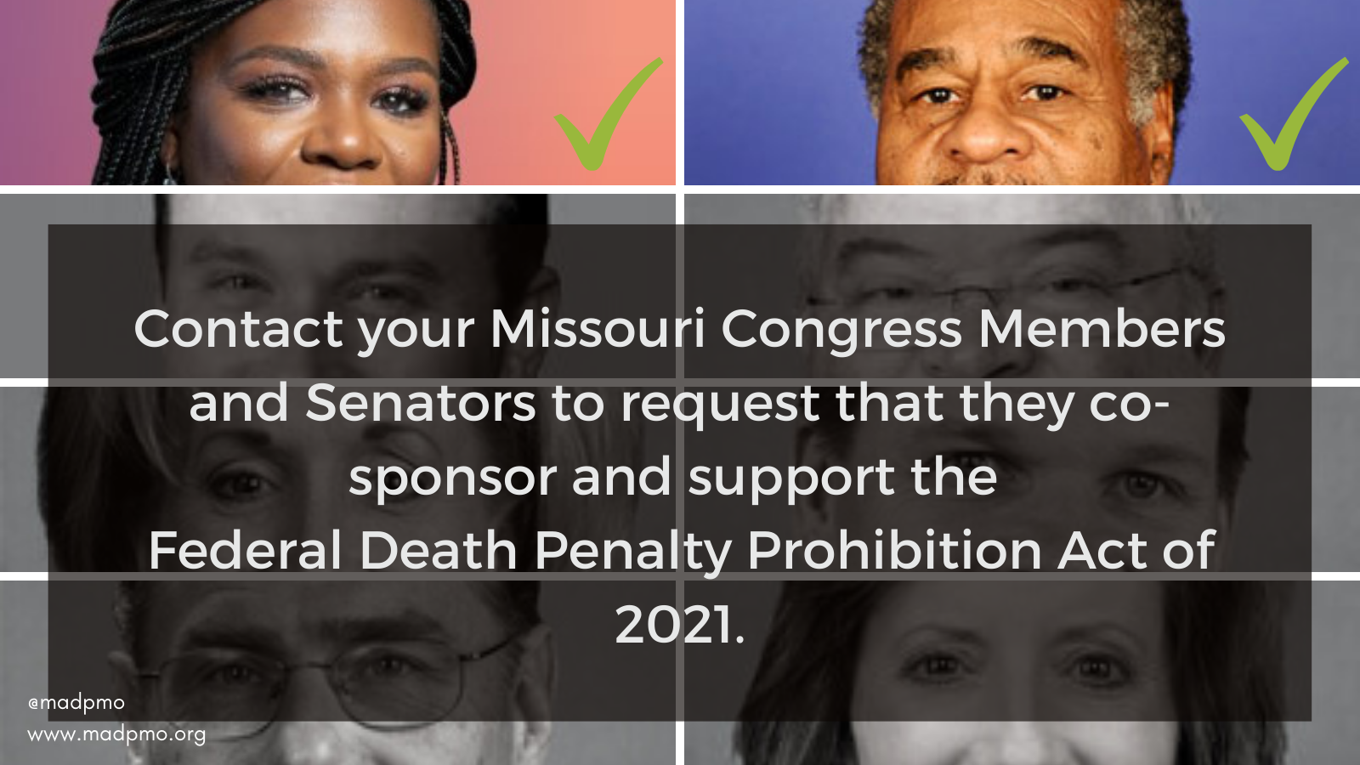

Facebook: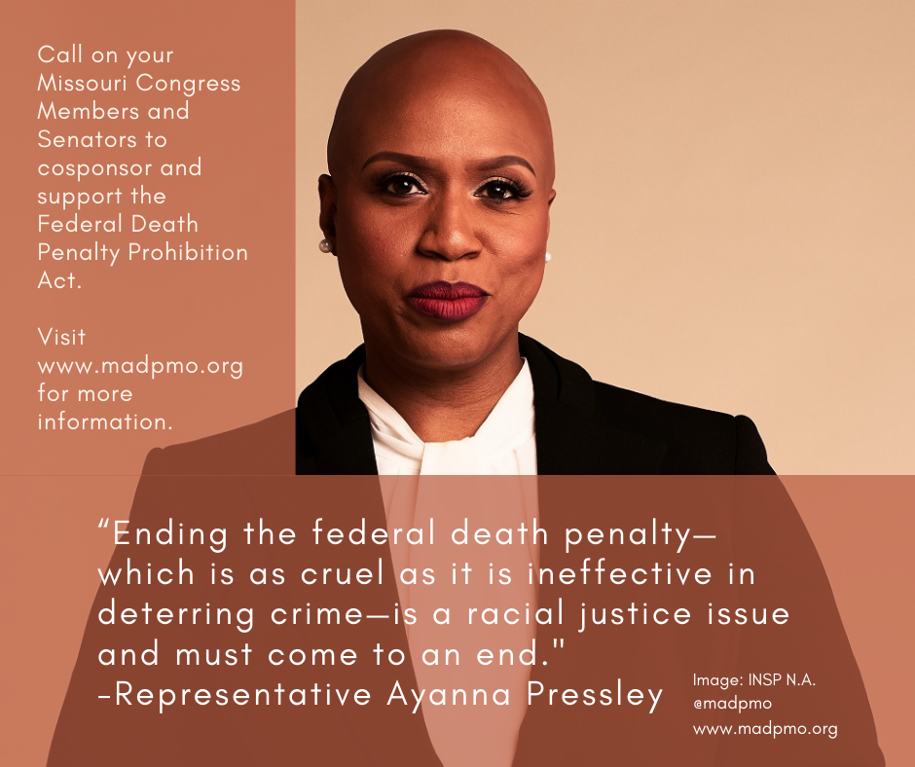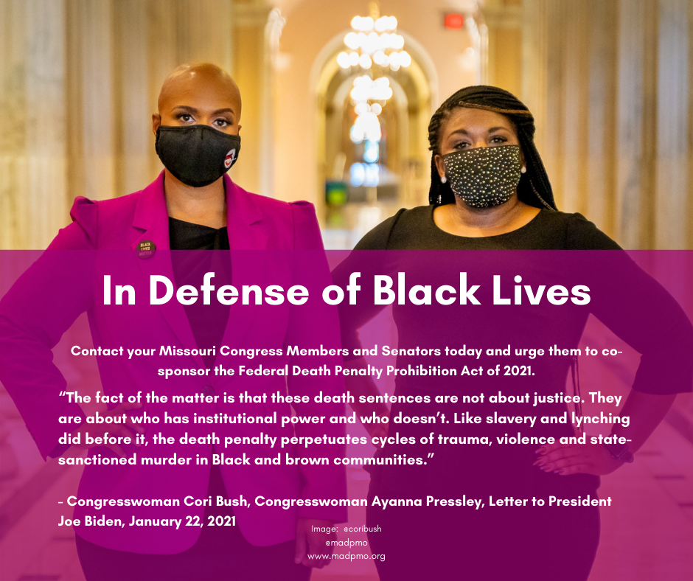
Facebook: 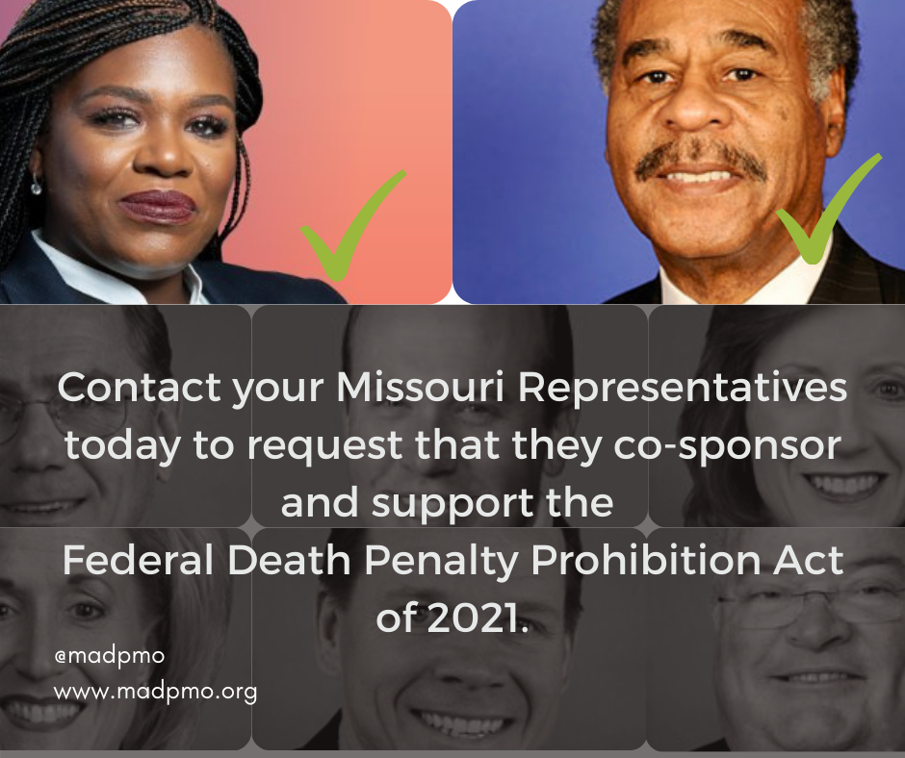
Facebook: 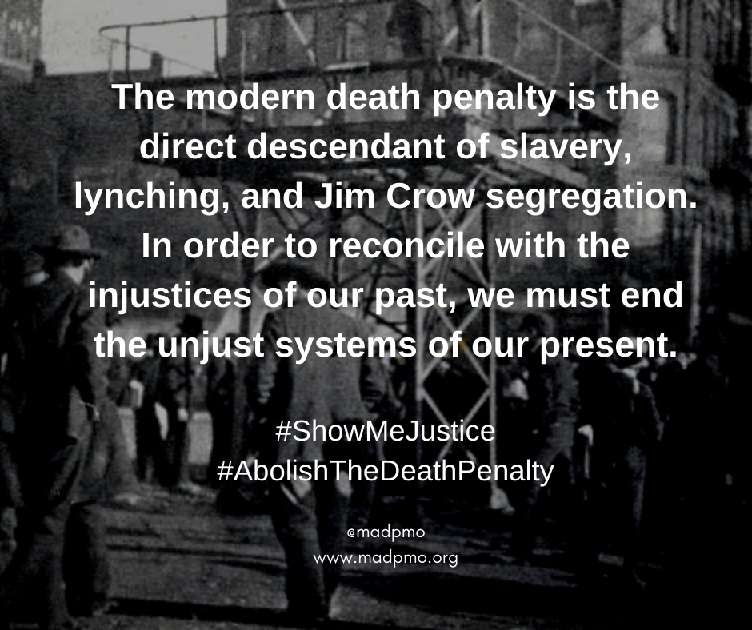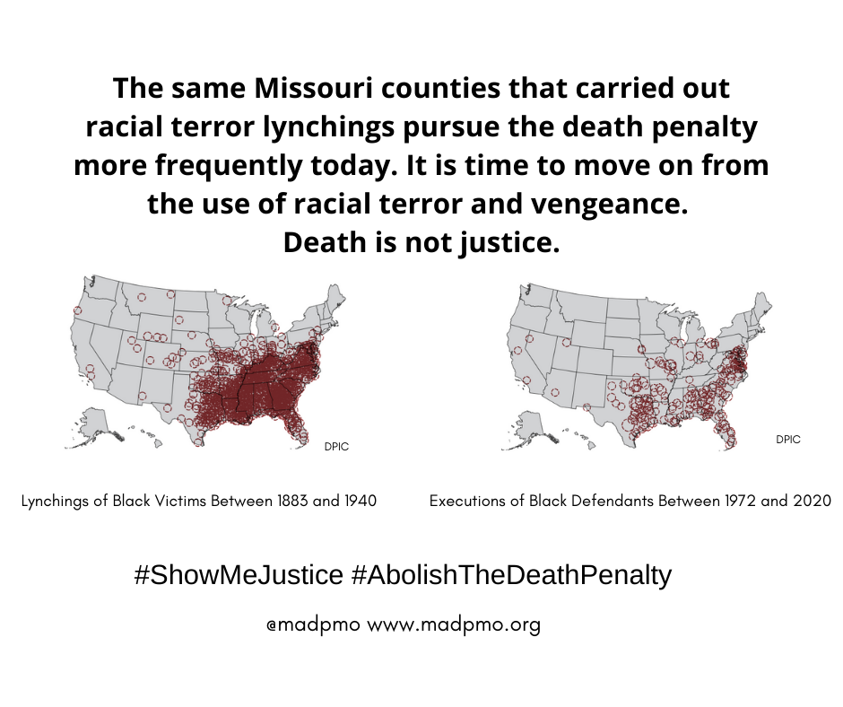
Instagram: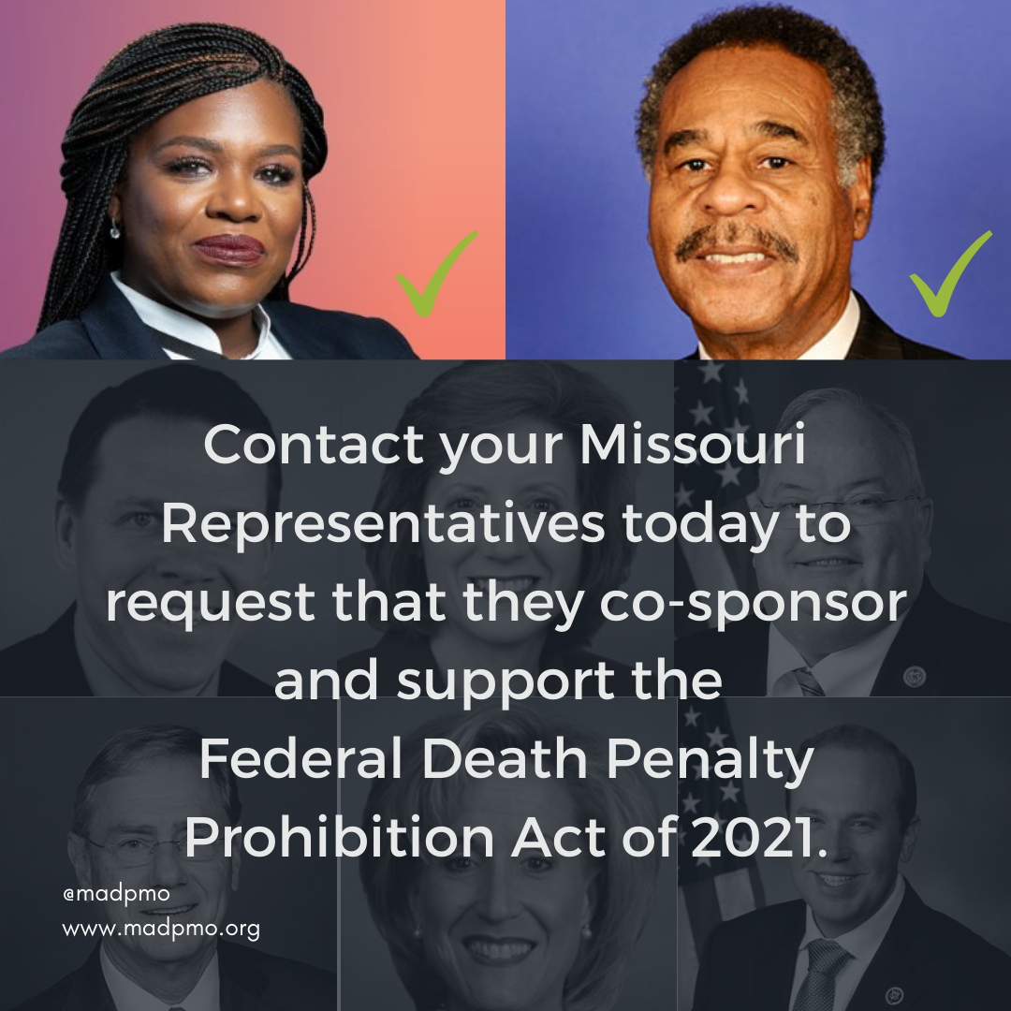
Instagram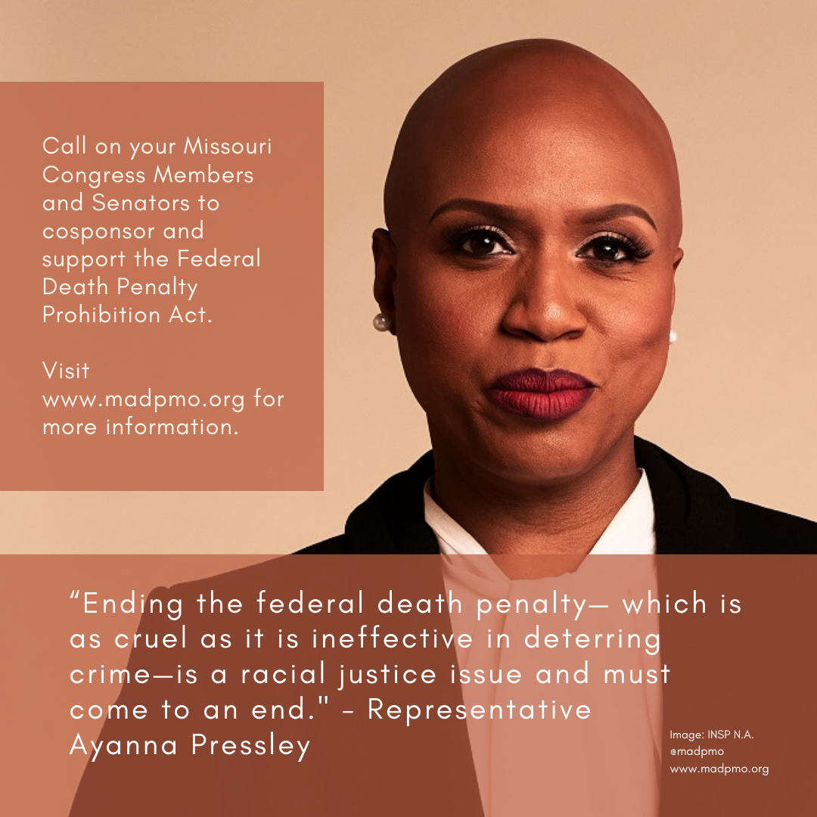
Instagram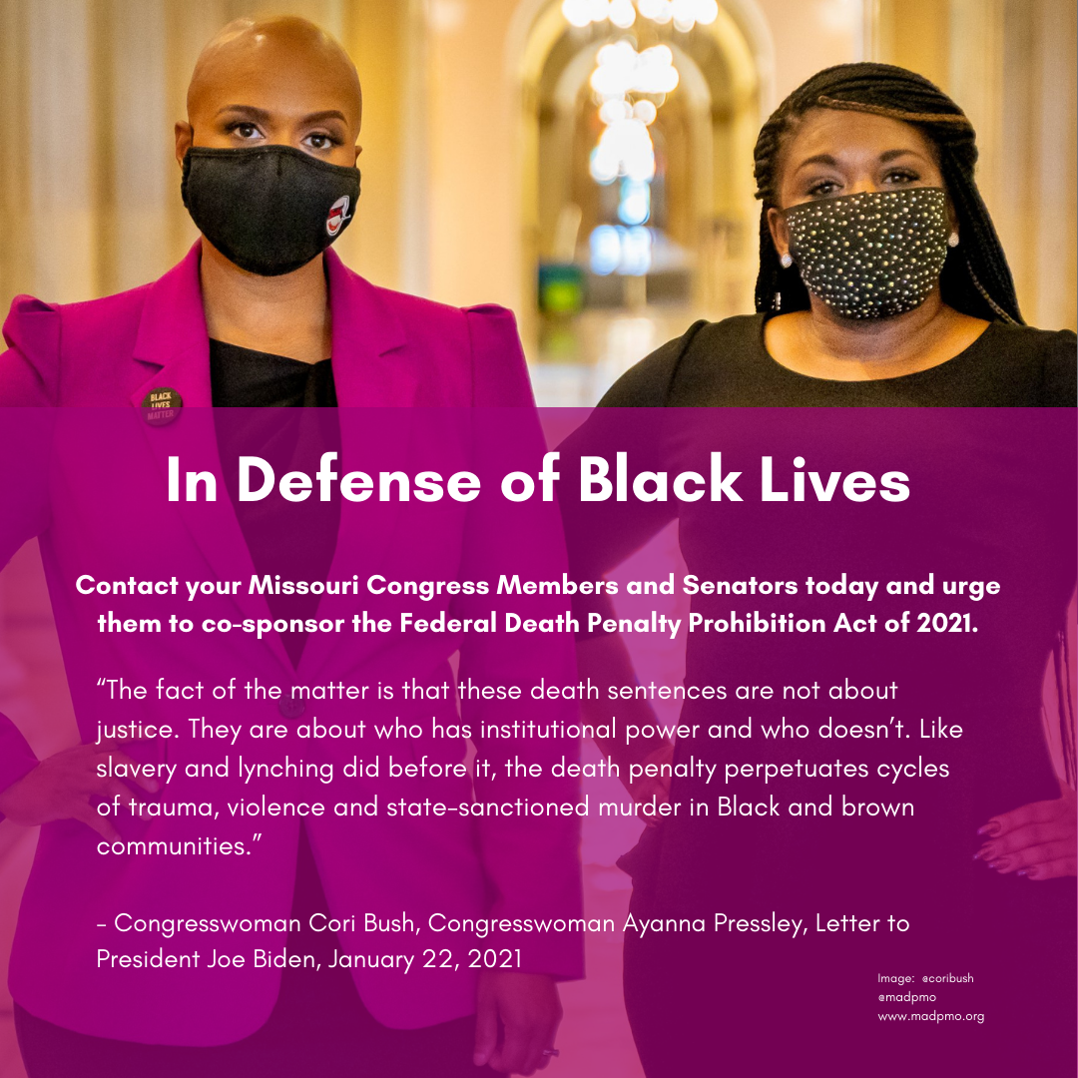Instagram: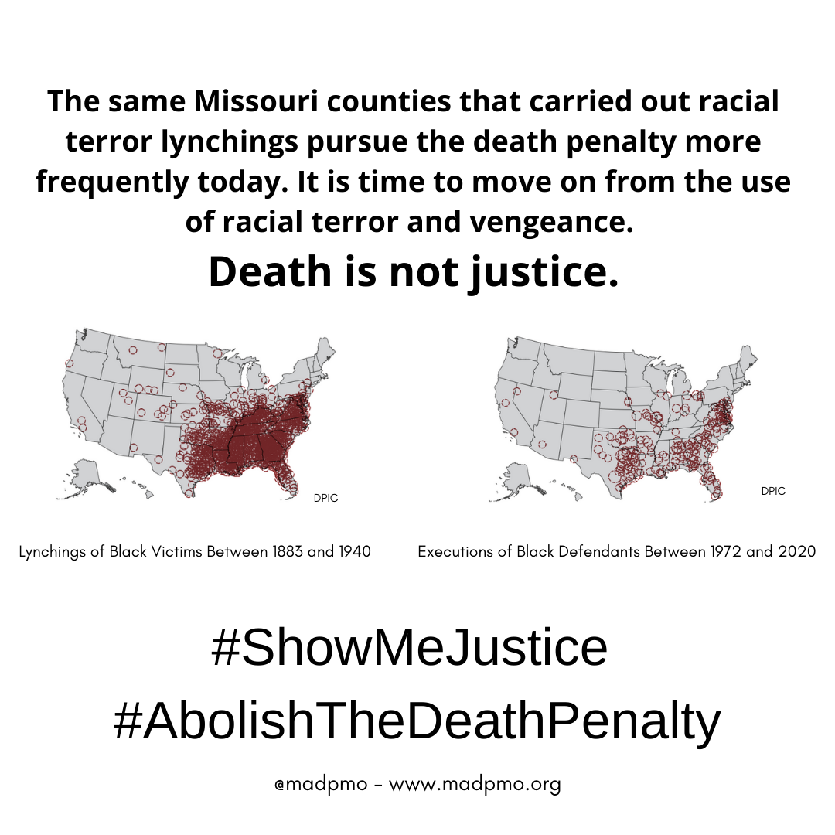

MADP Social Media Power Hour Sample Posts
Pair these sample posts with our Social Media Graphics to make more of an impact!
PLEASE USE ON APRIL 13th from 1PM-3PM CST!
For use on Twitter, Facebook, and Instagram. Feel free to add in more content from www.madpmo.org.

_______________________________________________________

The modern death penalty is the direct descendant of slavery, lynching, and Jim Crow segregation. In order to reconcile with the injustices of our past, we must end the unjust systems of our present. #ShowMeJustice #AbolishTheDeathPenalty @madpmo

_______________________________________________________

The Death Penalty:
-is a bloated government program
-kills innocent people
-delays justice for victims’ families
-wastes millions of taxpayer dollars

#ShowMeJustice #AbolishTheDeathPenalty @madpmo

_______________________________________________________

The death penalty diverts resources from genuine public safety and resources victims and their families. #ShowMeJustice #AbolishTheDeathPenalty @madpmo

_______________________________________________________

“Ending the federal death penalty—which is as cruel as it is ineffective in deterring crime—is a racial justice issue and must come to an end. @AyannaPressley

Call your MO Representatives/Senators to cosponsor & support the Federal Death Penalty Prohibition Act. #ShowMeJustice

_______________________________________________________

“... death sentences are not about justice. They are about who has institutional power & who doesn’t. Like slavery & lynching did before it, the death penalty perpetuates cycles of trauma, violence & state-sanctioned murder in Black & Brown communities.”
@CoriBush #ShowMeJustice

_______________________________________________________

Contact your Missouri Congress Members and Senators to request that they co-sponsor and support the Federal Death Penalty Prohibition Act of 2021.

#ShowMeJustice #AbolishTheDeathPenalty @madpmo @AyannaPressley @CoriBush @SenatorDurbin

_______________________________________________________

In Defense of Black Lives

Contact your Missouri Congress Members and Senators and urge them to co-sponsor the Federal Death Penalty Prohibition Act of 2021.

#ShowMeJustice #AbolishTheDeathPenalty @madpmo

_______________________________________________________

The same Missouri counties that carried out racial terror lynchings pursue the death penalty more frequently today.

It is time to move on from the use of racial terror and vengeance.

Death is not justice.

#ShowMeJustice #AbolishTheDeathPenalty @madpmo

Brought to you by Missourians for Alternatives to the Death Penalty - www.madpmo.org - @madpmo

You can find your representatives and their contact info by clicking on the link and entering your address and city: https://www.senate.mo.gov/legislookup/default.aspx

This Phone Zap Sample Script is for use on April 14th and 15th, 2021.

Picking up the phone and calling your legislators may be the easiest and quickest way to share your opinion. Don’t hesitate to call. Remember that your legislator wants to represent the needs of their district; remind them who they represent. By conveying your interests to your legislator, they will have a better understanding of how to serve their constituency’s needs. If you’re nervous about making this phone call and would like some assistance in preparing, read more info below and don’t hesitate to contact us for assistance at info@madpmo.org.

During Your Call
Identify yourself. When you contact the office, be sure to tell the person answering the phone that you are a constituent. Legislative offices get hundreds of phone calls a day. As a constituent, you should receive priority attention.
Make contact with the right person. Remember that telephone calls are often taken by a staff member, not the legislator. Ask to speak or leave a message with the aide who handles the issue you wish to leave a comment about.
Leave a brief message. After identifying yourself, tell the aide you would like to leave a brief message for the legislator, such as: “Please tell Representative _______________ that I support “Abolishing the Death Penalty,” or “Doing an Itemized Cost Study of Death Penalty in Missouri” State your reasons concisely.
Learn your representative’s stance and gather notes from your communications to share with MADP.
Thank your representative for their support and/or time. Legislator’s assistants are your best friend when it comes to communicating with legislators.

(Note: You can learn more about the death penalty in Missouri at www.madpmo.org/policy-issues)

SAMPLE SCRIPTS:

For Use on April 14th, 2021 - State Abolition Phone Zap Sample.

“Hi, my name is _____ and I live at/in _____. I am a constituent of Representative/Senator ______. I am calling today to ask for the support of legislation related to abolishing the death penalty and doing a thorough cost study of this broken system. (Optional: I oppose the death penalty because…[choose one, all from the list of Talking Points below, or fill in your own). Thank you for your time, to learn more about the death penalty in Missouri or to speak to a representative with MADP, please contact info@madpmo.org.”

Note: if you are leaving a message on an answering machine, make sure to clearly state your name and phone number or email address.

For Use on April 15th, 2021 - Federal Abolition Phone Zap Sample.

Please Use This Script if your Representative is: Ann Wagner, Blaine Luetekmeyer, Vicky Hartzler, Sam Graves, Billy Long, and Jason T. Smith:

“Hello, my name is _________ I am calling today to ask Congress Member _________ to co-sponsor and support HR 262, the Federal Death Penalty Prohibition Act of 2021. I live in [Name of city or your district].
I oppose the death penalty because…(choose one, all from the list of Talking Points below, or fill in your own). Thank you for your time, you can further reach me at _______ or speak with a Representative with MADP at info@madpmo.org.”

Note: if you are leaving a message on an answering machine, make sure to clearly state your name and phone number or email address.

Please Use This Script if your Representative is: Cori Bush and Emmanuel Cleaver:

“Hello, my name is [insert name] I am calling today to thank [Congress Member’s name] for cosponsoring HR 262, the Federal Death Penalty Prohibition Act of 2021. I live at/in _____. I oppose the death penalty because…(choose one, all from the list of Talking Points below, or fill in your own). Thank you for your time, you can further reach me at _______ or speak with a Representative with MADP at info@madpmo.org.”

Talking Points:

- The death penalty hurts the families of murder victims, subjecting them to decades of what-ifs and re-opening old wounds every time the case is mentioned in the news.
- Resources currently allocated for the death penalty should be reallocated for effective crime prevention, mental health treatment, education and rehabilitation, meaningful victims’ services, and drug treatment programs
- 185 people have been officially exonerated and freed after serving time on death row for a crime they did not commit. No one knows how many more innocent people are under sentence of death, or how many have actually been executed. Surely we can all agree that the risk of executing even one innocent person is too much.
- Law enforcement officials are on the record discussing how traumatic it is to take part in an execution.
- We can do a better job protecting the physical and mental health of our prison workers by eliminating the death penalty.
- We know that we can be kept safe and hold dangerous individuals accountable for their actions without the death penalty because it’s what we do the vast majority of the time.

[Thank the legislator and state your contact information.]

Once you’ve made your phone call, fill out the MADP response form to let us know how your call went and if you gathered any information about your legislator’s stance. You can fill out this form after each day, or once at the end of the week and return to info@madpmo.org.

Brought to you by Missourians for Alternatives to the Death Penalty - www.madpmo.org - @madpmo

You can find your representatives and their contact info by clicking on the link and entering your address and city: https://www.senate.mo.gov/legislookup/default.aspx

This Letter Writing and Email Sample is for use on April 14th, 2021.

If you do not use social media, you can take the time to write a handwritten letter to your representative during our Social Media Power Hour on April 12th. Remember, Handwritten letters sent in the postal mail always make the most impact.

Please use this sample below:

“My name is [insert name] and I am [writing/calling] today to ask Representative/Senator _______ to support ending the death penalty in Missouri. I live in [Name of city or your district].

I oppose the death penalty because…[choose one, all, or fill in your own from the list of talking points below]:

Talking Points

- Resources currently allocated for the death penalty should be reallocated for effective crime prevention, mental health treatment, education and rehabilitation, meaningful victims’ services, and drug treatment programs.
- According to the Death Penalty Information Center, for every eight people executed, one person has been exonerated. We know there are 20 men sentenced to death in Missouri, but no one knows exactly how many innocent people are on death row. We also don’t know how many innocent people have been executed. Surely, we can all agree that the risk of executing even one innocent person is too much.
- Law enforcement officials are on the record discussing how traumatic it is to take part in an execution. We can do a better job protecting the physical and mental health of our prison workers by eliminating the death penalty.
- The death penalty hurts the families of murder victims, subjecting them to decades of what-ifs and re-opening old wounds every time the case is mentioned in the news.
- We know that we can be kept safe and hold dangerous individuals accountable for their actions without the death penalty because it’s what we do the vast majority of the time.

[Thank the legislator]
[Signature]

Once you’ve completed your communication, fill out the MADP response form to let us know how your call went and if you gathered any information about your legislator’s stance. You can fill out this form after each day, or once at the end of the week and return to info@madpmo.org.

Brought to you by Missourians for Alternatives to the Death Penalty - www.madpmo.org - @madpmo

You can find your representatives and their contact info by clicking on the link and entering your address and city: https://www.senate.mo.gov/legislookup/default.aspx

This Letter Writing/Email Sample/Calling Aid is for use on April 15th, 2021.

If you do not use social media, you can take the time to write a handwritten letter during our Social Media Power Hour on April 12th. Handwritten letters sent in the postal mail always make the most impact.

Please use this script if your representative is: Ann Wagner, Blaine Luetkemeyer, Vicky Hartzler, Sam Graves, Billy Long, and Jason T. Smith:

“My name is __________ and I am [calling/writing] today to ask Congressmember ________ to co-sponsor and support HR 262, the Federal Death Penalty Prohibition Act of 2021. I live in [Name of city or your district].

I oppose the death penalty because…[choose one, all, or fill in your own from the list of talking points below]:

Please use this script if your Representative is: Cori Bush or Emmanuel Cleaver:

Hello, my name is ________ and I am [calling/writing] today to thank Congressmember __________ for cosponsoring HR 262, the Federal Death Penalty Prohibition Act of 2021. I live in [Name of city or your district].

I oppose the death penalty because…[choose one, all, or fill in your own from the list of talking points below]:

Please use this script if calling/writing Senators:

“My name is ________ and I am [calling/writing] today to ask Senator________ to co-sponsor and support the Federal Death Penalty Prohibition Act of 2021, SB 582. I live in [Name of city or your district].

I oppose the death penalty because…[choose one, all, or fill in your own from the list of talking points below]:

Talking Points

- The death penalty hurts the families of murder victims, subjecting them to decades of what-ifs and re-opening old wounds every time the case is mentioned in the news.
- Resources currently allocated for the death penalty should be reallocated for effective crime prevention, mental health treatment, education and rehabilitation, meaningful victims’ services, and drug treatment programs.
- 185 people have been officially exonerated and freed after serving time on death row for a crime they did not commit. No one knows how many more innocent people are under sentence of death or how many have actually been executed. Surely, we can all agree that the risk of executing even one innocent person is too much.
- Law enforcement officials are on the record discussing how traumatic it is to take part in an execution.
- We can do a better job protecting the physical and mental health of our prison workers by eliminating the death penalty.
- We know that we can be kept safe and hold dangerous individuals accountable for their actions without the death penalty because it’s what we do the vast majority of the time.

[Thank the legislator]
[Signature]

Once you’ve completed your communication, fill out the MADP response form to let us know how your call went and if you gathered any information about your legislator’s stance. You can fill out this form after each day, or once at the end of the week and return to info@madpmo.org.

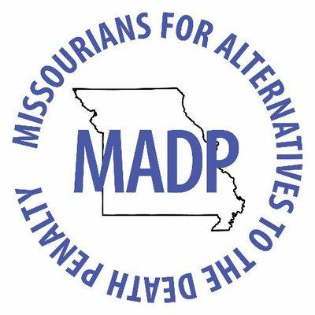

MADP 2021 Advocacy Week Response Form

Name:
Email:
Phone Number:
Address:

- Which member(s) of the legislature or staff did you contact? Were you able to speak directly to your legislator?

- What was the response from the legislator or staffer? Were there requests for follow-up? Please provide as much detail as possible.

- What outstanding questions did the office have?

- Please list any additional comments or notes below.

