DIRECTV Bargaining Bulletin #1
October 22, 2021

Since we transitioned from Effects Bargaining with AT&T, we have been meeting for several weeks with DIRECTV in an attempt to consolidate 10 different contracts (AT&T and Mobility) into one. The Union and the Company have had many discussions surrounding the Company’s policies, practices and procedures, as well as employee’s benefits and working conditions. It is CWA’s goal to negotiate a fair and just contract for all of our members that transitioned to the new DIRECTV.

Our committee started working on plans and logistics in accomplishing our goal while we were in Effects Bargaining. Based on the fact that we have 10 contracts to review and numerous titles, we decided to form committees where subject matter experts were assigned to work on formulating proposals to present to the Company.

While we’re negotiating with the Company, all existing contractual agreements will be honored and remain in full effect as is and we’ll continue to bargain with DIRECTV in an attempt to improve contractual provisions for all members nationwide.

In Unity,

Sylvia J. Ramos, Assistant to the VP, District 6
Mary Jo Reilly, Staff Representative, Telecommunication & Technologies
Pat Telesco, Area Director, District 1
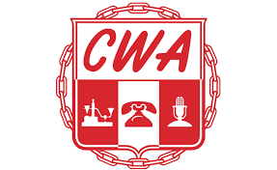
Angela Wells, Administrative Director, District 3
Herman Junkin, Jr., Staff Representative, District 3
Ron Gay, Jr., Staff Representative, District 4
Tony Shaffer, Staff Representative, District 6
Domonique Thomas, Assistant to VP, District 9

UNITED WE BARGAIN … DIVIDED WE BEG!!!
sv/opeiu#13

