Dear friends and friendly organizations June 29. 2025

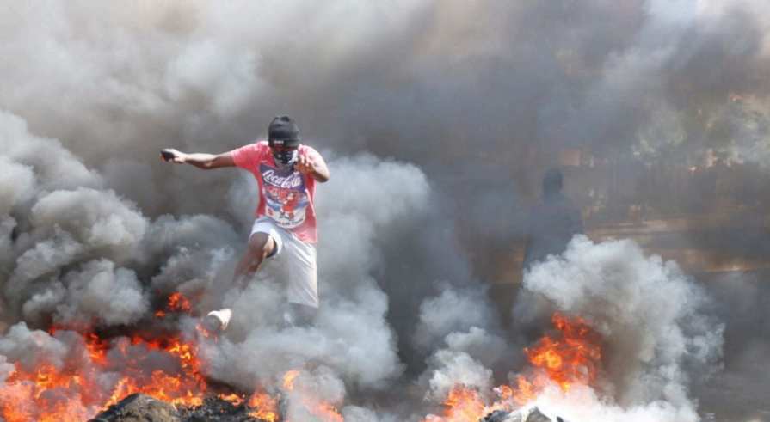
This is a direct appeal to you or your organization to donate to our coming youth climate summit in Kisumu Africa. It is to promote a breakthrough for peace and climate justice in Africa. Supported by the board of NAZCCA.org, I, Rolf vom Dorp, as a climate activist, ask for your support at a time when the youth and broader public are everywhere the victims of violence and climate injustice. We must do all we can locally and globally, in Africa too. We need to bring forward through this conference new leaders, new organizers, willing to build around repairing the climate not looting or violence. Currently as the oceans warm and land and atmospheric warming accelerate, we need everyone on board. Violence is erupting in many parts especially the Global South, including Kenya where this meeting is planned.

From the Daily Nation, June 25, 2025. A protester in Nakuru City, Kenya. Boniface Mwangi

Prior to forwarding donations, I will review the coalition’s payables, making sure all transactions are reasonable, correct, and transparent.

The peace and climate justice campaign in Africa began some 6 months ago. We, of Fridays for Future and the Peace and Climate Justice Network, were at the right place at the right time. A major conference is now planned for August, bringing together some 400 activists from ten African countries (Tunisia, Burundi, South Sudan, Uganda, Kenya, Tanzania, Nigeria, Republic of Congo, South Africa, Ivory Coast), and 25 organizations, including Fridays for Future groups, people of faith, and women's groups. The greater the donations, the more attendees we can welcome. I was told we could with proper funding double that number.

Here are the details of the plans, https://actionnetwork.org/user_files/user_files/000/125/651/original/FINAL_DRAFT617.docx.pdf. Additional links of interest are this peace and climate justice petition, https://actionnetwork.org/petitions/pcjafrica-2. The petition is being translated into Swahili, and the same petition is being circulated in Europe and the US to link these efforts. We are preparing for the conference in committees shown at this link, where you can volunteer too: https://actionnetwork.org/forms/pcjroleskisumu. Additional information includes Certification information, Kenya, https://actionnetwork.org/user_files/user_files/000/126/226/original/Subject__Request_for_Support_%E2%80%93_Pan-African_Youth_Climate_and_Peace_Summit.pdf
Or,
https://actionnetwork.org/user_files/user_files/000/126/225/original/Subject__Request_for_Support_%E2%80%93_Pan-African_Youth_Climate_and_Peace_Summit.docx

We need to subsidize room and board at the conference, create publicity, organize the presentations and breakout groups.

Donations for this work out of the US are tax deductible, earmarked as Africa to NAZCCA.org, https://www.nazcca.org/donate. Better yet, you can donate via your bank directly to the Wise Bank account in New York from your bank.The Wise Bank account number under my name of Rolf vom Dorp is 822000340593, routing number 026073150. Only after my review of payables will any of these donations be forwarded. Payments in Sweden can go to swish account 0724496424.

My wife and I have been active for sixteen years in the climate effort. We work with a local Fridays For Future Lund group (in Sweden), I write articles for the FFF Newsletter (global), I work with the Peace and Climate Justice network (global), and I am President of the Northern Arizona Climate Change Alliance (Arizona, US). We have donated all we can to climate causes for years, including in the US, in Sweden where we live, and in Africa. The Pan-African Youth-Led Climate Justice and Peace Summit now deserves generous support from all.

Best wishes,

Rolf vom Dorp
NAZCCA.org, FFF Action Network
slowclimate@gmail.com
+46724496243

.

